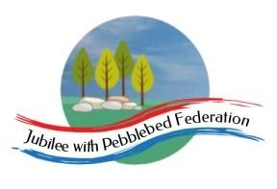
Learning
from Home

Year: Reception  Wk beg: 8/3/2021 | Lesson One | Lesson  Two | Lesson  Three | Lesson  Four | Lesson  Five
Monday 8th March | Name Practice  Practice writing your name either on a piece of paper or your name card.  Please encourage correct pencil hold – ‘nip, flip and grip’.  Make sure your child can form every letter correctly and without a visual.  Extend by encouraging your child to write the letters smaller and on a line. | Reading  Log onto Bug Club and pick a book to read to your grown up. Ask your child questions about the story and to sound talk the words.  https://www.activelearnprimary.co.uk/login?c=0  Practice reading some of the sound button words in their home learning pack.  e.g. h-u-ff huff  Or read and write the tricky words on their key ring. | Maths  Listen to and join in with these songs to help learn the days of the week.  https://www.youtube.com/watch?v=spi77By9-iA  https://supersimple.com/song/days-of-the-week/  Ask what day is it today? What day was it yesterday? What day will it be tomorrow?  Watch the story ‘What’s the time Mr Wolf?’  https://www.youtube.com/watch?v=9tkkQzI_9JY  Talk about the hands on the clock and where they point to show o’clock times. | Phonics  Review all letter sounds learnt so far – see flash cards in home learning pack. Focus on learning the digraphs qu ch sh th ng ai ee igh oa oo(long) oo(short) ar ur ow oi ear air  Learn the sound ure  https://www.youtube.com/watch?v=YwCzf71flBA  https://www.youtube.com/watch?v=IK8m-5JQmso  Then practice reading these words:  fair  airport  stairs  chair  cure  manure  lure  insure  We have learnt all the sounds in these words so see if your child can sound talk them e.g. f-air | Art  Talk with your child about Mother’s Day. Why is this day celebrated? What sorts of things to people do to say thank you to their Mum?  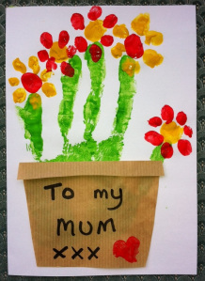  Now get creative and make a Mother’s day card using the resources you have at home. There are lots of simple ideas online if you need them.
Tuesday 9th March | Name Practice  Practice writing your name either on a piece of paper or your name card.  Please encourage correct pencil hold – ‘nip, flip and grip’.  Make sure your child can form every letter correctly and without a visual.  Extend by encouraging your child to write the letters smaller and on a line. | Reading  Log onto Bug Club and pick a book to read to your grown up. Ask your child questions about the story and to sound talk the words.  https://www.activelearnprimary.co.uk/login?c=0  Practice reading some of the sound button words in their home learning pack.  e.g. h-u-ff huff  Or read and write the tricky words on their key ring. | Maths  Listen to and join in with these songs to help learn the days of the week.  https://www.youtube.com/watch?v=spi77By9-iA  https://supersimple.com/song/days-of-the-week/  Ask what day is it today? What day was it yesterday? What day will it be tomorrow?  Talk with your child about what they do at different times of the day. Try to keep it to o’clock times. So you might get up at 7o’clock, go to school at 9 o’clock, have lunch at 12 o’clock etc. If you can talk about where the hands would be on the clock at these times. | Phonics  Review all letter sounds learnt so far – see flash cards in home learning pack. Focus on learning the digraphs qu ch sh th ng ai ee igh oa oo(long) oo(short) ar ur ow oi ear air ure  Learn the sound er  https://www.youtube.com/watch?v=WaxZN4BZjgc  Next ask your child to write these words:  pure  sure  manure  manicure  term  kerb  sister  dinner  We have learnt all the sounds in these words so see if your child can sound talk them e.g. p-ure | Handwriting  Help your child to practice writing the letters that make the sounds ure and er.  Try to encourage your child to hold the pen/pencil correctly. Look at the nip, flip and grip poster if you feel your child needs help with their pencil grip.  Make sure that your child is forming the letters correctly and correct them if needed.
Wednesday 10th March | Name Practice  Practice writing your name either on a piece of paper or your name card.  Please encourage  correct pencil hold – ‘nip, flip and grip’.  Make sure your child can form every letter correctly and without a visual.  Extend by encouraging your child to write the letters smaller and on a line. | Reading  Log onto Bug Club and pick a book to read to your grown up. Ask your child questions about the story and to sound talk the words.  https://www.activelearnprimary.co.uk/login?c=0  Practice reading some of the sound button words in their home learning pack.  e.g. h-u-ff huff  Or read and write the tricky words on their key ring. | Maths  Children make families of three snakes of different lengths out of playdough.  They arrange them in order, shortest first. Which snake is the longest snake? And the shortest?  Ask children to measure their snakes using cubes. | RE  Learn about Palm Sunday.  https://www.youtube.com/watch?v=lTmbTuutBgg  https://www.youtube.com/watch?v=Kht2SR8P0ko  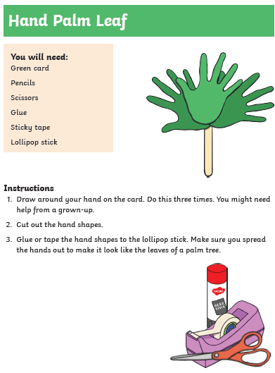 | PE  https://www.youtube.com/watch?v=14ou-fplEi4  https://www.youtube.com/watch?v=h5PpLvMvW2s
Thursday 11th March | Name Practice  Practice writing your name either on a piece of paper or your name card.  Please encourage  correct pencil hold – ‘nip, flip and grip’.  Make sure your child can form every letter correctly and without a visual.  Extend by encouraging your child to write the letters smaller and on a line. | Reading  Log onto Bug Club and pick a book to read to your grown up. Ask your child questions about the story and to sound talk the words.  https://www.activelearnprimary.co.uk/login?c=0  Practice reading some of the sound button words in their home learning pack.  e.g. h-u-ff huff  Or read and write the tricky words on their key ring. | Maths  Watch and talk about these ‘telling the time’ songs.  What time is it? How do you know?  https://www.youtube.com/watch?v=xJBek5XCexw  https://www.youtube.com/watch?v=g6tJAy_7AL4 | Phonics  Practise reading and writing tricky words I, no, go, to, the & into.  Tricky word cards in home learning packs.  https://www.youtube.com/watch?v=TvMyssfAUx0 | Literacy  Using the Mother’s Day card you created on Monday. Write a complimentary message inside the card for your Mum.  ‘To Mum’  ‘You are pretty’  ‘Love from…’  Encourage your child to sound talk the words they use.
Friday 12^{h} March | Name Practice  Practice writing your name either on a piece of paper or your name card.  Please encourage  correct pencil hold – ‘nip, flip and grip’.  Make sure your child can form every letter correctly and without a visual.  Extend by encouraging your child to write the letters smaller and on a line. | Reading  Log onto Bug Club and pick a book to read to your grown up. Ask your child questions about the story and to sound talk the words.  https://www.activelearnprimary.co.uk/login?c=0  Practice reading some of the sound button words in their home learning pack.  e.g. h-u-ff huff  Or read and write the tricky words on their key ring. | Maths  Make a clock face with your child. Draw and cut out a circle. Encourage your child to label their clock by placing the numbers on the clock in the correct position.  Draw 3, 6, 9, 12 first to support them if needed and then write the other numbers.  Extend by making a short and long hand and model telling the time to o’clock.  “Can you show me 4’oclock?” | Phonics  Practice reading and writing tricky words I, no, go, to, the & into.  Tricky word cards in home learning packs.  Can you put each word into a sentence?  E.g.  I can skip.  Let’s jump into the pool.  https://www.youtube.com/watch?v=TvMyssfAUx0 | Handwriting  We are going to practice writing numerals correctly in school. We are going to focus on forming numerals 1-5.  Practice writing each numeral 5 times. Encourage them to use correct pencil grip and to start each number at the right place.  https://www.youtube.com/watch?v=DzKqCmjVXLI
Please be aware that your home filter may allow unsuitable links to pop up when watching any YouTube video.

We would love to see any photos of the learning you are doing at home. Please send these to YRteacher@littleham.devon.sch.uk
Please let us know if you need any additional resources to help your child to complete their home learning with you at home.

