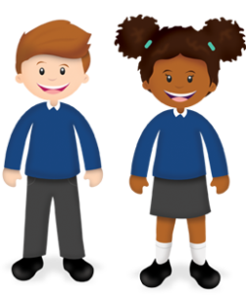
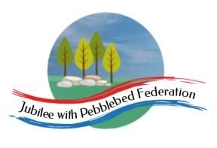

Year: 6  Wk beg: 16/10/20 | Lesson One | Lesson Two | Lesson Three | Lesson Four |  |  | Lesson Five
Monday | Reading – Own book.  Spellings – sheet taken home  Grammar – To use fronted adverbials https://classroom.thenational.academy/lessons/to-explore-fronted-adverbials-71h64t | Maths  PRACTISE TABLES  To know angles and find missing angles  https://classroom.thenational.academy/lessons/find-the-value-of-missing-angles-6cr3je |  | Project Hola Mexico  Mexican music  https://www.youtube.com/watch?v=0pPLnSSBwWs  LO – To use an atlas to locate Mexico  https://www.bbc.co.uk/bitesize/articles/z4dxt39  Learn the 7 continents, main seas and oceans, latitude and longitude  https://www.bbc.co.uk/bitesize/topics/zvsfr82/articles/zd4rmfr
Tuesday | Reading – Own book.  Spellings – sheet taken home  Grammar – To know what a relative clause is https://classroom.thenational.academy/lessons/to-explore-relative-clauses-65k30c?activity=video&step=1 | Maths  https://classroom.thenational.academy/lessons/compare-and-classify-triangles-6mu6at  LO Compare and classify triangles  PRACTISE TABLES |  | RE  I know the scientific explanation for the origin of the universe.  https://www.youtube.com/watch?v=DmUiCweDic4  Checked 10/10/2020 | MFL  I am learning Spanish numbers  https://www.youtube.com/watch?v=8fPF1eGvLLM  I know Spanish greetings  https://www.primaryresources.co.uk/mfl/mfl_spanish.htm
Wednesday | Reading – Own book.  Spellings – sheet taken home  Word – To understand word classes  https://classroom.thenational.academy/lessons/to-explore-word-class-65k6ar | Maths LO –  Compare and classify quadrilaterals  https://classroom.thenational.academy/lessons/compare-and-classify-quadrilaterals-71h38c  PRACTISE TABLES |  | Computing  Use the internet to conduct searches about Mexico. Use multiple sites and compare information gained on people, land use, cities, festivals and tourism.
Thursday | Reading – Own book.  Spellings – sheet taken home  English – Goodnight Mr Tom  https://classroom.thenational.academy/lessons/to-establish-a-background-knowledge-of-the-story-and-create-an-initial-impression-60rk8r | Maths LO  To find unknown angles in a triangle.  https://classroom.thenational.academy/lessons/find-unknown-angles-in-triangles-6tgkcd  PRACTISE TABLES |  | PSHE  https://classroom.thenational.academy/lessons/community-care-cctp8c |  | PE  Fitness – push-ups, squats, leg drives, star jumps, shuttle runs.
Friday | Reading – Own book.  Spellings – sheet taken home  English –Goodnight Mr Tom  https://teachers.thenational.academy/lessons/to-make-inferences-about-characters-in-the-book-cgu3gt | Maths  Transum Arithmetic  Basic add/subtract/multiply/ divide  https://www.transum.org/go/default_by_Topic.asp  PRACTISE TABLES |  | Project  Hola Mexico  Mexican music  https://www.youtube.com/watch?v=0pPLnSSBwWs  LO – To use an atlas to locate Mexico  https://www.bbc.co.uk/bitesize/articles/z4dxt39  Learn the 7 continents, main seas and oceans, latitude and longitude  https://www.bbc.co.uk/bitesize/topics/zvsfr82/articles/zd4rmfr  Research climate of Mexico.

