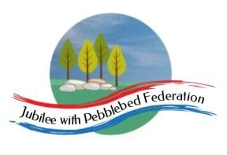
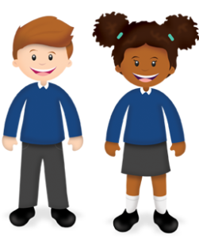
Play and Learn in Reception

Reception  January | As part of our Early Years Foundation Stage Curriculum we also learn lots through play! In school we will also be doing the following as part of our continuous provision. You are welcome to try some of these activities in addition to the home learning grid/Google Classroom
Finger Football Phonics  Write words on pieces of paper. Screw them up and use your finger to kick them into a goal (could use a food container). Encourage your child to read the word before their next go. | Shopping  Use the things in your house to make a shop. Take it in turns to be the shop keeper and customer.  Use real money if possible. | Construction  Build a bridge using construction materials you have at home. | Paint the fence  Use a brush, bowl of water and paint the fence or floor outside.  Extend by writing and drawing letters, numbers and shapes. | Reading Den  Can you use blankets and cushions to make a comfy space to make a den. Have fun reading books together. | Dressing up  Wear your fancy dress clothes and have some make-believe fun together!  Follow their lead as you play together.
Take a photo  Take 3 photos of your favourite things in your house.  Discuss why you took photographs of these things. | Cooking  Follow a simple recipe, use the scales to measure amounts. Eat it with your family. | Goat Art  Paint or draw a picture of a Billy  Goat Gruff from our story. Remember to include all of the goat’s body parts. | Threading  Practise using a threading card.  Thread pasta, beads onto a piece of string or pipe cleaner. | Go on a winter walk  Collect some nature treasures and make a picture with them back home. | Measuring with a stick  Use a stick and find things that are longer, shorter or the same size as the stick.

