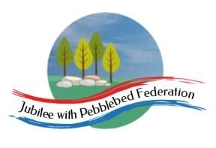
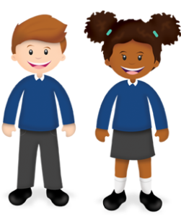
Learning
from Home

Year: Reception  Wk beg: 5/10/20 | Lesson One | Lesson Two | Lesson Three | Lesson Four | Lesson Five
Monday | Name Practise  Support your child to order the letters of their name using the letter cards in their home learning packs, or magnetic letters if you have them. Then get them to have a go at writing their name. Try to encourage your child to hold the pen/pencil correctly. | Reading  Share your child’s Lilac reading book. This can be one from their book bag or from Bug Club. Login details in reading record. | Maths  Using your numeral cards, count forwards and backwards to 10. Point to each number as they count.  Join with the patterns with the song Banana, banana, meatball by Blazer Noodle  On YouTube.com | Phonics  I spy  Place on the floor or on a table a selection of objects with names containing two or three phonemes (e.g. zip, hat, comb, cup, chain, boat, tap, ball). Check that your child knows the names of the objects. Then say I spy with my little eye a z-i-p. Can they work out which object it is? | Literacy  Watch ‘One Mole Digging a Hole’  https://www.youtube.com/watch?v=eJjwOwohdTY  Can your child spot the rhyming words?  Encourage them to join in with the counting also.
Tuesday | Name Practise  As Monday | Reading  Share your child’s class library book from their book bag or share a story that you have at home. | Maths  Play counting games on the website below. The link may not work so just type:  https://www.topmarks.co.uk/maths-games/3-5-years/counting  Start with numbers to 5 and move onto numbers to 10 if your child is ready. | Phonics  Clapping sounds  Think of words using the letters ‘s, a, t, p, i, n’ (e.g. sat, pin, nip, pat, tap, pit, pip) and  sound them out, clapping each phoneme with your child, then blend the  phonemes to make the whole word. | Understanding the World  Watch ‘Let’s Play’ on CBeebies – What would you like to be when you are older? What do you know about these jobs?  https://www.bbc.co.uk/iplayer/episodes/b04vsmn4/lets-play
Wednesday | Name Practise  As Monday | Reading  Share your child’s Lilac reading book. This can be one from their book bag or from Bug Club. Login details in reading record. | Maths  Using your numeral cards, count forwards and backwards to 10. Point to each number as they count.  Join with the patterns with the song Banana, banana, meatball by Blazer Noodle  On YouTube.com | RE  Show your child something that is special to you and explain why it is special.  Then help them to find something that is special to them and help them to talk about why it is special. | PE  Explore playing with a ball.  Have a go at rolling, throwing and catching.
Thursday | Name Practise  As Monday | Reading  Share your child’s class library book from their book bag or share a story that you have at home. | Maths  Maths  Play counting games on the website below. The link may not work so just type:  https://www.topmarks.co.uk/maths-games/3-5-years/counting  Start with numbers to 5 and move onto numbers to 10 if your child is ready. | Phonics  Mirror play  Look in a mirror together. Play at making faces and copying movements of the lips and tongue. Introduce sound making in the mirror and discuss the way lips move, for example, when sounding out ‘p’ and ‘b’, the way teeth and lips touch for ‘f’ and the way lips shape the sounds ‘sh’ and ‘m’. | Literacy  Watch ‘One Mole Digging a Hole’  https://www.youtube.com/watch?v=eJjwOwohdTY  Can your child spot the rhyming words?  Encourage them to join in with the counting also.
Friday | Name Practise  As Monday | Reading  Share your child’s Lilac reading book. This can be one from their book bag or from Bug Club. Login details in reading record. | Maths  Using your numeral cards, count forwards and backwards to 10. Point to each number as they count.  Join with the patterns with the song Banana, banana, meatball by Blazer Noodle  On YouTube.com | Phonics  I spy  Place on the floor or on a table a selection of objects with names containing two or three phonemes (e.g. zip, hat, comb, cup, chain, boat, tap, ball). Check that your child knows the names of the objects. Then say I spy with my little eye a z-i-p. Can they work out which object it is? | Art  Use play doh you have at home or make some together.  https://www.bbcgoodfood.com/ howto/guide/playdough-recipe  Can you roll the play doh to make ball/snake shapes?

