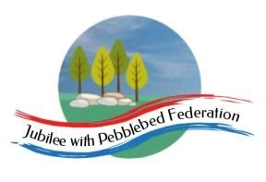
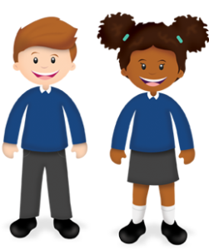
Learning
from Home

Year: Reception  Wk beg: 2/11/20 | Lesson One | Lesson Two | Lesson Three | Lesson Four | Lesson Five
Monday | Name Practise  Support your child to order the letters of their name using the letter cards in their home learning packs, or magnetic letters if you have them. Then get them to have a go at writing their name. Try to encourage your child to hold the pen/pencil correctly. | Reading  Share your child’s Lilac reading book. This can be one from their book bag or from Bug Club. Login details in reading record. | Maths  Sing ‘One Man Went To Mow’ https://www.youtube.com/watch?v=NQwVBebHyXE  Then choose an ‘Understanding Number’ activity. Please adapt using resources you have at home. | Phonics  Learn letter "s" with the Alphablocks Magic Words on CBeebies  https://www.youtube.com/watch?v=IEMMHCfj8aI  Can you think of things that start with the letter s?  Try writing the letter s. | Literacy  If you have the book at home read the traditional story of the ‘Three Little Pigs’ or watch  https://www.bbc.co.uk/iplayer/episode/p08lc7jz/mr-tumble-tales-the-three-little-pigs
Tuesday | Name Practise  As Monday | Reading  Share your child’s class library book from their book bag or share a story that you have at home. | Maths  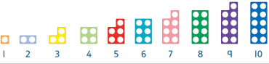  Order the Numicon in your home learning pack from the smallest to the largest number. Put the correct numeral under each Numicon. | Phonics  Learn letter "a" with the Alphablocks Magic Words on CBeebies  https://www.youtube.com/watch?v=egWW51b2hpE  Can you think of things that start with the letter a?  Try writing the letter a. | Fine Motor  Using string or a shoelace practise threading. You may have beads you can use, or you could use tubes of pasta or hooped shaped cereal. Can you make a bracelet or necklace?
Wednesday | Name Practise  As Monday | Reading  Share your child’s Lilac reading book. This can be one from their book bag or from Bug Club. Login details in reading record. | Maths  Sing ‘One Man Went To Mow’ https://www.youtube.com/watch?v=NQwVBebHyXE  Then choose an ‘Understanding Number’ activity. Please adapt using resources you have at home. | PSHE  Talk about feelings. How are you feeling today? When do you feel happy? Sad? Worried? Excited?  E.g. I feel happy when I go to school because I get to play with my friends. | PE  Practise catching a large ball. How many times can you throw and catch before dropping it? Can you make up a game that involves a large ball?
Thursday | Name Practise  As Monday | Reading  Share your child’s class library book from their book bag or share a story that you have at home. | Maths  Order the Numicon in your home learning pack from the smallest to the largest number. Put the correct numeral under each Numicon. | Phonics  Learn letter "t" with the Alphablocks Magic Words on CBeebies  https://www.youtube.com/watch?v=V0YX6Dy2lnk  Can you think of things that start with the letter t?  Try writing the letter t. | Literacy  If you have the book at home read the traditional story of the ‘Three Little Pigs’ or watch  https://www.youtube.com/watch?v=dXemLZIXy3M
Friday | Name Practise  As Monday | Reading  Share your child’s Lilac reading book. This can be one from their book bag or from Bug Club. Login details in reading record. | Maths  Sing ‘One Man Went To Mow’ https://www.youtube.com/watch?v=NQwVBebHyXE  Then choose an ‘Understanding Number’ activity. Please adapt using resources you have at home. | Phonics  Learn letter "p" with the Alphablocks Magic Words on CBeebies  https://www.youtube.com/watch?v=ejcsU9MfFko  Can you think of things that start with the letter p?  Try writing the letter p. | Art  Did you see any fireworks last night? What did they look/sound like? What colours did you see?  Create a firework picture using any resources (paints, crayons, pens) that you have at home. You could even add some glitter if you have some.

