Hub Weekly Challenges 3
Week beginning 4 May 2020
Get Building Challenge  Can you make a musical instrument only using objects found in the home?  Try a straw flute at youtube -How to make your own pan flute out of straws.  Or, How to make a cereal box guitar – youtube  Or, look at any musical instrument ideas on the internet. There are many you can try making! | Arty Crafty Challenge  Can you make a 3D animal of your choice out of materials you have in your home?  Check these out for ideas or design one of your own –  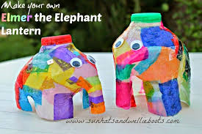  Milk bottle elephant - https://theimaginationtree.com/milk-jug-elmer-elephant-craft/  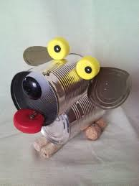  Tin can dog out of cans – be careful, this could be sharp!  Thinking of you Freddie!  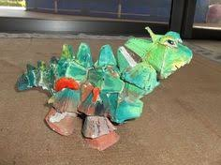  Junk model dinosaur -one for you maybe Harry?
The Tasty Challenge  Chocolate concrete - yum!  You will need:  8oz self-raising flour  1oz cocoa powder  6oz margarine  6oz sugar  1 egg  Mix all together. Bake on 160C, gas mark 3 for 15 minutes for a soft consistency, or turn down the oven and bake for another 15 minutes for proper concrete! | Keep Fit Challenge  Outdoor scavenger hunt  On your walk, can you find:  - A rock that has spots on  - Something heavy  - An object smaller than your thumb  - Something that smells good  - Something that can blow away  - A stick that is longer than your hand  - An insect with more than 4 legs  - A butterfly  - A spider’s web  - Name 5 things you can hear  - Name 5 things you can see that are green but different!
Can you find out Challenge?  WORD LADDERS - Start on the word WINK. Can you change one letter and make a new word? You should be able to get to KISS! For example, WINK – WIND –  Try this with Plane. Can you get to the word truck? | Pass the Parcel Challenge  Continue with your stories, poems and newspaper articles. You have a new one that has been passed onto you this week. You need to write the next paragraph or verse ONLY and then email it back to me. Each week, I’ll pass the stories around….amongst the adults as well! Our writing will grow each week.
Grill a Teacher Challenge  This week’s teacher is Mrs Cambridge.  Email any questions you would like to ask her and I’ll give you the answers next week. Make sure you are polite! | Your turn!  Would you like to set any of the challenges next week? Email me any of your ideas. Maybe you would like to set a Tasty Challenge or the next Keep Fit Challenge. Be creative!
I will email this out to you on a Monday. Please send me an email once a week with any of your responses, pictures etc. By Sunday 2.00pm please if you want your entries to be included. Send me an email to keepintouch@littleham.devon.sch.uk

Miss Hitchcock
Pass the Parcel Writing!
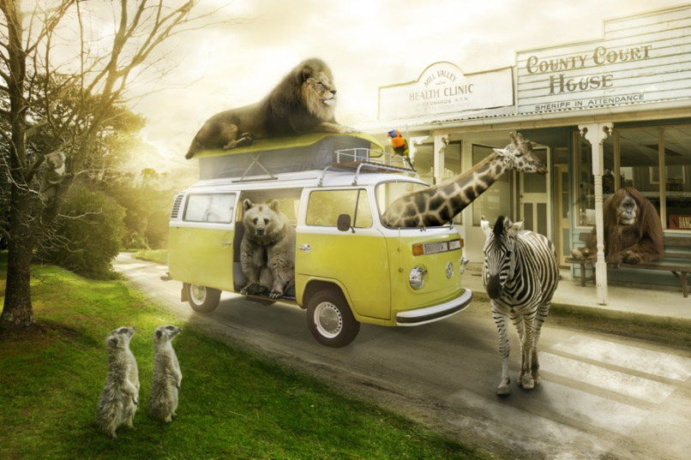
Most visitors are a little shocked (to put it mildly) when they arrive at Animal Town. Despite the fact that the name of the town gives a slight indication to passers-by that the inhabitants of the town are ‘not normal’, it’s as if people don’t believe things until they see them with their own eyes!
Once you get used to being in Animal Town – or so they say – seeing an orangutan behind a desk in a sheriff’s office and upholding the law to an impeccably high standard becomes relatively ‘normal’…
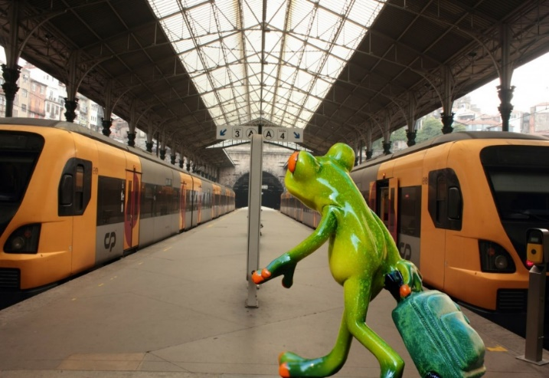
AF: There is even a train station that is run by a Rattlesnake called Lucy and her family. They help the other snakes to and from London, Zootropolis and Penzance.
GC: It is not unusual to see Zebras, in their black and white uniform of course, patrolling the streets, enforcing strict car parking measures, giving out the occasional parking ticket and obviously monitoring Zebra crossings! Don’t be fooled, these animals may look harmless and have on occasion, even been called cute, but they are feisty! There is literally nothing you can do to explain away why you had to park on the double black lines or why you decided to cross the Zebra crossing backwards. Fines and tickets are issued daily.

Mrs Cambridge
There was an old man with a beard
Who said, “It’s just how I feared!
Two owls and a hen
Four larks and a wren
Have all built their nests in my beard

JC -There was a silly old cat,
He wore a coat, some gloves and a hat,
He ate all day long,
To be big and strong,
But ended up very fat!

A young witch called Nellie,
Made potions that were smellie,
The spells were not right,
As she was not bright,
And she ended up with a sore belly!

Alex:
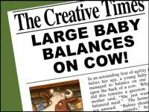
Reporter: Jacqui Clark

Yesterday, locals in the village of Hamlittle were shocked to see a giant baby sitting on a cow in a field that belonged to Farmer Jack McDonald (postcode , ei ei o).
Concerned for the baby's wellbeing, a local girl-Miss Muffett called the authorities and contacted us at the Fabled Times. Constable Dick Wittington was quick to attend the scene and deal with the situation. On speaking to Farmer Jack he was able to establish that there was no cause for concern as Jack informed him that the Beanstalk had grown back and that the baby belonged to the Giant family who lived in a castle in the clouds and they often came down to visit Jack and meet the cow that had brought the two families together. Mrs Giant was very positive about the friendship and said, " Although we are from different backgrounds, we get on famously.”

Mrs Clark
I wish there was a law that said………

KJ: That adults aren't in charge of children 7 days a week.
For one day, children have free reign. They can choose what they want to do, and where they want to go, and the adult must adhere to the rules!

Harry
In six days there will be no more chocolate in the world….ever! That’s what it said on The Seven Show. Jelly had nearly reached the next level of Zombie Puppy Dash, but hearing this made her plunge the pink puppy into a huge tank of zombie dog food. “Woah! What was that about chocolate….”
KJ: Jelly could not believe what she was hearing! How can this be?! Chocolate is Jelly's most favourite thing in the world (closely followed by Zombie Puppy Dash)
Jelly dreamed that one day she would own a chocolate shop, filled with all of her favourite bars; Crunchie, Twirl, Lion, Milkybar, Mars bar, to name a few. A chocolate bar Buckingham Palace to attract the customers, but now Jelly will have to think of a new dream...........
Jelly had to start the level of Zombie Puppy Dash again, and Jelly better eat chocolate for breakfast, lunch, and dinner for the next six days.

Mrs Jones
Dear Diary,
Today, the doorbell rang, and I eagerly ran down the stairs. By the time I had opened the door, the delivery driver had vanished, but a giant box had been left on my doorstep.
​SH - The box was too heavy to lift and too big to get through the door. I opened it to find a smaller box inside, covered in chains and padlocks. A note was stuck on the top that said ‘this box of secrets has been hidden for hundreds of years. Look closely and follow the clues’
I sat next to the box for a while, reading the note, wondering how I was going to solve this mystery. A white feather with two black spots on fell from the sky and landed on my foot. I picked it up and looked at it closely. Was this my first clue?

Freddie
Bleary-eyed, I went downstairs for breakfast, the house was empty, even the furniture had gone.
GC -I rubbed my eyes. Am I dreaming? But as my eyes adjusted to the morning light creeping in through the slits in the curtains, I realised this was no dream. What was happening? Walking around, in a shocked daze, I noticed dents in the carpet where the furniture had been. There had sat my favourite rocking chair with my fluffy purple cushion; over there had lived my piano with one key missing and beyond had stood my slightly faded sofa. Suddenly, a chill ran down my spine, and turning sharply, I thought I noticed a slight scurry of movement in the corner of the room.
SH: As I turned, the piano key flew across the room and the piano started to play. What on earth was going on? I rubbed my eyes again, I couldn’t quite believe what I was seeing. I crept across the squeaky floorboards towards the piano key that was dangling in front of the living room window. As I reached out to get it, it flew straight past me and up the stairs. Now I really was nervous, but I slowly crawled up the stairs, following the piano key. It led me to the bathroom, but my bathroom was no more, there in front of me, was a spiralling circle, whizzing around so fast I went a bit dizzy! I sat on the floor, the piano suddenly stopped and a whispering voice said ‘Crawl through the whizzing tunnel, your adventure is about to begin’.

Hub Exhibition

w/b. 20.4.20 Alex’s bottle rocket, carrot cake and proudly wearing his new Blue Peter badge which arrived this week. FANTASTIC!
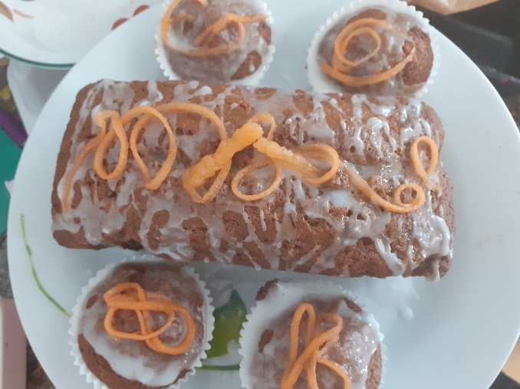
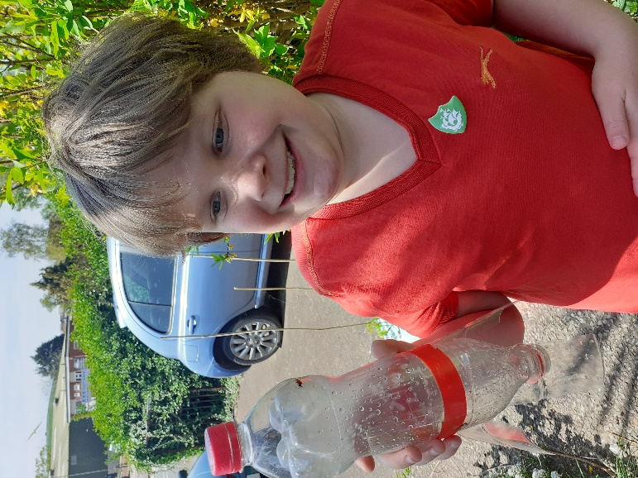
w/b. 27.5.20
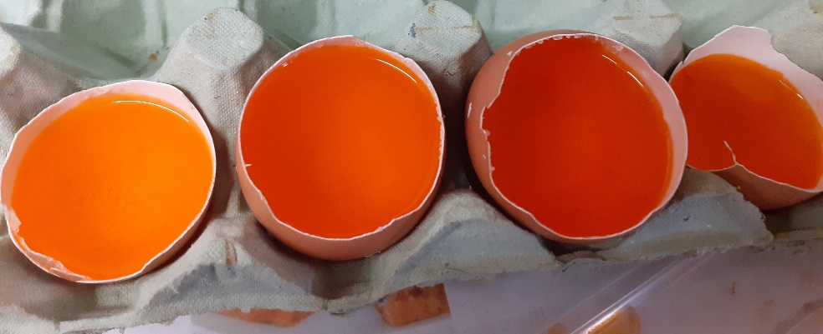
Alex started to make his crystal geode eggs.
These look exciting! Can we have a picture once they have crystalised?

