Hub Weekly Challenges 19
Kensuke’s Kingdom Week 1  This week we are starting our new topic based around Michael Morpurgo’s book, ‘Kensuke’s Kingdom’. Each week you will need to read or listen to two chapters. I am sending you home with the book and an audio CD.  1.This week sit back and listen to Chapters 1 and 2 or curl up with the book!  2. Have a listen to Michael Morpurgo answering his five 5 most asked questions:  https://www.youtube.com/watch?v=-MV9WqzT3TM  3. Have a go at our Kensuke’s Kingdom Chapter 1 Quiz. It’s on Google Classrooms or you can use a paper copy if you prefer. | The Debate Section!  Should children be allowed to eat chocolate for breakfast?  What do you think? Can you ask different members of your family for their opinions? Can you ask friends and family when you next Zoom or phone them? Remember, I want to hear reasons for and against eating chocolate for breakfast! I want to hear different opinions and ideas. Get asking!
The Tasty Challenge  Have a go at making pancakes this week to celebrate Shrove Tuesday. Shrove Tuesday is a day of celebration as well as repentance (saying sorry) because it's the last day before Lent. Lent has traditional been a time of abstinence, of giving things up. So Shrove Tuesday is the last chance to indulge yourself, and to use up the foods that aren't allowed in Lent. In the old days there were many foods that Christians would not eat during Lent: foods such as meat and fish, fats, eggs, and milky foods. So that no food was wasted, families would have a feast on the Shrove Tuesday, and eat up all the foods that wouldn't last the forty days of Lent without going off.  Use the recipe attached to your paper pack or find it on Google Classrooms.  This year in school we are looking at the 40acts of kindness. Instead of giving things up, we encourage you to do one kind act a day. Look at the sheet provided for ideas or you will find it on Google Classrooms. | Maths Madness  1.Play a game of dominoes and familiarise yourself with the game.  2. Can you solve the Domino  Square Investigation.  3. Play the Greatest or  Smallest Domino Game.  1.Revist Clock Solitaire on Youtube:  CardGameHeaven.com  Are you getting better at this?  2. Have a look at the rules for Go Fish. You will need someone to play with. You can find it here,  https://www.youtube.com/watch?v=emvdufe6t-8  Now, it’s your turn to have a go.  3. If you need a game to play on your own, try this one – Solitaire  https://www.youtube.com/watch?v=eTG6EgEv1Ag
Arty Crafty  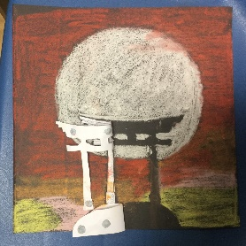  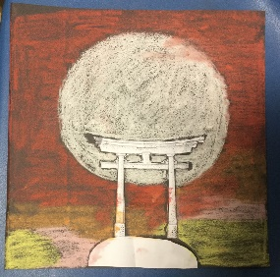  Can you make a Japanese Torri Gate/Pagoda scene using chalks or pastels? Here’s one Mrs Clark did…  1.Cut out a Torri Gate/Pagoda out of paper. Stick with blu-tac to your paper.  2.Use pastels to create a sunset scene around a full moon.  3.Remove the cut-out shape and enjoy!  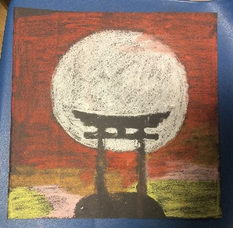 | Stay healthy!  Make sure you do some Funfit at home. My challenge to you this week is to see if you can beat your score for how long you can keep a ball up in the air for. Remember you could try this with a badminton racket and shuttlecock, a tennis racket and ball, a table tennis bat and ball or anything similar. Try alternating the side of the bat on each turn.  Or you could log onto PE with Joe on a Mon, Wed and Fri morning at 9.00 on YouTube or you can play them back at any time.  Do something this week that you enjoy, or you are good at. Perhaps you play an instrument, are good at art or sports. Maybe you like reading or cooking. Print out a photo of yourself or draw a picture. Then cut and stick pictures from magazines or draw pictures of things you love doing all around you. Stick it up in your bedroom to remind yourself of all the things you love to do. Choose something from there when you are feeling bored or fed up. It will give you a boost!  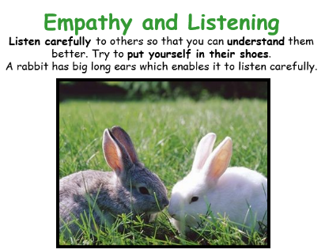  You are doing so well learning from home now. Keep on going! This week be inspired to become like a rabbit who listens really well. It’s easy to talk, but not so easy to become a listener.  Looking after your Mental Health  Remember to log on to Google Classrooms and watch Mrs Fagan’s Mental Health sessions each week. A paper copy, is attached if you can’t manage to log on.
Icebreakers…
Discuss with your family, maybe over a mealtime or when you have a few minutes to spare….

If you could go anywhere in the world, (after Covid 19) where you go?
Collective Worship
Our value this half term is Justice.

Every week you will find a weekly collective worship by Rev Benedict, Rev Steve, Brooke (Youthworker) or Sam Burnett (Baptist Minister of The Wave) on Google Classrooms.
Mrs Padbury leads a Collective Worship every Monday.
There’s also a sheet full of ideas on Google Classrooms for you to do together with your family. This will be in your pack if you are getting a paper copy.

This week, at the start of Lent, we are starting the 40 Acts of Kindness.
The Game Exchange!  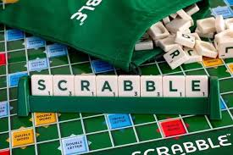  In your home learning box this week, I’ve sent you home with some games to play.  Have fun!  Remember you can exchange them for new ones whenever you are ready! | Your turn!  Would you like to set any of the challenges next week? Send me any of your ideas. Maybe you would like to set a Tasty Challenge or the next Would You Rather. Be creative!

Parents, please be aware that when accessing the YouTube clips I post, that adverts could pop up. It is always advisable to have your home security filters on. Please let me know if there are any issues.
This will be on the school website and on Google Classrooms by 8.30am every Monday. Please send me your responses and pictures by Friday 4.00pm please if you want your entries to be included in our Hub Exhibition. Send me an email to hubteacher@littleham.devon.sch.uk or reply in Google Classrooms.

