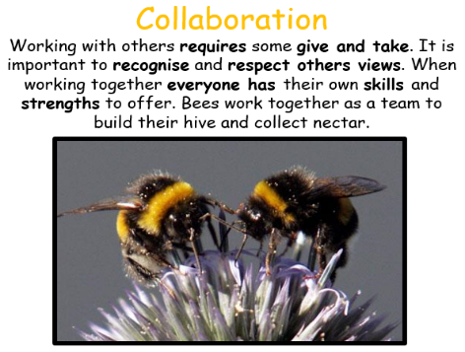
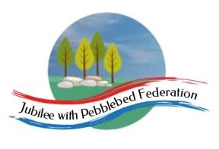
Learning
from Home

Year: Reception  Wk beg: 29/3/2021 | Lesson One | Lesson  Two | Lesson  Three | Lesson  Four | Lesson  Five
Monday 29th March | Name Practice  Practice writing your name either on a piece of paper or your name card.  Please encourage correct pencil hold – ‘nip, flip and grip’.  Make sure your child can form every letter correctly and without a visual.  Extend by encouraging your child to write the letters smaller and on a line. | Reading  Log onto Bug Club and pick a book to read to your grown up. Ask your child questions about the story and to sound talk the words.  https://www.activelearnprimary.co.uk/login?c=0  Practice reading some of the sound button words in their home learning pack.  e.g. h-u-ff huff  Or read and write the tricky words on their key ring. | Maths  Practice writing numbers correctly.  https://www.youtube.com/watch?v=DzKqCmjVXLI  Write these additions on cards or pieces of paper.  2+1= 3+1= 4+1= 5+1=  6+1= 7+1= 8+1= 9+1=  Shuffle the eight addition cards and place face down in a pile.  Ask your child to take one. Read it together.  Then help your child to make the addition using cubes, e.g. take 5 cubes, then 1 more to make 6, then write the answer on the card. | Phonics  Review all letter sounds learnt so far – see flash cards in home learning pack. Focus on learning the digraphs qu ch sh th ng ai ee igh oa oo(long) oo(short) ar ur ow oi ear air ure er  Revisit the sounds th by watching the clips below:  https://www.youtube.com/watch?v=7uwgHxH2H20  https://www.youtube.com/watch?v=6U354eD-hgQ  Then practice reading these words  ship  flash  fish  shell  thud  Beth  them  cloth  We have learnt all the sounds in these words so see if your child can sound talk them,  e.g. th-u-d thud | Art & Literacy  Make and write an Easter card.  There will be lots of ideas for simple Easter cards you can make together online. Once made help your child to write the message inside.  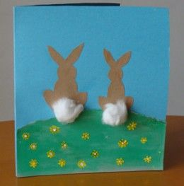  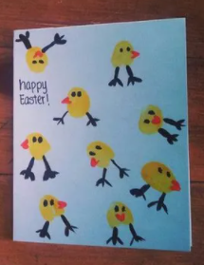
Tuesday 30th March | Name Practice  Practice writing your name either on a piece of paper or your name card.  Please encourage correct pencil hold – ‘nip, flip and grip’.  Make sure your child can form every letter correctly and without a visual.  Extend by encouraging your child to write the letters smaller and on a line. | Reading  Log onto Bug Club and pick a book to read to your grown up. Ask your child questions about the story and to sound talk the words.  https://www.activelearnprimary.co.uk/login?c=0  Practice reading some of the sound button words in their home learning pack.  e.g. h-u-ff huff  Or read and write the tricky words on their key ring. | Maths  Practice writing numbers correctly.  https://www.youtube.com/watch?v=DzKqCmjVXLI  Make a number track to 12 by putting the cards from your home learning pack in order.  Then place 2 counters on number 6, one for you and the other for your child. Take turns to toss a coin. If it shows heads, you say the number that is 1 more, if it shows tails you say the number that is 1 less.  If correct you move your counter to the correct number.  Repeat until one of you reaches either end of the track. | Phonics  Review all letter sounds learnt so far – see flash cards in home learning pack. Focus on learning the digraphs qu ch sh th ng ai ee igh oa oo(long) oo(short) ar ur ow oi ear air ure er  Revisit the sound ng by watching the clips below:  https://www.youtube.com/watch?v=zb6S29aUZKs  https://www.youtube.com/watch?v=vQshNmncnBs  Next ask your child to write these words:  with  this  moth  thin  song  hang  rung  thing  We have learnt all the sounds in these words so see if your child can sound talk them e.g. h-a-ng hang | Handwriting  Help your child to practice writing some of the ladder letters l, i & j.  Try to encourage your child to hold the pen/pencil correctly.  Make sure that your child is forming the letters correctly and correct them if needed.  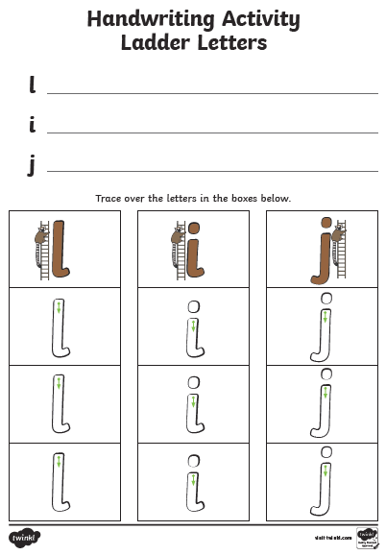
Wednesday 31st March | Name Practice  Practice writing your name either on a piece of paper or your name card.  Please encourage  correct pencil hold – ‘nip, flip and grip’.  Make sure your child can form every letter correctly and without a visual.  Extend by encouraging your child to write the letters smaller and on a line. | Reading  Log onto Bug Club and pick a book to read to your grown up. Ask your child questions about the story and to sound talk the words.  https://www.activelearnprimary.co.uk/login?c=0  Practice reading some of the sound button words in their home learning pack.  e.g. h-u-ff huff  Or read and write the tricky words on their key ring. | RE  Please watch the Easter collective worship on Google Classroom.  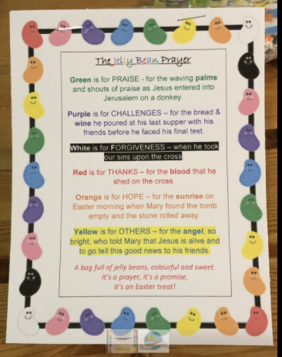 | Phonics  Review all letter sounds learnt so far – see flash cards in home learning pack. Focus on learning the digraphs qu ch sh th ng ai ee igh oa oo(long) oo(short) ar ur ow oi ear air ure er  Now practise reading and writing these tricky words:  I  no  go  to  into  the  he  me  be  she  we | PE  https://www.youtube.com/watch?v=14ou-fplEi4  https://www.youtube.com/watch?v=h5PpLvMvW2s
Thursday 1st April  Littleham World Book Day | Name Practice  Practice writing your name either on a piece of paper or your name card.  Please encourage  correct pencil hold – ‘nip, flip and grip’.  Make sure your child can form every letter correctly and without a visual.  Extend by encouraging your child to write the letters smaller and on a line. | Reading  Log onto Bug Club and pick a book to read to your grown up. Ask your child questions about the story and to sound talk the words.  https://www.activelearnprimary.co.uk/login?c=0  Practice reading some of the sound button words in their home learning pack.  e.g. h-u-ff huff  Or read and write the tricky words on their key ring. | Dress up for World Book Day  Dress up as a character for World Book Day  Take a selfie in your fantastic outfit.  Please send us a photo as we would love to see what you look like. Teacher email below. | Literacy  Draw a picture of you as your world book day character. Remember important body parts, facial features and any props your character may use.  Colour your character using appropriate colours. Encourage them to stay in the lines where possible.  Extend by writing a short sentence about what your character can do.  E.g. He can run and jump.
Please be aware that your home filter may allow unsuitable links to pop up when watching any YouTube video.

We would love to see any photos of the learning you are doing at home. Please send these to YRteacher@littleham.devon.sch.uk
Please let us know if you need any additional resources to help your child to complete their home learning with you at home.

