Unit 2: Ordering numbers; sequencing |  |  | AUTUMN Understanding Number: Unit 2, Exploring and Playing
Play Activity 1: Race to the ten
Aims: To order numbers to 6 (or 10)  To count to 10 and beyond with confidence | You will need: Ace to 10 playing cards: a set per child
Preparation: None required
What to do:  - Give each child a shuffled set of 1 to 6 playing cards, shuffled and face down.  - Turn over a minute sand timer.  - Each child turns over their cards and tries to put them in the right order before the sand runs out!  - They shuffle their cards and repeat. Are they getting faster? Can they beat the timer?!  Some children may try this with 1-10 cards |  | 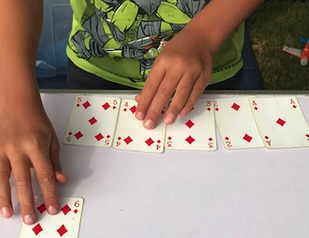
Talking points  - Which card always starts the sequence? Which card ends it?  - How many cards are in my sequence?  - What strategies can I use to make me faster? | Evidence of learning:  Listen to children talking. Can they count to 6 /10 reliably?  Observe children. Do they use strategies to improve their time, e.g. getting the 1st and last cards positioned first?
Outcomes: I can count to 6 /10 reliably, starting at any point in the sequence.
I can sequence the numbers 1 to 6 (or 1 to 10) reliably.

Unit 2: Ordering numbers; sequencing
Play Activity 2: Costing least or most?
Aims: To place items costing £1 to £10 (or £6) in order from least to most expensive | You will need: items in the class shop, labelled with prices £1 to £10 (or £6)
Preparation: Price some toys ready for the shop.
What to do:  - Label items £1 to £10 in the class shop.  - Place £1 coins in purses.  - Children ‘buy’ the items using the £1 coins.  - Place the items in order from least to most expensive.  - They discuss which costs more than £4, which costs less than £3 and so on. |  | 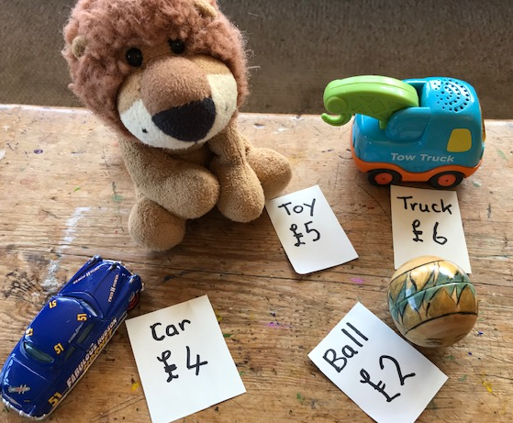
Talking points  - Which thing is most expensive to buy? Which thing costs least money?  - How much is this? Is it more or less than that?  - Which thing costs six pounds? Which things are more expensive than that? | Evidence of learning:  Listen to children talking. Can they say how much each thing costs?  Observe children. Do they understand that the more an item costs, the more expensive it is? Can they put the items in order of price?
Outcomes: I can place items in order of price from least to most expensive.
I understand that the more a thing costs, the more expensive it is.
Unit 2: Ordering numbers; sequencing
Play Activity 4: Lengthy pens
Aims: To place items in number order  To put non-consecutive numbered items in an order |  | You will need: DuploTM/LegoTM bricks; toy animals
Preparation: None required
What to do:  - Provide DuploTM/LegoTM bricks in different colours.  - Children make pens for different toy animals.  - They count how many bricks long each pen is for each different type of animal.  - They line up the pens in order, shortest to largest.  - They then count how many bricks wide each one is.  - Children then count how many bricks are used in total. |  |  | 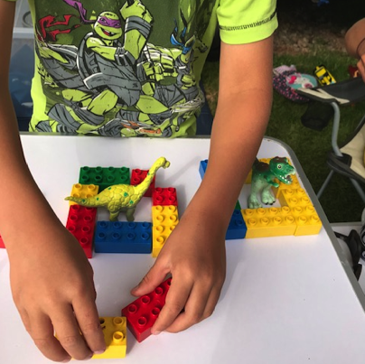
Talking points  - How many bricks long is this pen? Is it the longest or the shortest?  - Which pen is longer, the 5 or the 8?  - How do I know where to put this pen? | Evidence of learning:  Listen to children talking. Can they say which pen is longer?  Observe children. Do they understand how to order non-consecutive numbers?
Outcomes: I can place non-consecutive numbers in order, e.g. 2, 3, 5, 7, 9…
I can count a number and match it to its place in a sequence.

Unit 2: Ordering numbers; sequencing
Activity 1: Towering numbers
Aims: To order the numbers 1 to 6 or 1 to 10  To match spoken to written numbers | You will need: a 1 to 6 or a 1 to 10 number track (see resources); one or two spotty dice, LegoTM/DuploTM
Pedagogy: Small groups
Preparation: None required
What to do:
- Show children the 1-6 number track. Have a pile of Lego/DuploTM ready alongside.
- Take turns to throw the dice. What number have you thrown? Do you others agree?
- They then build a tower to match that number and place it on the number track in the appropriate place.
- Continue taking turns and building towers. If a child throws a number already thrown they can make another tower.
- When the number track has at least one tower on every space, place the six towers in a line next to each other and ask what children notice about the towers. (They go up in steps of 1.)
Support children by counting along the track each time to establish the spoken number.
Challenge children by using a 1 to 12 track and allowing them to throw either one or two dice.
Outcomes: I can match a spoken to a written number.
I can order numbers 1 to 6 / 10 and place towers in matching order.

Unit 2: Ordering numbers; sequencing |  | Understanding Number: Unit 2, Active Learning
Activity 3: Counting claps
Aims: To count actions and sounds with accuracy To match a count to a written number  To place numbers in order | You will need: Number cards 1-10 (see resources)
Pedagogy: Groups of around 6
Preparation: you will need to choose the cards to suit the children, i.e. 1-6 or 1-8 or 1-10
What to do:
- Spread out the cards face up on the table in random order.
- Clap 5 times. Ask children: How many times have I clapped? You may have to repeat your clapping, as it is hard to count!
- Now ask children to clap 5 times but trying out different rhythms with the same number of claps. Listen to some different examples.
- Ask children to choose the card to match that number of claps and place it apart from the other cards. This is the start of our number line.
- Repeat this, but clapping 3 times. Ask children to count and then to try out different rhythms.
- Find the card. Discuss which side of the ‘5’ we need to place this. Three comes before 5 in the number line.
- Continue like this, gradually building up a number line to 6, 8 or even 10. Before placing each card, discuss where it will need to go to create your number line of claps.
Support and challenge children by varying the limit of the number line.
Outcomes: I can count sounds/actions with accuracy.
I can place non-consecutive numbers in order to build a number line.

Unit 2: Ordering numbers; sequencing
Activity 4: Suit yourself
Aims: To create a number line, 1 to 10  To place numbers in order | You will need: pack of playing cards with the Jacks, Queens and Kings removed
Pedagogy: 4 children
Preparation: None required
What to do:
- Spread out the cards face up. Point out the different suits and explain what each one is called: hearts, spades, clubs and diamonds. Allow each child – in turn - to choose a suit. (They can choose a different suit in the second round!)
- Each child collects all the cards in their suit.
- They lay out their cards in order, from 1 to 10, to create a number line in their own suit.
- Once all four lines have been created, count in unison to 10 with each child pointing to their own number line as they count.
- Repeat, this time removing one card from each suit (e.g. hearts might miss the 3, clubs might miss the 6, etc.)
- Children again lay out the cards in their suit but this time with a missing number.
- Count along the lines and when each child is missing a number they have to be quiet when that number is said!
Support children by using numbers 1 to 6 only.
Outcomes: I can place numbers in order
I can sequence the numbers 1 to 10 (or 6).

