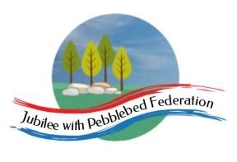
Learning
from Home

Year: 4  Wk beg:  18.1.21 | Lesson One | Lesson Two | Lesson Three | Lesson Four
Monday  Our learning animal this week is perservenrance!  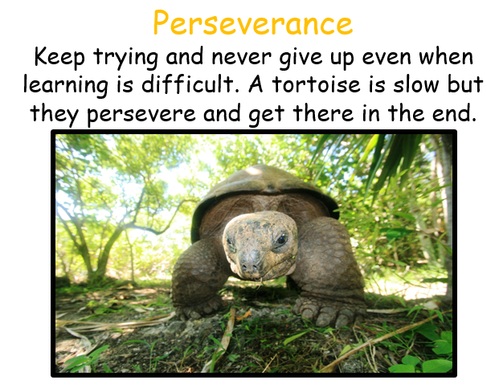 | English  Non Fiction  Information Text  LO: To experience a virtual trip and discuss how it feels to visit a place  Take a virtual tour of London through the following sites:  https://www.visitlondon.com/things-to-do/sightseeing/london-attraction/top-ten-attractions  https://360.visitlondon.com/#  This is a fantastic site which shows London and its famous sights. You can explore places and look inside The Royal Albert Hall and Harrods!  Task:  - Talk with an adult or older sibling what it’s like to visit somewhere virtually  - Make a list of 5 things you can see and do in London.  - Say what you would like to see and do if you were to visit by writing some sentences.  Start your sentence with:  If I visited London, I would like to…..  You could do this on a piece of paper, take a phot and send it back to me by email or a word doc and email it back to me. | Maths  Division  LO: To use chunking to solve division questions  Go to Google Classroom  I have attached today’s lesson AND tomorrow’s lesson.  - Look through slides on pdf for DAY 1  - Select either sheet 1 or sheet 2  - Solve divisions using empty number line method. | Spelling  LO: To read and spell new words  Go to Google Classroom and find your spelling list.  - Practise your words by LCWC  - Choose 3 words from your list and compose 3 sentences using the words in the right context. | Science  Living Things and their Habitats  Living Things – What are they?  LO: To ask questions about the local habitats and to carefully observe and record the living things in your local area.  Today – you are going on an investigation into living things in your garden or a nearby park.  - Go to Google Classroom where I have attached a Local Living Things Recording sheet. If you can print this out, use this to record your findings.  - If not then you could create the sheet by drawing it on a piece of paper.  - Look at this link I have attached and find the leaf identification sheet that will be really useful too  http://www.woodlandtrust.org.uk/naturedetectives/activities/2015/09/leaf-id/
Tuesday | English  Non Fiction  Information Text  LO: To understand how speech is punctuated  Watch Oaktree lesson:  https://classroom.thenational.academy/lessons/to-explore-punctuating-speech-first-c9j30c?activity=video&step=1  Practise writing speech sentences.  Have a conversation with a family member about place you know or are interested in. Could you ask them some questions? Perhaps they have been to London or another UK city.  Write up the conversation on a piece of paper of type it into a word document.  Use inverted commas (speech marks) to indicate the speech.  For example  ‘’Dad, what is it like in Exeter?’’ I say.  ‘’Exeter is full of history. The Romans settled there. There are some Roman ruins around the city.’’ Dad tells me.  You could have a conversation about Exmouth or London or another place you know or perhaps don’t know but your parents have visited. | Maths  Division  LO: To use chunking to solve division questions  Go to Google Classroom  Day 2 division as chunking | RE  Diwali  LO: To learn about how Hindu’s celebrate together in the community.  Aarti is a Hindu religious ritual of worship, a part of puja, in which light (usually from a flame) is offered to one or more deities.  Watch: https://www.bbc.co.uk/programmes/p02n5wvr (woeship in the community) and https://www.truetube.co.uk/film/charlie-and-blue-hear-all-about-hindu-worship (worship at home, they would have watched this last week but need to recap) compare Hindu worship at home and at the temple.  Task:  Make a poster showing the similarities between worship at home and in the community. | PE  Workout with Joe Wicks!  https://www.youtube.com/watch?v=-TGEdzRzSbw
Wednesday | English  Non Fiction  Information Text  A Walk in London  LO: To learn by heart a small section from a text.  Go to Google classroom | Maths  Division  Divisions with remainders  LO: Divide 2-digit numbers just above the 10th multiple with remainders  Go to Google Classroom for lesson and sheets  I have attached today’s and tomorrow’s lesson on the same pdf.  Solve at least 5 divisions | Topic Blue Abyss  LO: To explore the Great Barrier Reef and understand where it is located.  The Great Barrier Reef is possibly the grandest natural wonder in the world. It’s bigger than The Great Wall of China and the only living thing visible from outer space!  It is the largest collection of corals on Earth and is one of the richest areas of diversity, with its sponges, anemones, worms, tropical fish, birds, mammals and reptiles.  Take a tour of the reef here:  http://www.airpano.com/360photo/great-barrier-reef-australia/  https://greatbarrierreef.com.au/great-barrier-reef-facts-for-kids/  https://www.gettyimages.co.uk/photos/great-barrier-reef-aerial?phrase=great%20barrier%20reef%20aerial&sort=best  Task  Create a mini fact file about The Great Barrier Reef  This could include:  - pictures/ photos of life in the reef  - names of fish and plants  - how pollution is affecting the reef  or anything other bits of interesting information you want to include.  Don’t forget to use headings, subheadings and labels to help you organise your information.  You can do this on paper or a word document or on a power point using slides to present your work.  You can email this back to me or take a photo and send it back to me. | Spelling  LO: To read words with –mis prefix  A prefix are the letters that can come at the start of a word. They change the meaning of the word.  Go to Google Classroom for the –mis prefix list.  Read the word list to an adult.  Then choose three words, and on a piece of paper write threes sentences with one of the words in each sentence. Alternatively, you can type this onto a word document and attach it to an email to send back to me.  Take a photo of your work and send it back to me if you can’t type onto a word document.
Thursday | English  Non Fiction  Information Text  A Walk in London  LO: To distinguish between the facts and the spoken parts of information in the text.  Go to Google Classroom | Maths  LO: Divide 2-digit numbers just above the 10th multiple with remainders.  Go to Google Classroom for lesson and sheets  Answer worded problems on division.  Either from sheet 1 OR 2 | Topic Blue Abyss  LO: To understand who Jacques Cousteau was  Watch this youtube clip about Jacques Cousteau  https://www.youtube.com/watch?v=SYwQu3Fqa28  Go to Google Classroom  Open the pdf on Jacques Cousteau and read through the pages  Task:  On a piece of paper, a word document or a powerpoint presentation, write some sentences to explain who Jacques Cousteau was.  You should include:  - When and where he was born  - What he did  - What he invented  - Show some pictures of his inventions  - Draw a picture of him diving | Mental Health  LO: To practise breathing techniques for relaxation  https://www.youtube.com/watch?v=YFdZXwE6fRE  Watch and follow the link on google classroom
Friday | English  Non fiction Information Text  A Walk in London  LO: To combine sentences to create the best effect  Go to Google Classroom | Maths  LO: To investigate divisions with remainders  Go to this website  https://nrich.maths.org/6402  Follow instructions on the page and investigate solving divisions with remainders | PE  Joe Wicks workout  https://www.youtube.com/watch?v=tSi2ix1i180 | Reading  Reading Comprehension  LO: To read and retrieve information from a text.  Go to Google Classroom for a Reading Comprehension task.

