Revision – factors and multiples
Multiples of a number are found by count up in that number.
Example – Multiples of 3 are 3, 6, 9, 12, 15 etc
- Write down…
- Five multiples of 4 greater than 22.
- Five multiples of 5 that are odd.
- Five multiples of 9 less than 89 but more than 28
- Five multiples of 7 that are even.
- Five multiples of 3 that are greater than 100
Common multiples of two numbers are found in both times tables.
Example – A common multiple of 2 and 3 is 6 because 6 is found in the 2x table and the 3x table.
- Find three common multiples of…
- 2 and 5
- 3 and 4
- 5 and 6
- 2, 5 and 10
- 3,4 and 5
Factors of a number divide exactly into that number.
Example – Factors of 12 are 1, 2, 3, 4, 6 and 12 as each of these numbers divides exactly into 12. They are often written in order or as pairs: 1,12; 2,6; 3,4 because 1 x 12 = 12; 2 x 6 = 12 and 3 x 4 = 12
- Find all of the factors of…
- 15
- 24
- 17
- 30
- 23
- 49
What do you notice about the factors of 17 and 23? Can you remember what these numbers are called?
Find three more examples.
- 2) 3)
Why is 49 different? Can you remember what type of number it is?
Find three more examples.
- 2) 3)

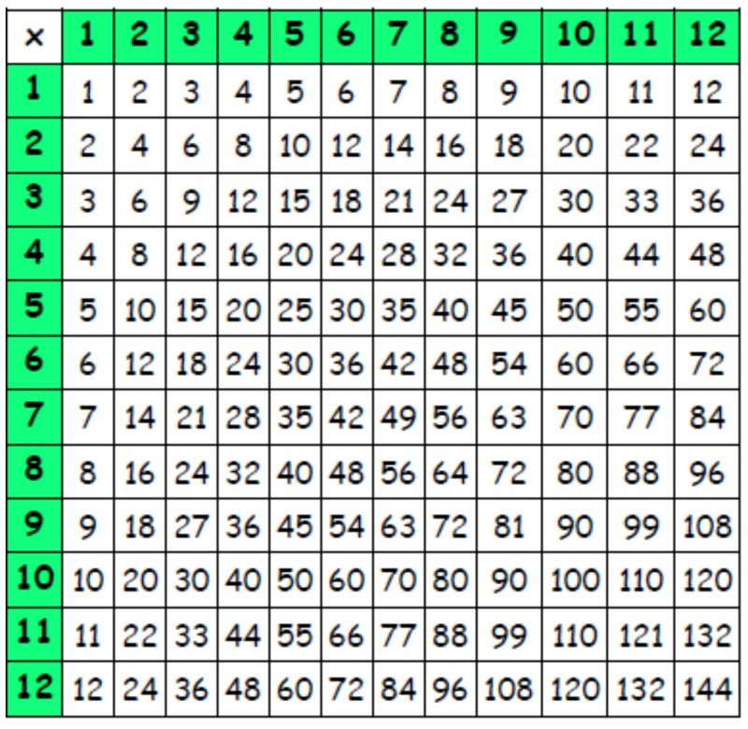
Now practise any of the times tables you need.
Think about the eight related statements and the fractions.
4 x 6 = 24, 6 x 4 = 24, 24 = 4 x 6, 24 = 6 x 4
24 ÷ 4 = 6, 24 ÷ 6 = 4, 6 = 24 ÷ 4, 4 = 24 ÷ 6
¹/₆ of 24 = 4 ¼ of 24 = 6

