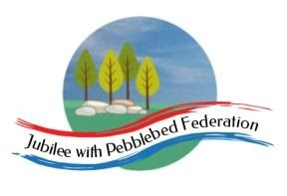
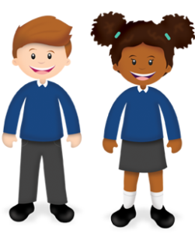
Learning
from Home

Year: 4  Wk beg:  25.1.21 | Lesson One | Lesson Two | Lesson Three | Lesson Four
Monday  The theme for this week’s learning behaviour is curiosity!  Our learning animal this week is a questioning cat!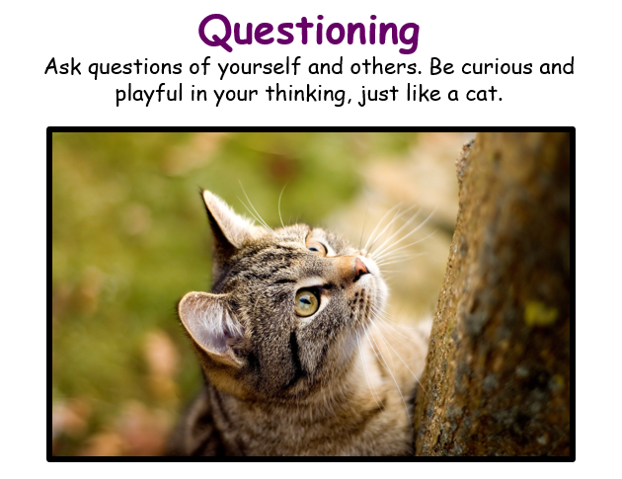 | English  Non Fiction  Information Text  LO: I can create a conversation between characters and record them in speech bubbles.  In the book – A Walk in London, the little girl and her mum visit lots of exciting places in London.  We read snippets of conversation in the book as the little girl narrates the journey they take.  Today you will create a conversation between mum and daughter in one of the places they visit in London. Look at the mother and daughter on page 13 where they are standing in the middle of Trafalgar Square.  What could the little girl say to her mum? What might mum say?  Is the little girl excited? How do you know? Does she want to climb the lions and splash in the fountain?  What would her mum say?  You could take some of the facts from the page and use this to create some speech for mum.  Draw the girl and her mum in the middle of Trafalgar Square on a piece of paper. Record the conversation using speech bubbles from the characters.  Little girl (you can give her a name)  Mum | Maths  Multiplication and Division  LO: To multiply and divide by 9.  Go to Google Classroom for Day 1 lesson power point and practice worksheet | Spelling  LO: To read and spell new words  Go to Google Classroom and find your spelling list.  - Practise your words by LCWC  - Choose 3 words from your list and compose 3 sentences using the words in the right context. | Science  Living Things and their Habitats  How are things classified?  LO: To observe features of living things and sort them into different groups.  Animals can be group in different ways according to their physical features. Below is an example of a branching database.  The questions always have a yes or no answer. It is the answer to a question that leads to another question.  For example we don’t classify (or group) beetles in the same group as butterflies because they have different features. So you could ask: Does it have antennae? Yes/no  Does it have it have 6 legs? Yes/no  Does it have wings? Yes/no  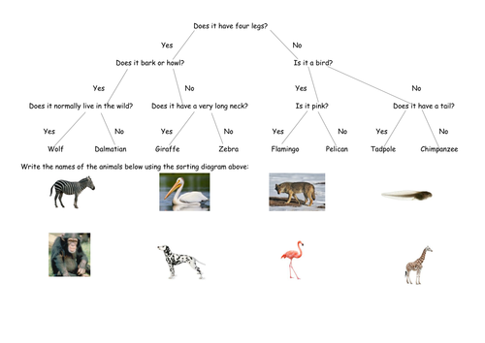  Watch this clip and then complete the task.  https://www.bbc.co.uk/teach/class-clips-video/what-is-an-ecosystem/zdrtscw  Go to Google Classroom  And look through the power point slides.  I have attached animals and minibeasts sheets there too.  Task  Sort the minibeasts and animals by creating a database like the example one. Cut out and stick the pictures on to a piece of paper. If you can’t print the pictures, you can draw them. You don’t have to do all of them! Use a ruler to draw the lines and write in pencil to show your questions.
Tuesday | English  LO: To explore pronouns  Watch Oaktree Lesson:  https://classroom.thenational.academy/lessons/to-explore-pronouns-cmvkjr | Maths  Measures and Data  LO: Collect and organise data and record in a bar chart.  Go to Google Classroom for lesson and sheets.  Day 1 | RE  Diwali  LO:To identify at least two of the main characters in the story behind Diwali and say what they did.  Watch this video about Diwali:  www.bbc.uk/bitsize/topics/zh86n39/articles/zjpp92p  Look at the PowerPoint about the story of Rama and Siti, this explains the origins of Diwali. You will need Google Classroom to look at this.  What is the message from the story? Talk about how the story can teach Hindus about how goodness can overcome bad deeds or attitudes.  Activity:  Pupils sort story pictures into correct order.  Complete the temptation table.  Additional activity: Children to think about their own struggle to be good; produce an outline of themselves. Write inside the outline some of the bad things and good things that they might have done; write around the outside some examples of good deeds they have actually done. Talk about who helps them to be good. | PE  Workout with Joe Wicks!  https://www.youtube.com/watch?v=EXt2jLRlaf8
Wednesday | English  Non Fiction  Information Text  A Walk in London  LO: I can write a conversation between two characters using speech marks.  Today you will practise using speech marks.  You have created a conversation between mum and the little girl visiting Trafalgar Square.  You are going to write this using speech marks.  Speech mark rules  - Open speech by inserting speech marks (inverted commas) before the first word spoken. “  - At the end of the last word spoken, use close speech marks. ”  - Each new character’s speech starts on a new line.  - End the line of speech with a comma, question mark or exclamation mark.  - Use a reporting clause to indicate who is speaking.  Write up the conversation on a piece of lined paper if you can.  Watch this link to help you. https://www.bbc.co.uk/bitesize/clips/zvftsbk | Maths  Multiplication and division  LO: To Begin to know multiplication and division facts for the 7 times table.  Go to Google Classroom for lesson and sheets  Day 2 of MONDAY’S power point. | Topic Blue Abyss  Oceanic food chains  LO: To research the food chain of a sea creature  Food chains show what animals eat within a habitat and how energy is passed on over time. All food chains start with a producer, which is typically a green plant. The producer is eaten by a primary consumer (prey), which is eaten by a secondary consumer (prey), which is eaten by a tertiary consumer. All food chains end with a top or apex predator. Changes within a food chain, such as an abundance or lack of one food type, have an impact on the entire food chain.  Go to Google classroom to look at the food chain pack. If you can’t print this, then draw the animals to create the food chain.  https://www.sheppardsoftware.com/content/animals/kidscorner/games/foodchaingame.htm  https://www.bbc.co.uk/bitesize/ks2/science/living_things/food_chains/play/  Task  Create your own food chain using food chain resource pack | Mental Health  10 A DAY  LO: To be active in body and mind.  Activity  Go to this link and watch and do Yoga Yak video;  https://www.nhs.uk/10-minute-shake-up/shake-ups/yoga-yak
Thursday | English  Non Fiction  Information Text  A Walk in London  LO: To combine two sentences to create one multiclause sentence using a conjunction to join them.  We can create longer sentences using two clauses which can be joined together with a conjunction.  Today you will create multiclause sentences by combining two sentences and using a conjunction to join them together.  Go to Google Classroom for the sheet with the sentences for combining and my examples. | Maths  Multiplication an division  LO: To begin to know the 11 and 12 times tables  Google Classroom  Day 3 of Monday’s powerpoint | PHSCE  LO: Taking responsibility for my own actions including my own learning behaviour  Watch this video  https://www.bbc.co.uk/teach/class-clips-video/am-i-always-responsible-for-my-actions-with-classroom-discussion/zfxtscw  Task  Create a poster to explain and show others how you can responsibility for your own actions.  Go to Google Classroom for a sheet on responsibilities and rights | Reading  Reading Comprehension  LO: To read and retrieve information from a text.  Go to Google Classroom for a reading task
Friday | English  Non fiction  Information Text  A Walk in London  LO: To mark on a map the trip the girl and her mum made around London  Read the book again look at the places the little girl visited around London. As you read through, write down the names of the places in a list and in order they visited them.  For example, they first get off the bus in Westminster, so this is where their journey starts. The next place they go from there is St. James’ Park, so then this would be the second place we record in our list.  When you have identified all the places, find the places on the map and mark out their trip.  Go to Google Classroom for a map or use a map of London you have or can download online. | Maths  Problem solving and reasoning  LO; Solve problems on 9 and 7 times tables and explain reasons for answers  Go to Google Classroom for problem solving and reasoning questions on this week’s unit. | PE  Joe Wicks workout  https://www.youtube.com/watch?v=YIB2SJnBHBQ | Game Time  Go to:  https://www.ictgames.com/mobilePage/index.html  and select from Literacy or maths games to play on  Play a board game or a card game with a family member

