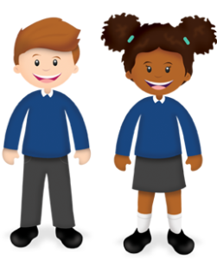
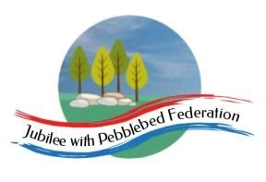
Year 1
Learning from Home

Year:  Week beg:  08/3/2021 | Lesson One | Lesson Two | Lesson Three | Lesson Four
Monday | Maths  - Counting forwards and backwards in ones.  - Distinguishing teen and ty numbers.  - Addition facts with numbers up to 10.  - Addition and subtraction to 20.  - Count in 2s, 5s, 10s.  - Double and halving numbers.  - Recognise 2D and 3D shapes. | English and Art  Make puppets and describe their characters. | Reading  Log in to Bug Club and read a book from your ‘library’. https://www.activelearnprimary.co.uk/login?c=0  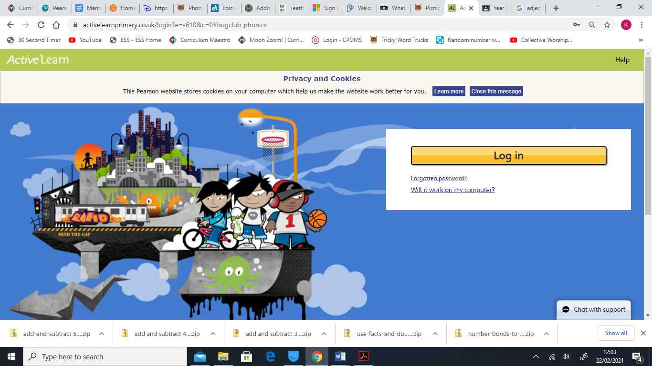 | Phonics  Recap of phase 3,4 and 5 sounds, all phase 3,4 and 5 tricky words and alien/real words.
Tuesday |  | English and Drama  Use puppets in role play.
Wednesday |  | English and Art  Write speech in speech bubbles.
Thursday |  | English, PE and Music  Listen to poetry and songs, perform a song.
Friday |  | English and Art  Write a letter to a monster. Suggest ways to cheer up a sad monster.

Please be aware that your home filter may allow unsuitable links to pop up when watching any YouTube videos.
How have you worked like a Parrot this week? Send me a photo for our display at school!

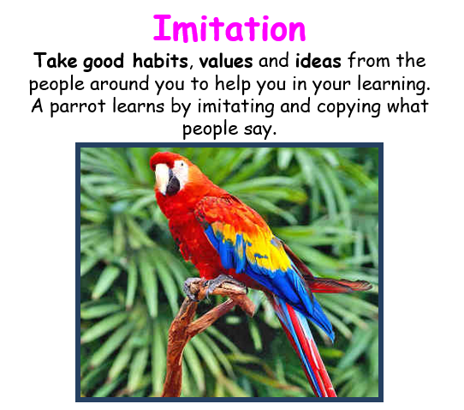

__________has behaved like a ‘Parrot’ at home by…..

