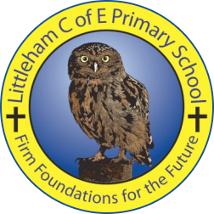
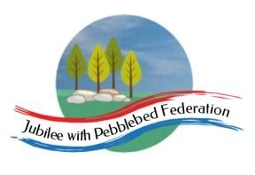

Year 5 Learning from Home Grid
Week Beginning 1.3.2021
Learning Behaviours

In school we are really thinking about:
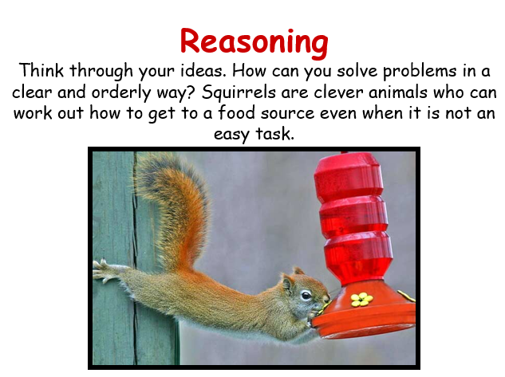

Reading – This week we are going to explore Get Epic
https://www.getepic.com/
If you have not already logged in the code is:
Jla6766
This week I would like you to click on your character and explore the books in your AR. Have fun!
Please ensure that you monitor any YouTube clips for ads and ensure that your children only click on the links to the videos that I have included.
Monday | Collective Worship:  Follow the link to Mrs Padbury’s Collective Worship on Google Classroom  PE:  A Joe Wicks work out from before half-term.  https://youtu.be/3qZNFOrqSX0  Or an alternative!  https://youtu.be/L_A_HjHZxfI  Nothing beats getting outdoors! If you have a garden, or can get outside have a run, cycle, set up your own obstacle course. The beach would be great too! In class for this half-term, we are focusing on Health, Fitness, stamina and well-being. So, anything which ticks those boxes would be good.  Reading  Find a quiet spot to read. Spend at least 20 minutes quality time enjoying and sharing a book.  Alternatively, look at the link below and read about Sir Francis Drake and repeat back some interesting facts to someone. This will help you with your Science this afternoon.  https://www.ducksters.com/biography/explorers/sir_francis_drake.php  Maths  Times Table practice. Can you beat your last score? What time limit did you set yourself last time? Rather than try to complete them all (That would be good though, but not to worry if you can’t). Go for a set time. For example, 20 minutes, but no more than 30 minutes. You can also focus on the Times Table you find the most tricky, particularly those ‘Table enemies’, such as x6, x7, x8, x9… I will include the sheet again in the paper pack and on Google Classroom.  You can also play the Times Table video below. You can play it all, or skip to the times table you need practice with.  You can always try TT Rock Stars.  https://youtu.be/C3PojOwjHcc  Living things and their habitats  Have you completed your back to back books, or power points? If not, then please finish them off, hopefully ready for next if we return on 8th March.  NEW FOCUS: Find out about the work of naturalists and animal behaviourists e.g. Sir Davis Attenborough, or Jane Goodall. Alternatively, you might like to study the work of Greta Thunberg, the teenage environmentalist. Again, choose either a back to back book, or power point to present your work. This topic will finish at the end of this term, so you have plenty of time. (See Google Classroom for any additional information).  Just google their names and lots of information will come up!  https://youtu.be/uCYDT2SVgbY Celebrating Sir David Attenborough’s 90th Birthday! There are many more to choose from!  Jane Goodall.  https://youtu.be/sCoaMjrF8Ek  There are many more to choose from.  Science  Why does a compass always point north?  Pre-investigation task.  Write a short biography about Sir Francis Drake, including his famous achievement of circumnavigating the globe. (Also refer to his importance locally-eg Exeter and Plymouth). Can you imagine what it was like to be an early explorer, navigating unknown seas? Look at drawings of creatures Tudors thought lurked in the seas. Refer to the information from this morning.  Sir Francis Drake circumnavigates the world.  https://youtu.be/WiwEwSdKh0c  This will help.  French  Numbers. Les nombres!  How many can you remember? Watch the video as a recap!  https://youtu.be/H2-REbL2OU0  A wordsearch will be included on Google Classroom, or in the packs
Tuesday | Reading:  The British – Benjamin Zephaniah  Lesson 1 – To learn about a poet and the historical context of a poem  https://classroom.thenational.academy/lessons/to-learn-about-a-poet-and-the-historical-context-of-a-poem-74u3ec  English:  LO: To experiment with personification in a poem  This activity can be found on Google Classroom or in your paper pack. Please share your work either via Google Classroom, via the Year 5 email address or keep it safe in your paper pack to return to school.  Y5Teacher@littleham.devon.sch.uk  Maths:  LO: Use decomposition to subtract pairs of numbers with up to 5 digits  - Follow the PowerPoint on Google Classroom or in your pack  - Choose your activity – Mild or Spicy (challenge yourself if you can!)  These activities can be found on Google Classroom or in your paper pack. Please share your work either via Google Classroom, via the Year 5 email address or keep it safe in your paper pack to return to school.  Y5Teacher@littleham.devon.sch.uk  History:  Tudor Rules and Laws  Read the information about the Ordinance of Eltham. These are the rules that the people who lived at Hampton Court Palace with Henry VIII had to follow, these can be found in Google Classroom or in your paper pack. Imagine that you are a king or queen, you need to write a set of rules (no more than 10 no less than 5!) setting out what your subjects and servants must do to keep you happy.  What would be important to you?  How strict or kind do you want your rules to be?  Please share your work either via Google Classroom, via the Year 5 email address or keep it safe in your paper pack to return to school.  Y5Teacher@littleham.devon.sch.uk  PSHE:  Oak Academy Money Matters Lesson 4 – Men and Women at work  https://classroom.thenational.academy/lessons/men-and-women-at-work-c8v3et
Wednesday | Reading:  The British – Benjamin Zephaniah  Lesson 2 – To read and analyse a poem  https://classroom.thenational.academy/lessons/to-read-and-analyse-a-poem-68u30c  English:  LO: To generate ideas for my own poem describing using a variety of techniques.  This activity can be found on Google Classroom or in your paper pack. Please share your work either via Google Classroom, via the Year 5 email address or keep it safe in your paper pack to return to school.  Y5Teacher@littleham.devon.sch.uk  Collective Worship:  Exmouth Coastal Churches  https://www.youtube.com/watch?v=ibcdh2V0VtQ&list=PLqWt6-qhTKHF_Yb18Npn-Ni0kRTQ-9-yp  Look at the playlist on the side for the Collective Worship for this week  Maths:  LO: Use decomposition to subtract pairs of numbers with up to 5 digits  - Follow the PowerPoint on Google Classroom or in your pack  - Choose your activity – Mild or Spicy (challenge yourself if you can!)  These activities can be found on Google Classroom or in your paper pack. Please share your work either via Google Classroom, via the Year 5 email address or keep it safe in your paper pack to return to school.  Y5Teacher@littleham.devon.sch.uk  Music:  Alas my love you do me wrong  Listen to Greensleeves more than once and then read the lyrics whilst listening to the music. What do you think it is about? Greensleeves is a song from Henry VIII to Anne Boleyn that he wrote for her before they were married. It is his way of persuading her that he is a good match for her. Using the sheet with the words have a go at singing it! You can find the music to Greensleeves here: https://www.bbc.co.uk/teach/school-radio/history-tudors-music/zm4gvk7  The words can be found on Google Classroom and in your paper pack.  Mental Health:  Please follow the link to session 6 on the school website and work through the PowerPoint/Activity you find there – this is also available on Google Classroom.  http://www.littleham.devon.sch.uk/website/mental_health/535426
Thursday | Reading:  The British – Benjamin Zephaniah  Lesson 3 – To explore the writer’s purpose  https://classroom.thenational.academy/lessons/to-explore-the-writers-purpose-6nk3ed  English:  LO: To write my own poem  This activity can be found on Google Classroom or in your paper pack. Please share your work either via Google Classroom, via the Year 5 email address or keep it safe in your paper pack to return to school.  Y5Teacher@littleham.devon.sch.uk  Collective Worship:  ICE Exeter, the link can be found on Google Classroom.  Maths:  LO: Use decomposition to subtract pairs of numbers. Solve word problems.  - Follow the PowerPoint on Google Classroom or in your pack  - Choose your activity – Mild or Spicy (challenge yourself if you can!)  These activities can be found on Google Classroom or in your paper pack. Please share your work either via Google Classroom, via the Year 5 email address or keep it safe in your paper pack to return to school.  Y5Teacher@littleham.devon.sch.uk  Outdoor Learning:  Take yourself outdoors and try the cloud gazing activity (as long as the weather is nice!) This activity can be found on Google Classroom or in your paper pack. Please share your work either via Google Classroom, via the Year 5 email address or keep it safe in your paper pack to return to school.  Y5Teacher@littleham.devon.sch.uk
Friday | Reading:  The British – Benjamin Zephaniah  Lesson 4 – To answer questions on a poem and to plan my own poem  https://classroom.thenational.academy/lessons/to-answer-questions-on-a-poem-and-to-plan-my-own-poem-6gvkgc  English:  Today I would like you to look at the poem that you wrote yesterday. Check your spellings, that it makes sense and that you are happy with your word choices.  Then I would like to publish your poem in your neatest handwriting (not on the computer!) you can illustrate your poem as well. Can you then keep your poem safe and bring it to school with you on Monday so that we can make a class poetry book!  Maths:  LO: Investigate subtraction  - Follow the PowerPoint on Google Classroom or in your pack  - Choose your investigation – Mild or Spicy (challenge yourself if you can!)  These activities can be found on Google Classroom or in your paper pack. Please share your work either via Google Classroom, via the Year 5 email address or keep it safe in your paper pack to return to school.  Y5Teacher@littleham.devon.sch.uk  ICT:  Oak Academy – Web Page Creation Lesson 2 How would you lay out your web page?  https://classroom.thenational.academy/lessons/how-would-you-lay-out-your-web-page-6djp2t  RE:  What do Jewish people believe about God?  Work through the PowerPoint and complete the task at the end, this can be found on Google Classroom or in your paper pack. Did you know:  - The Jewish religion began 4000 years ago  - Jewish people believe that there is only one god  - The holy book in Judaism is The Torah  - Jewish people say a prayer (She’ma) 3 times a day.  - That Jewish people cannot write the word God, they write it as G*d  Please share your work either via Google Classroom, via the Year 5 email address or keep it safe in your paper pack to return to school.  Y5Teacher@littleham.devon.sch.uk

