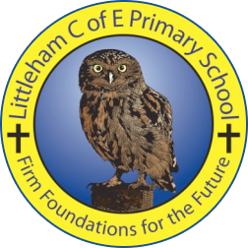
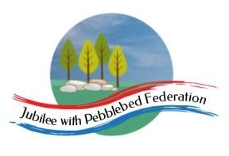
Year 1
Learning from Home

Year:  Week beg:  22/3/2021 | Lesson One | Lesson Two | Lesson Three | Lesson Four | Lesson 5
Monday | Maths  Find pairs to 8 and 9 | English  To listen to a story and respond | Reading  Log in to Bug Club and read a book from your ‘library’. https://www.activelearnprimary.co.uk/login?c=0  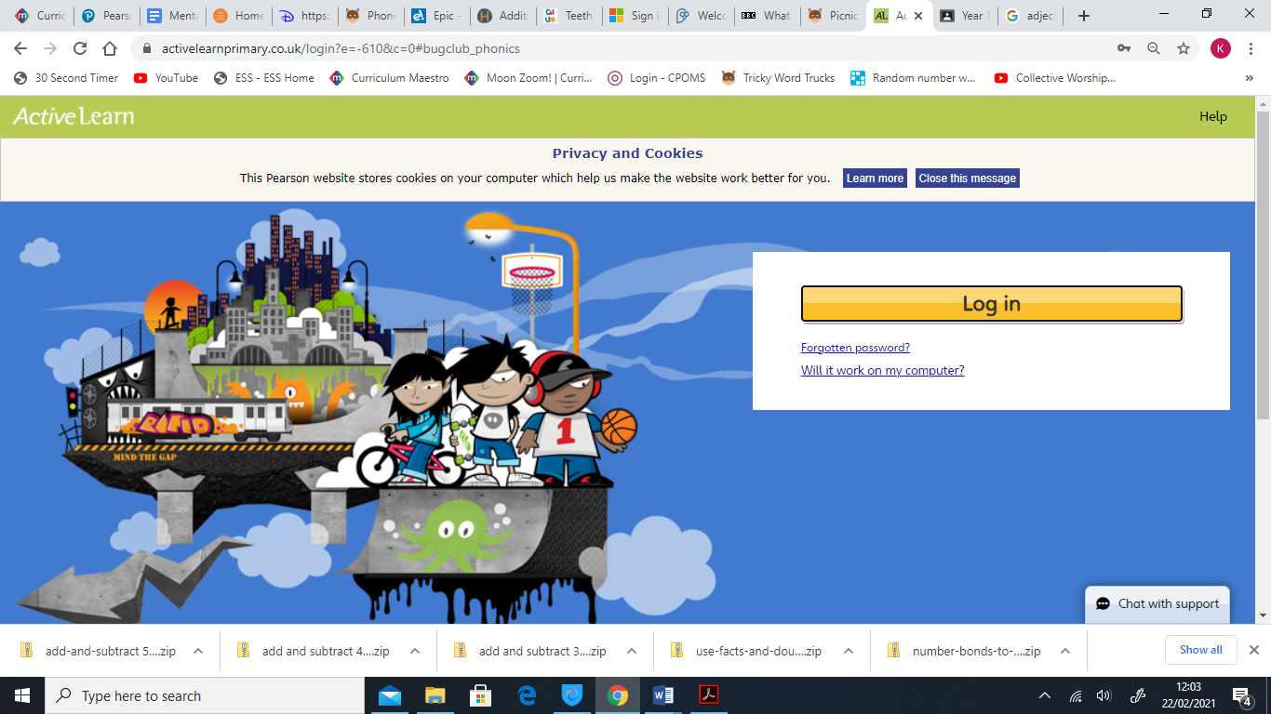 | Phonics  Recap of phase 3,4 and 5 sounds, all phase 3,4 and 5 tricky words and alien/real words. | PE  https://youtu.be/VHbQD7aZQxA
Tuesday | Maths  Relate addition and subtraction number facts | English  To recall the story of ‘The Clocktower’. |  |  | Art  To create a pice of artwork based on spring.
Wednesday | Maths  Find doubles and near doubles | English  To use adjectives to describe |  |  | Science  To sort animals based on the food they eat. https://www.bbc.co.uk/bitesize/  topics/zn22pv4/articles/z846gdm
Thursday | Maths  Add 10, then small multiples of 10 to 2-digit numbers. | English,  To use ‘and’ in a sentence. |  |  | Collective worship – What does Justice mean? https://www.youtube.com  /watch?v=btojLhvXzUc
Friday | Maths  Subtract 10 and then small multiples of 10 from 2-digit numbers | English  To use capital letters and full stops. |  |  | RE - To learn about how a Jewish person prepares for Shabbat.
Please be aware that your home filter may allow unsuitable links to pop up when watching any YouTube videos.

