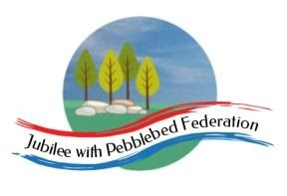
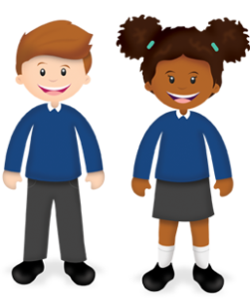
Learning
from Home

Year: Reception  Wk beg: 7/12/2020 | Lesson One | Lesson Two | Lesson Three | Lesson Four | Lesson Five
Monday | Name Practise  Support your child to order the letters of their name using the letter cards in their home learning packs, or magnetic letters if you have them. Then get them to have a go at writing their name. Try to encourage your child to hold the pen/pencil correctly. | Reading  Share your child’s reading book. This can be one from their book bag or from Bug Club. Login details in reading record.  Model reading sound button words together in home learning pack, e.g. s-a-t sat | Maths  Choose a ‘One more and one less’ activity. Please adapt using resources you have at home. | Phonics  Revisit sounds previously taught s a t p i n m d g o c k ck e u r h b – see flash cards in home learning pack.  Teach the sound f  https://www.bbc.co.uk/iplayer/episode/p0872zkp/alphablocks-magic-words-6-meet-alphablock-f  Magic Words: Meet Alphablocks F | Literacy  Can you make and write a simple Christmas card? Try to draw your own Christmas picture on the front and use your best writing inside.
Tuesday | Name Practise  As Monday | Reading  Share your child’s class library book from their book bag or share a story that you have at home.  Model reading sound button words together in home learning pack, e.g. s-a-t sat | Maths  Order numerals 1-10. Point to each card and count forwards and backwards.  Use objects that you have at home. Can you make me a set of …? | Phonics  Revisit sounds previously taught s a t p i n m d g o c k ck e u r h b f – see flash cards in home learning pack.  Teach the sound l  https://www.bbc.co.uk/iplayer/episode/p08730d4/alphablocks-magic-words-12-meet-alphablock-l  Magic Words: Meet Alphablocks L | Understanding the World  Watch the Christian Christmas Story  https://www.youtube.com/watch?v=FrTFAZPQxpE
Wednesday | Name Practise  As Monday | Reading  Share your child’s reading book. This can be one from their book bag or from Bug Club. Login details in reading record.  Model reading sound button words together in home learning pack, e.g. s-a-t sat | Maths  Choose a ‘One more and one less’ activity. Please adapt using resources you have at home. | Fine Motor  Cut some strips of paper and make some paper chains together.  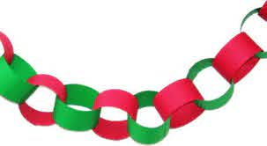 | Singing  Try to learn these Christmas songs.  https://www.youtube.com/watch?v=bIUkmWh4X_o  https://www.youtube.com/watch?v=BvcmOSEQ7X8
Thursday | Name Practise  As Monday | Reading  Share your child’s class library book from their book bag or share a story that you have at home.  Model reading sound button words together in home learning pack, e.g. s-a-t sat | Maths  Order numerals 1-10. Point to each card and count forwards and backwards.  Use objects that you have at home. Can you make me a set of …? | Phonics  Revisit sounds previously taught s a t p i n m d g o c k ck e u r h b f l – see flash cards in home learning pack.  Watch https://www.bbc.co.uk/iplayer/episode/b00qhslb/alphablocks-series-1-1-alphablocks-az  to review letter sounds learnt so far. | PE  https://www.youtube.com/watch?v=xbVr38Bhe7E
Friday | Name Practise  As Monday | Reading  Share your child’s reading book. This can be one from their book bag or from Bug Club. Login details in reading record.  Model reading sound button words together in home learning pack, e.g. s-a-t sat | Maths  Choose a ‘One more and one less’ activity. Please adapt using resources you have at home. | Phonics  Revisit sounds previously taught s a t p i n m d g o c k ck e u r h b f l – see flash cards in home learning pack.  Watch  https://www.bbc.co.uk/iplayer/episode/b00qhvyh/alphablocks-series-1-2-top  Encourage your child to say the letter sounds to try to read the words with the Alphablocks. | Singing  Continue learning these Christmas songs.  Do you know any other Christmas songs?  https://www.youtube.com/watch?v=bIUkmWh4X_o  https://www.youtube.com/watch?v=BvcmOSEQ7X8

