Year 5
Learning from Home

Year:  Week beg:  29/3/2021 | Lesson One | Lesson Two | Lesson Three | Lesson Four
Monday | Science ( Follow up from last week.  Make a simple wet compass.  Think about observations from last week. What did you notice?  What worked well? Why?  What didn’t work well? Why not?  What would you change? Why?  Think about choosing a variable to change, if you didn’t last week?  Activity.  Write up the experiment, including photos, drawings and observations. | Get your heartrate up! Try some PE with Joe Wicks  https://www.youtube.com/watch?v=WhnRJbSNyfM | Maths  https://classroom.thenational.academy/lessons/adding-using-the-column-method-6wt64c | English  https://classroom.thenational.academy/lessons/to-explore-expanded-noun-phrases-64r3ec
Tuesday | English  https://classroom.thenational.academy/lessons/to-explore-the-functions-of-fronted-adverbials-6dhpcc | Maths  Spend some time working on your times tables you can do this using TT Rockstars or Hit the Button.  https://www.topmarks.co.uk/maths-games/hit-the-button | PE  Try some Yoga!  Cosmic Kids – https://www.youtube.com/watch?v=VWIt7mVwbD0 | PSHE  https://classroom.thenational.academy/lessons/food-glorious-food-64vkec  Eat Well Live Well Lesson 3
Wednesday | English  https://classroom.thenational.academy/lessons/to-explore-pronouns-75h38c | Maths  https://classroom.thenational.academy/lessons/subtracting-using-the-column-method-6xj32d | Spelling  https://classroom.thenational.academy/lessons/to-explore-word-class-68tkjc | Art  Colourful Easter Bunnies (with cool glasses) Draw a bunny (or use the template). Split it into sections and fill each with a different pattern. If you want to you could cut it out and stick it onto coloured or painted paper. Add some funky glasses too – you could add foil, sequins or even feathers to them!  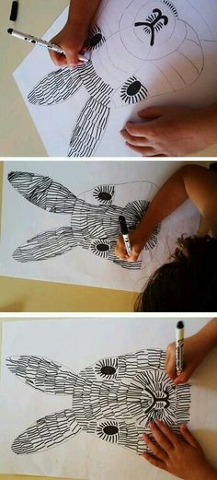  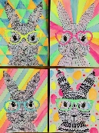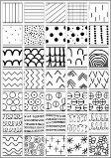
Thursday | English  https://classroom.thenational.academy/lessons/to-explore-relative-pronouns-74v62c | Maths  https://classroom.thenational.academy/lessons/short-multiplication-c8v64c | ICT  https://classroom.thenational.academy/units/web-page-creation-0205  Today’s lesson is Think before you link.
Reading
This week I would like you to read for 20 minutes every day. You can read a book at home or you can access a book through
https://www.getepic.com/
If you have not already logged in the code is: Jla6766
Click on your character and explore the books in your AR band, have fun!

Please be aware that your home filter may allow unsuitable links to pop up when watching any YouTube videos.

Please remember to send in your work to the year 5 email address: Y5Teacher@littleham.devon.sch.uk

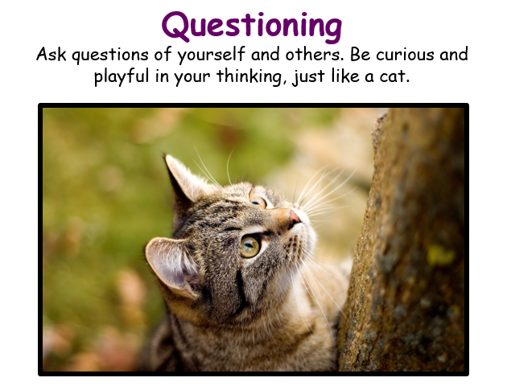
This week’s learning animal is the cat. The cat is always curious and playful and asks questions! Look for times when you are learning like a cat!

