Creating a scene from Jack and the Beanstalk
using various materials and methods

Here are some ideas of different ways you could create the tall beanstalk reaching the clouds and giants castle.
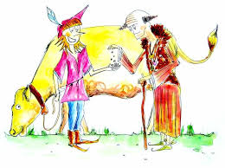
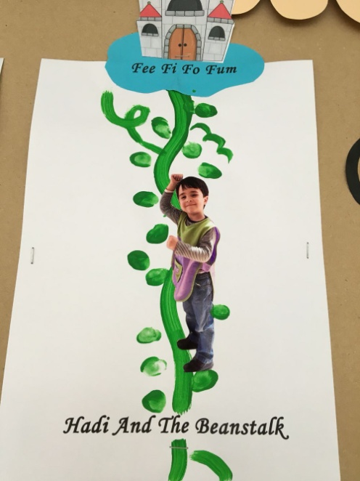
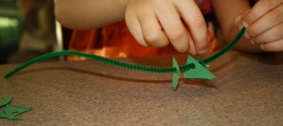
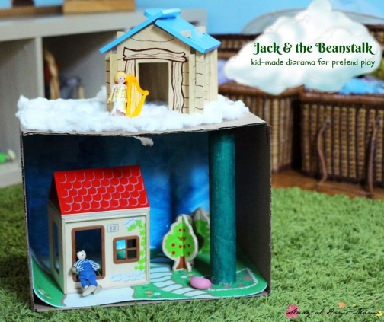

You will need:
- selection of materials of your choice (could be as simple and pens and paper)

Activity:
- Can you create the beanstalk and clouds from the Jack and the Beanstalk story. Maybe you want to make a scene with Milky White the Cow and the Mysterious Man?
- Think about how you can use different materials to create a desired outcome.
- What characters are in your scene? What did you use to create it?

