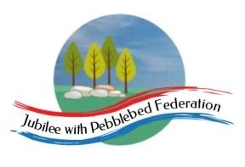
Learning
from Home

Year: 4  Wk beg:  8.2.21 | Lesson One | Lesson Two | Lesson Three | Lesson Four
Monday  The theme for this week’s learning behaviour is collaboration!  Our learning animal this week is a bee!  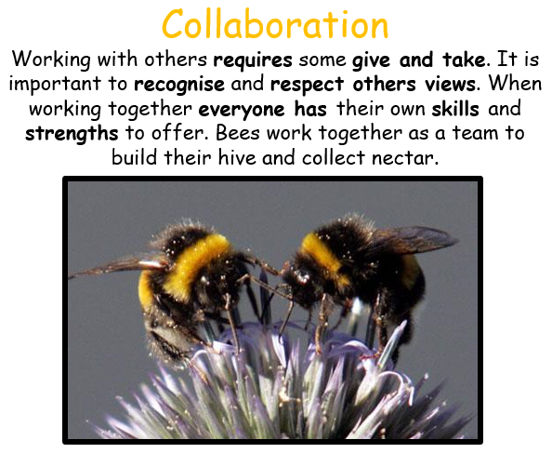 | English  A Walk in London  Non Fiction  Information Text  LO: To map out the places I visit on my ‘Day out in Exmouth’  This week we will be writing ‘A Walk in Exmouth’.  By now, you should have some facts that you have researched about some places of interest on the sheet that I provided with some suggestions.  You must select 3 or 4 places for your writing. Use the sheet I have attached to Google Classroom to plan out your ‘journey’  You could include any place in Exmouth and there are more places that you know about – such as Phear Park. I have only suggested a few to you.  Remember that you will be narrating your ‘ day out’, presenting a conversation between you and the adult you are out with and you will present impersonal information in the form of facts about the places you visit.  You are writing this as if you are telling the reader directly. This is called first person.  See my examples on Google Classroom  Reading  We are trying out a new reading website.  Click on the link or copy and paste the link into a web browser.  Once you have opened the link, you should be able to go straight to the book and start reading  https://www.getepic.com/book/47166396/blue-sharks?utm_source=t2t&utm_medium=link&utm_campaign=content&share=31358271639 | Maths  Multiplication and division  LO: Use tables facts and place value to multiply multiples of 10 and 100 by 1-digit numbers  Go to Google Classroom  Power point  DAY 1 | SPAG  (spelling, punctuation and grammar)  LO: To understand the difference between questions and commands.  Go to Google classroom.  Look at the pdf I have attached on commands and questions.  Decide which examples are commands and which ones are questions.  List some examples on the sheet I have provided and add two or three more of your own.  LO: To understand how pronouns replace nouns  Go to Google Classroom for instructions, explanations and resources.  In class, we have done lots of work on nouns and pronouns.  Look at the sheet and decide which pronoun to use in replacement of the nouns which have been put in brackets. The sheet uses the parentheses, which means brackets in this case. | Music Blue Abyss  LO: To listen to a classical piece of music by a famous composer.  As part of our Blue Abyss themed work, I have selected a piece of classical music for you to listen to.  See if you can identify any of the instruments in the orchestra.  This piece of music is called La Mer by the French composer Claude Debussy.  LA MER is the French word for THE SEA.  This is for your listening pleasure – you could combine this listening activity with some yoga stretches or simply lie down and relax with your eyes closed. You will focus better on the sounds of the instruments and how the tone of the music changes from loud to soft.  https://www.youtube.com/watch?v=nn0tZHOuTKQ
Tuesday | English  LO: To understand and use expanded noun phrases.  Follow this link for the online lesson. There will also be two worksheets on Google Classrooms if you would like to do more.  https://classroom.thenational.academy/lessons/to-explore-expanded-noun-phrases-6hh36c  For further information and videos to explain more, follow this link to BBC Bitesize.  https://www.bbc.co.uk/bitesize/articles/zhfgcqt | Maths  LO: Read the 24 hour clock, convert to am and pm times and vice versa.  Go to Google Classrooms for the lesson and worksheets for the task.  If you are using the Home Learning pack there are slides to follow and worksheets for the task.  For further information and another video about the 24 hour clock follow this link to BBC Bitesize.  https://www.bbc.co.uk/bitesize/topics/zkfycdm/articles/zcrmqty | RE Hinduism  LO: To think about what it is like to be a Hindu in Britain today.  Use the internet to research British Hindu life today. Once you have completed your research think about how your life is different to the life of a Hindu child. Consider what good things come from sharing in worship and rituals in family and community | PE  Workout with Joe Wicks!  https://www.youtube.com/watch?v=9uw9ug_g-gM
Wednesday | English  A Walk in London  Non Fiction  Information Text  LO: I can punctuate speech accurately in writing.  Continue to write you ‘Day out in Exmouth’ and focus carefully on punctuating the speech parts of your writing.  Go to google classroom for a checklist I have attached and some examples of writing speech. | Maths Multiplication and division  LO: Multiply multiples of 10 and 100 by 1-digit numbers using tables facts. Write inverse division sentences  Google classroom Day 2 | Topic Blue Abyss  Geography  LO: To consider environmental issues affecting our seas and oceans  Our environment is becoming polluted with waste (rubbish), and our ocean animals are being affected by plastic waste! What happens to animals and their habitats (environment) when they are being damaged and destroyed by plastic waste?  In this lesson, you will consider the dangers of pollution to animals and what we can do to stop ocean pollution.  https://www.youtube.com/watch?v=ODni_Bey154  https://attenboroughsreef.com/experience_intro.php  https://www.nationalgeographic.com/magazine/2018/06/plastic-planet-animals-wildlife-impact-waste-pollution/  Go to Google classroom. I have attached an ebook for you to read on plastic pollution and a document with ocean pollution images.  Task  Design a poster to warn people of the dangers and threats to sea creatures.  What can we do to help stop pollution?  Your poster could include:  - Pictures of animals in danger and what is causing them harm  - Picture of piles of rubbish  - Writing to inform people of the harm pollution is causing  - Suggestions on how we can all help | French  LO: I can say the days of the week in French  Monday - lundi  Tuesday – mardi  Wednesday – mercredi  Thursday – jeudi  Friday – vendredi  Saturday – samedi  Sunday – dimanche  The French do not write the days of the week using a capital letter at the start of the word.  Practise saying the days of the week  https://www.youtube.com/watch?v=QF9lUh5XPxo
Thursday | English  A Walk in London  Non Fiction  Information Text  LO: To complete writing ‘A Day out in Exmouth’  Add your drawings and any photos you have of you in the places you have included.  You must read your writing and ensure you have included the narrative (telling the story in first person)  Go to Google Classroom. | Maths  Multiplication and division  LO: Use tables facts and place value to multiply multiples of 10 and 100 by 1-digit numbers  Google Classroom  Day 3 | Topic Blue Abyss  Sea Poetry  LO: To read a poem about the sea and create my own sea poem  Go to Google Classroom  Read the poem The Sea by James Reeves. Try reading it out loud and to another family member.  Look at the questions and write your answers on a piece of paper.  Task  - Draw a picture of the sea as the dog. What does it look like?  - Choose another animal that can be likened to the sea. It could be a snake or a playful cat or an angry lion.  - Draw your animal and around the edges of your picture, write down some characteristics of the animal. Make sure you use verbs to describe what the animal does!  - Have a go a writing a short poem about your animal which you are comparing to the sea. | Mental Health  10 A DAY  Actively caring for others  LO: I can help in the house by doing the washing up, setting the table or tidying my room.  How helpful can you be in your family home?  Helping others – even just small things can make a huge difference to someone else!  Help out at home by doing one or two small jobs at home.  Do not do anything without your parents’ permission or do anything alone which requires adult supervision.  For example – do not use a kettle by yourself!  You can definitely tidy up though!!
Friday | English  A Walk in London  Non fiction  Information Text  LO: To check that my writing includes all the right ingredients for it to be effective  Today you must complete this piece of writing and you must check that you have included:  - Narrative – this is you telling the journey of your day out to the reader  - Speech and used speech marks to show the characters speaking  - Impersonal information on each place you visit | Maths  LO: I can solve problems involving multiplication and division  Google classroom  Problem solving and reasoning questions | PE  Joe Wicks workout  https://www.youtube.com/watch?v=krTYcWgUlKI | Game Time  Go to:  https://www.ictgames.com/mobilePage/index.html  and select from Literacy or maths games to play on  Play a board game or a card game with a family member.

