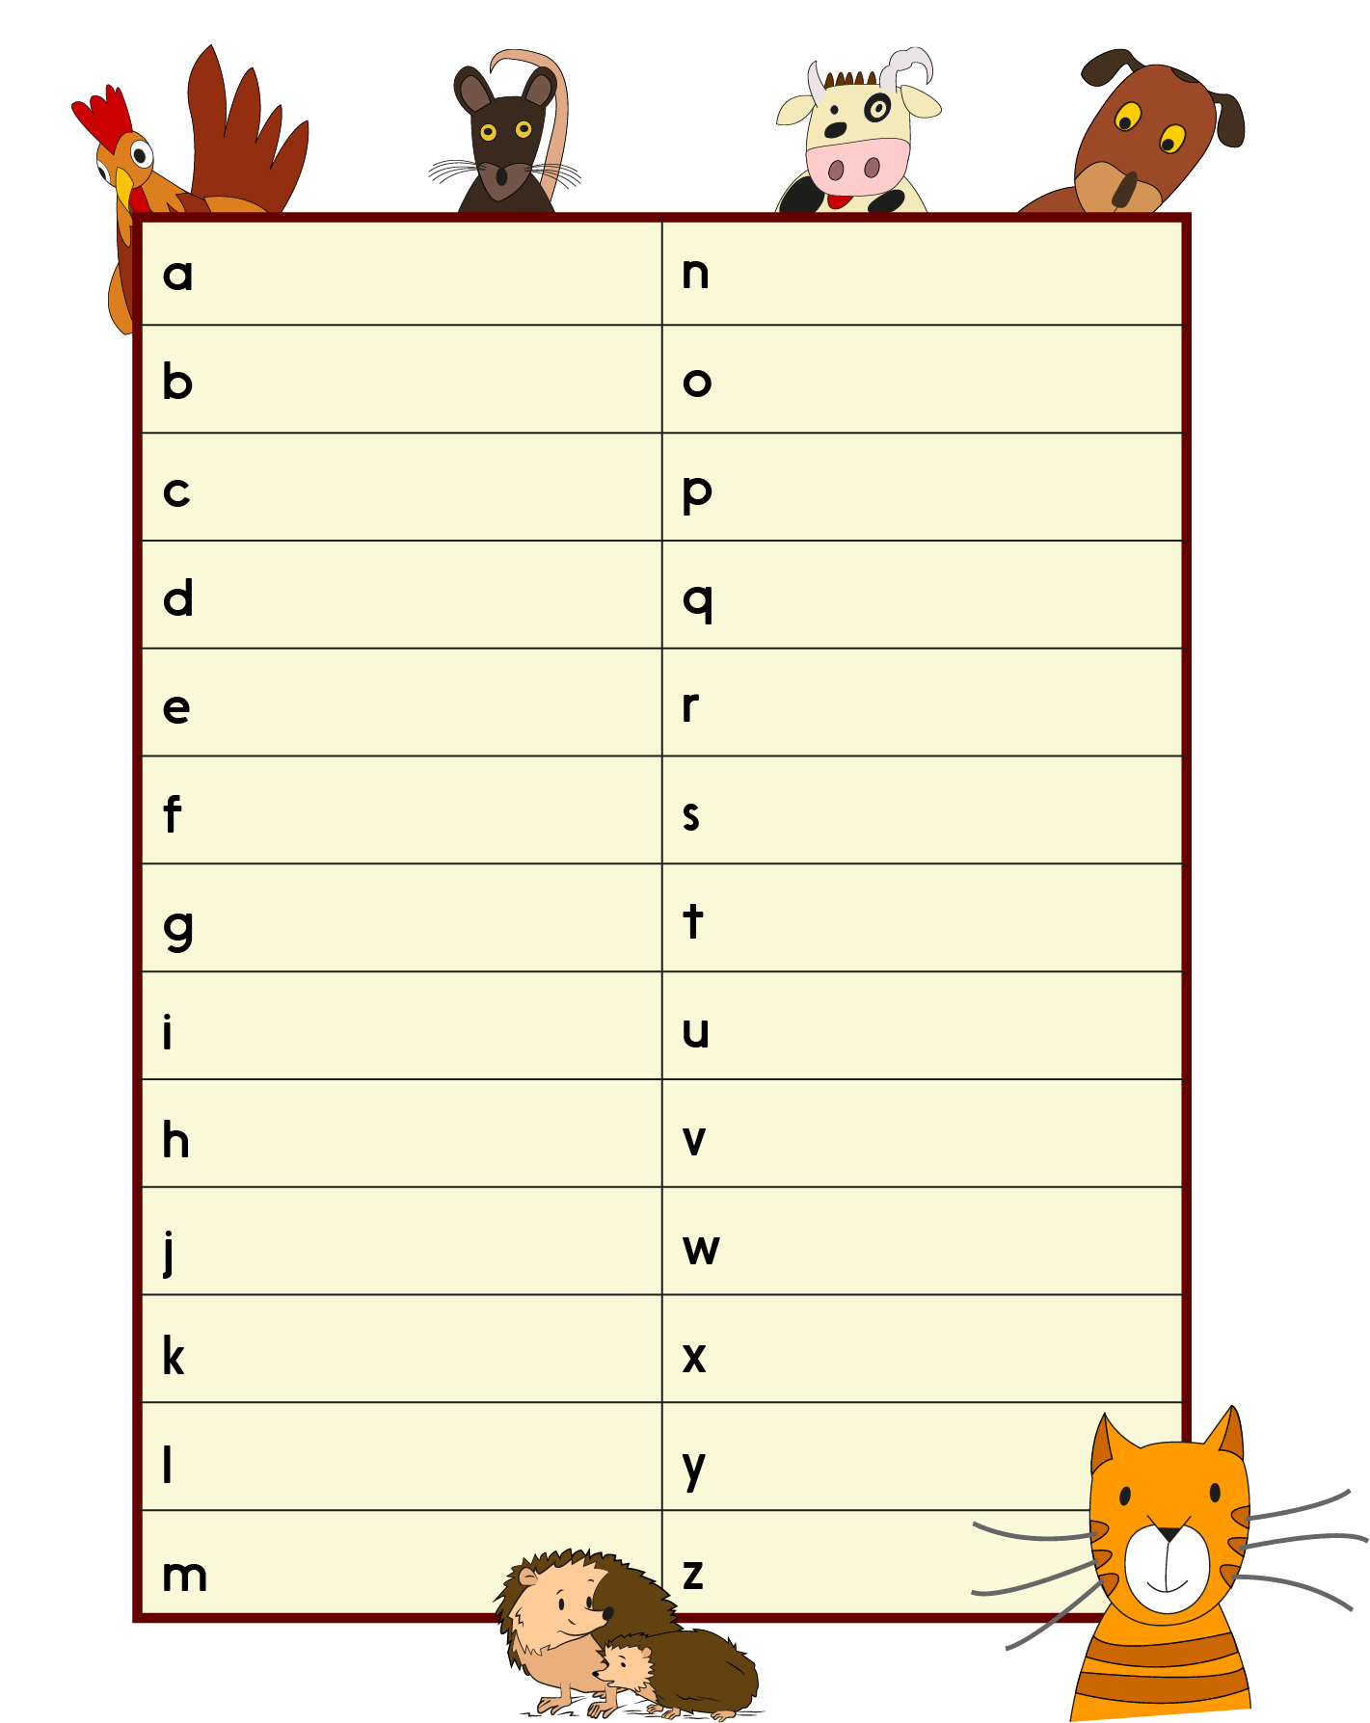
Alphabet of Animals

Unit 1 Day 1

Polka-dotted Donkey
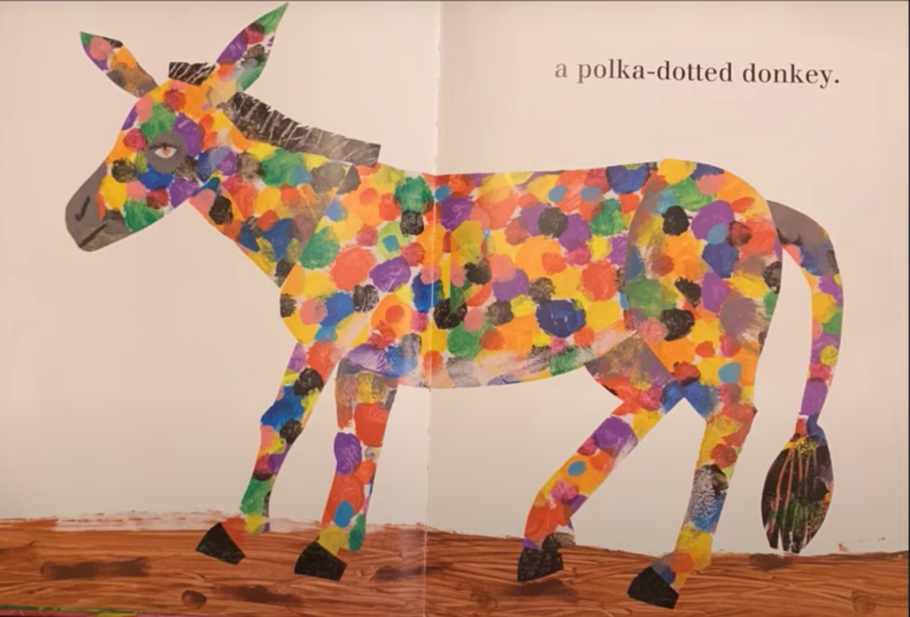

Unit 1 Day 1

Book Cover Image
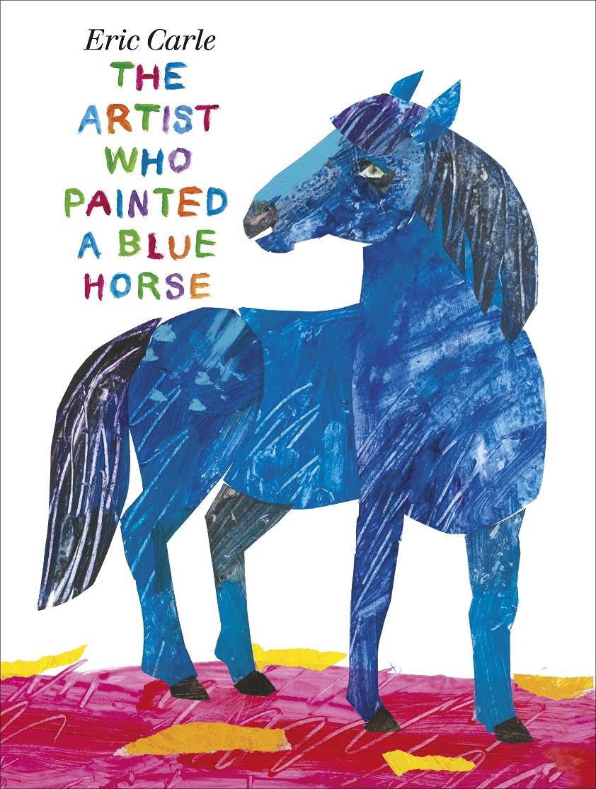

Unit 1 Day 2

Afterword from The Man who Painted Blue Horses.
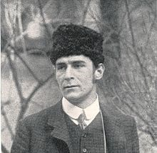
Franz Marc was born in Germany in 1880. He loved to paint animals in bright and unusual colours. At the time, some people did not like his new ideas and his unusual painting style. But Marc and some other like-minded artists formed an art group that was highly influential in the modern way of painting. His paintings of blue horses are particularly famous. Franz Marc was killed, while fighting in World War One. In the pocket of his uniform was found a sketchbook with 36 pencil drawings that as he wrote to his wife, he was planning to make into oil paintings on his return.

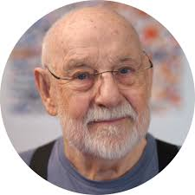
Eric Carle was born in United States in 1929 but spent his boyhood in Germany. At that time, the repressive Nazi government forbade creating or displaying modern art which they called ‘degenerate’. But one day, when Eric was 12 or 13 years old, his art teacher Herr Krauss secretly showed him some of the forbidden art. “I like the freedom and looseness in the way you draw and paint,” he said “but I'm only permitted to teach realistic art.” And pointing to the reproductions he went on, “Just look at the looseness and freedom and the – ah - beauty of these paintings. Those Nazis have no idea what art is. They are charlatans!” At first young Eric was shocked by the art and feared that Herr Krauss had gone mad. Now Eric says, “My green lion, polka-dotted donkey and other animals, painted in their own colours were really born on that day 70 years ago.”
Adapted from The Artist who Painted Blue Horses
Unit 1 Day 2
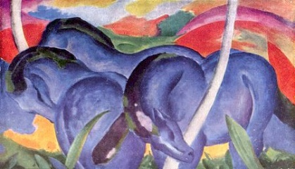
Comprehension Task
Franz Marc
Franz Marc was born in ______________ in 1880.
His paintings of animals were unusual because he used ______________________ colours.
His most famous paintings were of _______________________________.
When he died in the war, he still had a _______________ in his pocket.

Eric Carle
___________________ spent his childhood in Germany, 20 years after Marc had died.
The government had banned _________________ art.
When Eric was 12 or 13 years old, his _____________ secretly showed him some of the forbidden art.
His teacher was only supposed to teach _______________ art.
He liked the paintings because they were loose, free and _____________.
Words to use: modern, teacher, Germany, realistic, bright, sketchbook, blue horses, beautiful, Eric Carle
Unit 2 Day 2
Paint Colours 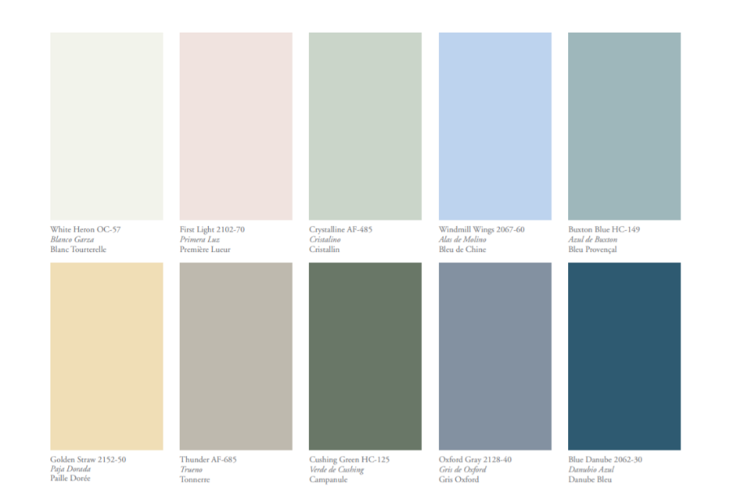 Unit 2 Day 2
Paint Colours
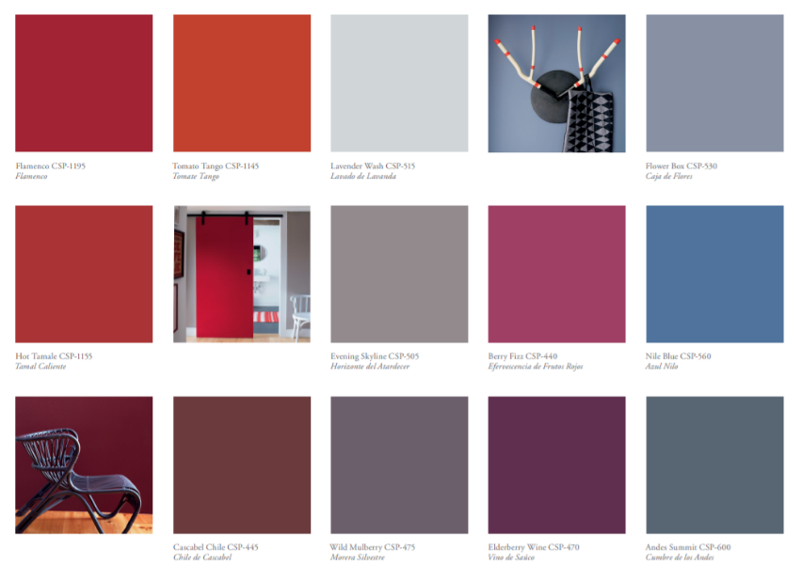 https://www.benjaminmoorepaint.co.uk/explore-colour/colour-cards/ Unit 2 Day 2
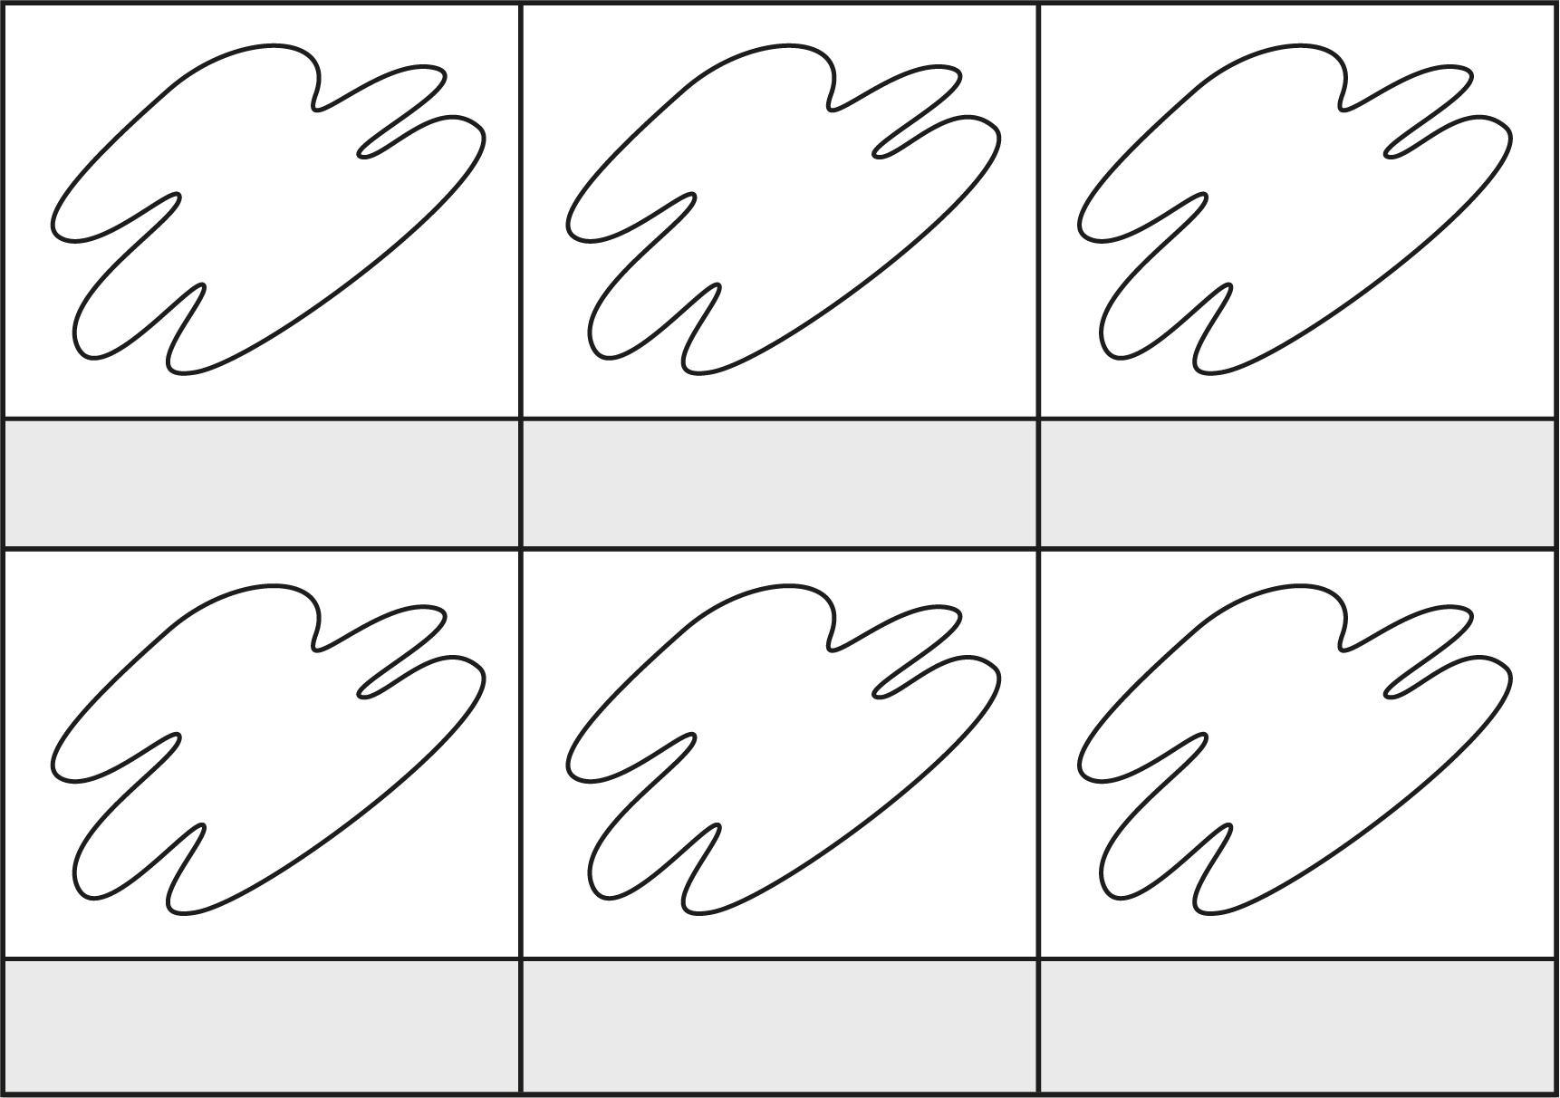
Emotions Colour Chart

Unit 2 Day 2

Questions to Think About

Why did you choose this animal?
Can you describe your animal?
What colour/s have you chosen? Why?
How does you animal feel about being in your picture?
What emotions are you thinking of while you draw or paint?
What do you find most interesting about it?
What do you want people to feel when they see your animal?

Unit 1 Day 3
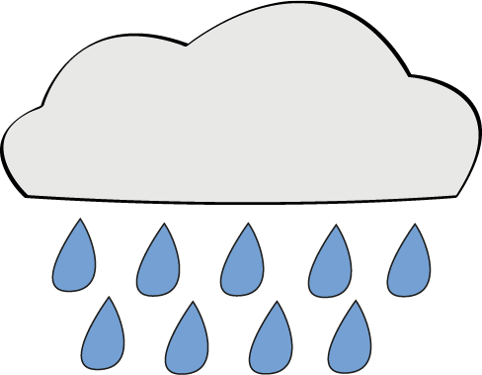
Moody

Blue
is my mood today.
And grey
like the falling rain.

I'm red
when I'm angry,
purple, in pain.
Green is for jealousy,
black for despair
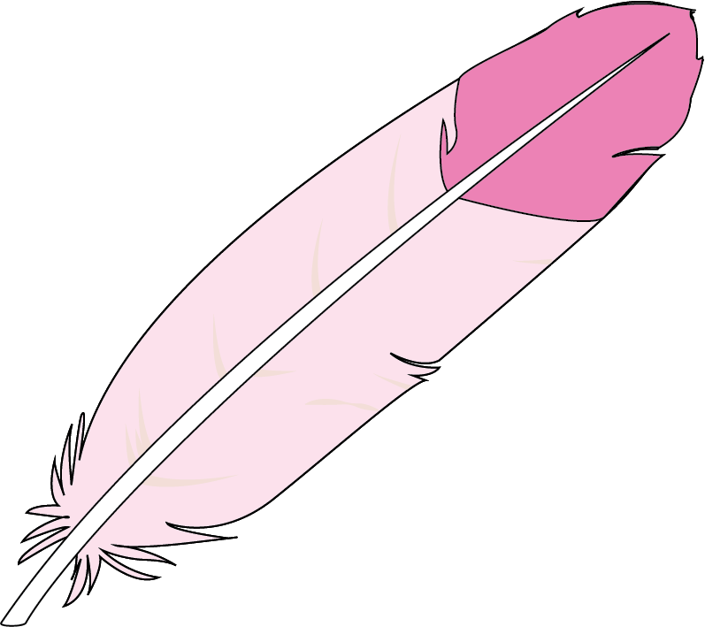
when the world’s not fair
but I'm not such a misery
as you might think.
Sometimes
I'm tickled

Pink.

By Ann Bonner

p.39 A First Poetry Book, Pie Corbett and Gabby Logan
Unit 1 Day 4
Example Poem
I am blue like the ocean.
I feel mighty,
Like I could wash over beaches and cliffs.

I am blue like the summer sky.
I feel calm and peaceful,
Like I could stretch out over the world and snooze.

I am blue like bubbles in a fizzy drink.
I feel energetic and excited,
Like I could explode!

I am blue like a stormy day.
I feel restless and angry,
Like I could whip up a tornado.

I am blue like an iceberg.
I feel cold and lonely,
Like I need a hug.

Unit 1 Day 4
Writing Frame

I am ____________ like ________________________
I feel ____________________________________
Like I could _______________________________

I am ____________ like ________________________
I feel ____________________________________
Like I could _______________________________

I am ____________ like ________________________
I feel ____________________________________
Like I could _______________________________

I am ____________ like ________________________
I feel ____________________________________
Like I need _______________________________
Unit 1 Day 4
Colouring Sheets
