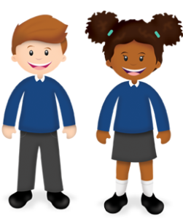
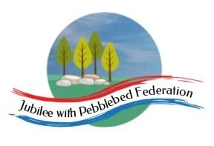
Learning
from Home

Year:  Wk beg: | Lesson One | Lesson Two | Lesson Three | Lesson Four
Monday | Reading  Read library book or allocated bug club books | English  https://classroom.thenational.academy/lessons/to-generate-vocabulary-for-character-description-6rtkct | Maths  https://classroom.thenational.academy/lessons/using-comparative-symbols-to-compare-numbers-6cupct | History  https://classroom.thenational.academy/lessons/what-were-the-different-periods-in-the-stone-age-crtkad
Tuesday | Spelling  https://classroom.thenational.academy/lessons/to-practise-and-apply-knowledge-of-more-suffixes-past-and-present-tense-including-test-ctj68c | English  https://classroom.thenational.academy/lessons/to-practise-and-apply-knowledge-of-suffixes-past-and-present-tense-including-a-test-61h3ce | Maths  https://classroom.thenational.academy/lessons/deriving-new-facts-from-number-bonds-part-2-64t66d | RE  https://classroom.thenational.academy/lessons/what-is-the-sacred-text-of-christianity-c8r6cd
Wednesday | Handwriting  https://www.youtube.com/watch?v=B0UFmR0h7OM | English  https://classroom.thenational.academy/lessons/to-analyse-the-opening-scene-70u36t | Maths  https://classroom.thenational.academy/lessons/finding-number-bonds-for-numbers-up-to-20-74uked | PE  https://app.gonoodle.com/  Guided dances
Thursday | Reading  Read library book or allocated bug club books | English  https://classroom.thenational.academy/lessons/to-write-the-first-part-of-the-opening-part-1-6ctp6c | Maths  https://classroom.thenational.academy/lessons/applying-number-bonds-within-ten-to-add-and-subtract-71k38c | Science  https://classroom.thenational.academy/lessons/what-are-the-parts-of-a-plants-life-cycle-75hpae
Friday | Reading  Read library book or allocated bug club books | English  https://classroom.thenational.academy/lessons/to-write-the-first-part-of-the-opening-part-2-ccr36t | Maths  https://classroom.thenational.academy/lessons/applying-number-bonds-within-twenty-to-add-and-subtract-c8v32t | PSHE  https://classroom.thenational.academy/lessons/community-care-cctp8c

