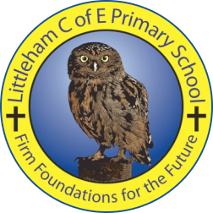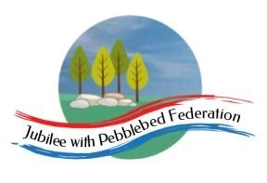

|  |  |  |  |  |  |
| --- | --- | --- | --- | --- | --- |
| Year: Nursery  Wk beg: 29.3.21 | Lesson One  Literacy | Lesson Two  Learning to write | Lesson Three  Mathematics | Lesson Four  Cross curricular & PSED | Lesson Five  Physical development |
| Monday | Today’s Literacy & mark making challenge:  To make some Easter cards for people we won’t get to see this Easter (or people we will!). What you do is up to you here are some ideas…  *Hold Control & click on picture for weblink if desired.* | | Shape challenge:  Have a go at these [Easter Egg shape puzzles](http://www.toddlerapproved.com/2011/04/cracked-egg-number-shape-puzzles.html). They are easy to make at home. Please use the common shapes: circle, square, triangle, rectangle, oval, diamond. | Fine Motor:  We will be making salt dough Easter candleholders full instructions [here](https://www.learningandexploringthroughplay.com/2016/05/flower-candle-holder-salt-dough.html). Salt dough is easy and cheap to make but let me know if you need some  ingredients you can have  some of ours! | |
| Tuesday | Today’s Literacy & mark making challenge:  Write your Easter cards and envelopes. Please let your child do some “writing” and “drawing” and you can add what they say their writing says. | | Shape challenge:  use some  stickers  to make these  fun shapes | Can you paint your lovely flower candle holders today. If you need some paint please let us know. | Gross Motor:  Please try [this](https://www.youtube.com/watch?v=uNrIB6O_Abo) family yoga from Cosmic Kids. The Peter Cottontail is great for Easter. |
| Wednesday | Today’s Literacy & mark making challenge:  Rea an Easter or spring themed story together. Then ask your child to draw a picture from the story. Encourage them to think about their picture and talk about it with them as they draw. Once you know what they are drawing use comments rather than questions “Ahhh, you’ve drawn a round shape for the head.” “I see you have drawn an oval is that the egg?” You can use less language with younger ones or those earlier on in their learning journey. “circle… head!” “you are drawing” “like that shape”. Try to aim for three comments to each question. | | Shape challenge:  Can you make some signs for your Easter egg hunt using shapes? Something like this… | Can you have a go at this [Easter bunny dance](https://www.google.com/url?sa=i&url=https%3A%2F%2Fwww.youtube.com%2Fwatch%3Fv%3D9gV85rd3yTc&psig=AOvVaw2pI-JH8V4jpIWMc0C8ogav&ust=1616610753343000&source=images&cd=vfe&ved=2ahUKEwjvp-i-hsfvAhVJ_4UKHanKD6YQr4kDegUIARCZAQ) with your family! It’s good exercise, good for mental health and good fun… Go on… Dance like no one is watching! | Fine Motor:  It’s Easter and there is some lovely Easter colouring available on the website. We are going to be doing it across the week in Nursery so please use this slot to do some at home. Et Please let know if you need it printed. |
| Thursday | Today is our “EasterParty Day”. We will be doing parachute games, disco dancing, watching an Easter programme at snack time and an easter egg hunt. Please have a go at doing some of these fun activities at home too! | | | | |
| Friday | Good Friday! Happy Easter  Fghjlpvnwei | | | | |