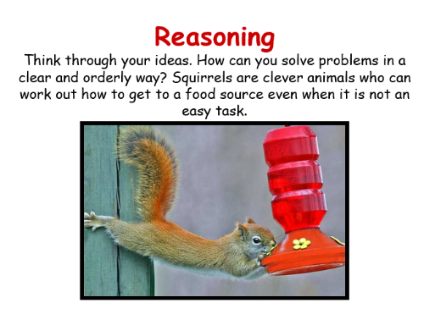
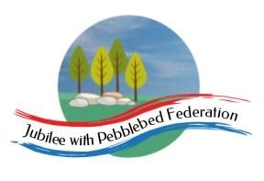
Learning
from Home

Year: Reception  Wk beg: 01/03/2021 | Lesson One | Lesson  Two | Lesson  Three | Lesson  Four | Lesson  Five
Collective Worship/Family Mental Health and Well-being | Collective Worship: Choose a time to watch Collective Worship on Google Classroom  Mental Health and Well-Being: http://www.littleham.devon.sch.uk/website/mental_health/535426
Monday 1st March | Name Practice  Practice writing your name either on a piece of paper or your name card.  Please encourage correct pencil hold – ‘nip, flip and grip’.  Make sure your child can form every letter correctly and without a visual.  Extend by encouraging your child to write the letters smaller and on a line. | Reading  Log onto Bug Club and pick a book to read to your grown up. Ask your child questions about the story and to sound talk the words.  https://www.activelearnprimary.co.uk/login?c=0  Practice reading some of the sound button words in their home learning pack.  e.g. h-u-ff huff  Or read and write the tricky words on their key ring. | Maths  Start today by counting forwards and backwards to 10/20. Put number cards in home learning pack in order to help with counting if needed.  Use the 4X4 grid and the number tiles 0-10.  Ask your child to choose a number and place it on the grid. What number is it? Then give them instructions to place all the other numbers. E.g. Put number 5 above number 7. Place number 2 below number 5. Put number 1 beside number 7. Place number 9 between number 8 and 3. | Phonics  Review all letter sounds learnt so far – see flash cards in home learning pack. Focus on learning the digraphs qu ch sh th ng ai ee igh oa oo(long) oo(short) ar ur ow  Learn the sound oi  https://www.youtube.com/watch?v=IRTITdRL_cU  Then practice reading these words:  now  drown  owl  clown  coin  boil  coil  join  We have learnt all the sounds in these words so see if your child can sound talk them e.g. n-ow  You may want to complete the oi Bug Club worksheet also. | Literacy  Today you will model writing instructions to make a magic potion. First decide what the potion will do. Next think of what you will put in. It would be good to stick to the rhyming words from last week (cat, rat, bat, mat, hat) but you may want to think of your own. Then use the prompt cards to write instructions. You write and your child watches today. They will have a go at writing on Thursday. As you write show your child how to leave finger spaces between words.  Your instructions may look something like this:  Tip in a rat.  Add a mat.  Mix in bats.  Boil the hat.  Stir in cats.
Tuesday 2nd March | Name Practice  Practice writing your name either on a piece of paper or your name card.  Please encourage correct pencil hold – ‘nip, flip and grip’.  Make sure your child can form every letter correctly and without a visual.  Extend by encouraging your child to write the letters smaller and on a line. | Reading  Log onto Bug Club and pick a book to read to your grown up. Ask your child questions about the story and to sound talk the words.  https://www.activelearnprimary.co.uk/login?c=0  Practice reading some of the sound button words in their home learning pack.  e.g. h-u-ff huff  Or read and write the tricky words on their key ring. | Maths  Start today by ordering the number cards in your home learning pack. Use numbers to 5, 10 or 20 depending on how confident your child is with numbers.  Next complete the ‘Positions on the Farm’ activity.  Start by finding the animals and then see if your child can answer the questions by looking at the picture.  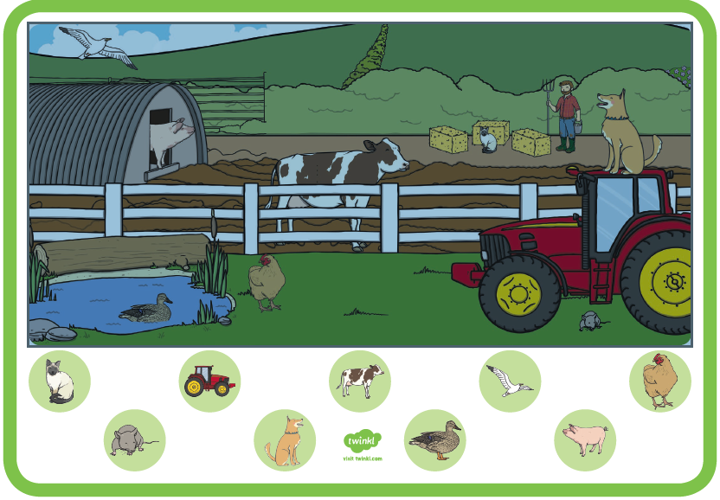 | Phonics  Review all letter sounds learnt so far – see flash cards in home learning pack. Focus on learning the digraphs qu ch sh th ng ai ee igh oa oo(long) oo(short) ar ur ow oi  Learn the sound ear  https://www.youtube.com/watch?v=EneZ1UubxSA  Next ask your child to write these words:  ear  fear  gear  tear  year  beard  You may want to complete the ear Bug Club worksheet also. | Handwriting  Help your child to practice writing the letters that make the sounds oi and ear.  Try to encourage your child to hold the pen/pencil correctly. Look at the nip, flip and grip poster if you feel your child needs help with their pencil grip.  Make sure that your child is forming the letters correctly and correct them if needed.  Handwriting sheet – On Google Classroom
Wednesday 3rd March | Name Practice  Practice writing your name either on a piece of paper or your name card.  Please encourage  correct pencil hold – ‘nip, flip and grip’.  Make sure your child can form every letter correctly and without a visual.  Extend by encouraging your child to write the letters smaller and on a line. | Reading  Log onto Bug Club and pick a book to read to your grown up. Ask your child questions about the story and to sound talk the words.  https://www.activelearnprimary.co.uk/login?c=0  Practice reading some of the sound button words in their home learning pack.  e.g. h-u-ff huff  Or read and write the tricky words on their key ring. | Maths  To compare two, then three lengths.  Use the language shorter, shortest, longer, longest.  Take any two objects which are different lengths. Use the language to discuss.  Then try with 3 different length objects to compare, using the language. You might like to draw and cut out objects, such as snakes, or any other objects.  Or use the ’comparing caterpillars’ sheet in the home pack, or on Google classroom.  Sing along to the short/ long song.  https://youtu.be/wboCEkpPS34 | RE  Discuss with the children who helps us in and outside of school. Think about how the ‘helping services,’ have helped us, particularly in these difficult times.  E.g. Nurses, doctors, and the NHS, the fire brigade and the police.  ‘I need help.’  Watch the video.  https://youtu.be/5uTOOQDEMLI  Draw and colour a picture of someone who helps us, on a piece of paper. | PE  If you have an opportunity to get outside and get active, including on a bike, then that would be great!  Try throwing and catching a ball!  - I can throw a ball at a target.  - I can throw a ball into a target.  Video clips will be included here and Google Classroom.  https://youtu.be/fgxR1PiEiDk  https://youtu.be/2X1p0Yd6WAo
Thursday 4th March | Name Practice  Practice writing your name either on a piece of paper or your name card.  Please encourage  correct pencil hold – ‘nip, flip and grip’.  Make sure your child can form every letter correctly and without a visual.  Extend by encouraging your child to write the letters smaller and on a line. | Reading  Log onto Bug Club and pick a book to read to your grown up. Ask your child questions about the story and to sound talk the words.  https://www.activelearnprimary.co.uk/login?c=0  Practice reading some of the sound button words in their home learning pack.  e.g. h-u-ff huff  Or read and write the tricky words on their key ring. | Maths  Place or draw a bus picture on a table, along with a number of small animals/toys in a basket. Introduce ‘Talking points’.  Encourage talk about where they have placed the animals/toys, using position words  - Who is sitting in front of the cow?  - Which animals are sitting at the top/bottom/back/front of the bus?  - Who is sitting under the horse?  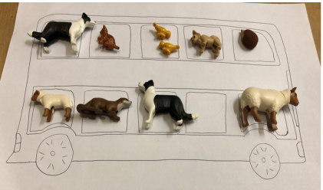  - Can you put the sheep behind the goat? | Phonics  Review all letter sounds learnt so far – see flash cards in home learning pack. Focus on learning the digraphs qu ch sh th ng ai ee igh oa oo(long) oo(short) ar ur ow oi ear  Learn the sound air  https://www.youtube.com/watch?v=T3rWZYN5jno  Then practice reading these words:  year  ear  clear  earring  air  pair  hair  stair  We have learnt all the sounds in these words so see if your child can sound talk them e.g. h-air | Literacy  Make your own potion recipe book. Fold a piece of paper in half to create a small book.  Do you remember the instructions we thought about together on Monday?  Encourage your child to write simple instructions for your potion.  ‘tip it in’  ‘mix it up’  ‘add in the bats’….  Use words that your child will be able to sound talk themselves if possible. Encourage them to use finger spaces between the words.  Extend by asking your child to draw a picture for each instruction.
Friday 5th March | Name Practice  Practice writing your name either on a piece of paper or your name card.  Please encourage  correct pencil hold – ‘nip, flip and grip’.  Make sure your child can form every letter correctly and without a visual.  Extend by encouraging your child to write the letters smaller and on a line. | Reading  Log onto Bug Club and pick a book to read to your grown up. Ask your child questions about the story and to sound talk the words.  https://www.activelearnprimary.co.uk/login?c=0  Practice reading some of the sound button words in their home learning pack.  e.g. h-u-ff huff  Or read and write the tricky words on their key ring. | Maths  Encourage your child to make a potato head using a real potato and any crafty bits you have in the house.  Encourage them to talk about what they are doing, as they position the different parts. I am putting the eyes above the nose.  - Describe where the nose is?  - Why did you put the mouth there?  - Can you add a freckle under his left eye?  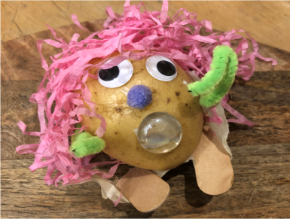  - Can you add an earring to the right ear? | Phonics  Review all letter sounds learnt so far – see flash cards in home learning pack. Focus on learning the digraphs qu ch sh th ng ai ee igh oa oo(long) oo(short) ar ur ow oi ear air  Revisit ear & air  https://www.youtube.com/watch?v=WEKPH4TR8nU&feature=youtu.be  https://www.youtube.com/watch?v=k3bCEfX42jg&feature=youtu.be  See sheet provided. Have a go at matching the words to the pictures. Then have a go at writing them.  tear pair ear beard hair | Handwriting  Help your child to practice writing the letters that make the sound air.  Try to encourage your child to hold the pen/pencil correctly. Look at the nip, flip and grip poster if you feel your child needs help with their pencil grip.  Make sure that your child is forming the letters correctly and correct them if needed.  Handwriting sheet – On Google Classroom
Please be aware that your home filter may allow unsuitable links to pop up when watching any YouTube video.

We would love to see any photos of the learning you are doing at home. Please send these to YRteacher@littleham.devon.sch.uk
Please let us know if you need any additional resources to help your child to complete their home learning with you at home.

