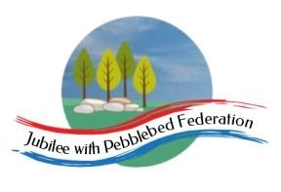
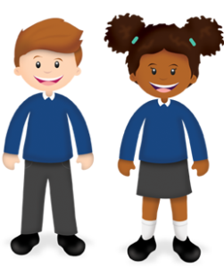
Play and Learn in Reception

Reception  March | As part of our Early Years Foundation Stage Curriculum we also learn lots through play! In school we will also be doing some of the following as part of our continuous provision. You are welcome to try some of these activities in addition to the home learning grid/Google Classroom
Hide and Seek  Play hide and seek using cuddly toys inside the house or outside Purposely use positional language, such as “The teddy is hiding behind the sofa”. | Reading  Enjoy and read books together. Challenge yourselves to read at least one book together each day? | Potion Making  Make a potion using a large mixing bowl, spoon and a range of random ingredients you have at home. | Crowns  Cut and decorate a beautiful crown for a King or Queen. Measure it to fit around your head. | Puppet Show  Using cuddly toys, puppets and toys you have at home make a puppet show together. You could do it behind a sofa or make your own puppets. “He is behind you!” | Jewellery  Using beads, pasta or cheerios you have at home. Make jewellery for a king or queen. Measure to fit.
Small World  Play and imagine together using characters you have at home. Model talking with your character and initiate play themes. | House chores  Work together to complete some jobs such as dusting, washing up or hanging up the washing. Praise them for their efforts. | King or Queen Art  Draw or paint a King or Queen.  What would they wear? | Royal Picnic  Together prepare for a picnic inside the house or outside. Work together to make and choose the food, gather and lay out the cutlery. Invite siblings to join in too. | Phonics  Play Phonics games on ‘Phonics Play’ (Phase 2 + 3).  Website is free to use throughout lockdown  Username: jan21  Password: home | Send some love  Draw a picture or write a message for someone you care for. You could post it through a letter box or send it through the post to truly make someone’s day!
We would love to see any photos of the fun things you are doing at home. Please send these to YRteacher@littleham.devon.sch.uk If you need any additional resources to support your child with their home learning please let us know.
Please be aware that your home filter may allow unsuitable links to pop up when watching any YouTube video.

