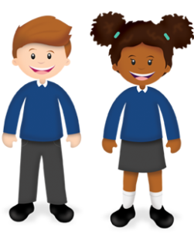
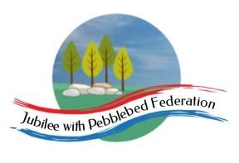
Learning
from Home

Year:  Wk beg: | Lesson One | Lesson Two | Lesson Three | Lesson Four
Monday | Reading  Read library book or allocated bug club books | English  https://classroom.thenational.academy/lessons/to-identify-the-features-of-an-explanation-text-6tgk2r | Maths  https://classroom.thenational.academy/lessons/solving-correspondence-problems-cgt6ae | Maths games  https://www.topmarks.co.uk/number-facts/number-fact-families
Tuesday | Reading  Read library book or allocated bug club books | English  https://classroom.thenational.academy/lessons/to-explore-compound-words-6wwpat | Maths  https://classroom.thenational.academy/lessons/using-doubles-to-multiply-cdjkcr | History  https://classroom.thenational.academy/lessons/who-were-the-celts-and-why-did-they-use-iron-cnhkjr
Wednesday | Handwriting  https://www.youtube.com/watch?v=2NQ6uS8blwY&t=82s&ab_channel=MisterTeach | English  https://classroom.thenational.academy/lessons/to-explore-using-apostrophes-for-plural-possession-cgvk2d | Maths  https://classroom.thenational.academy/lessons/using-ten-times-greater-for-known-times-tables-c4t68e | PE  https://www.youtube.com/watch?v=h3DSYn2jIKE&t=2s&ab_channel=MihranTV
Thursday | Reading  Read library book or allocated bug club books | English  https://classroom.thenational.academy/lessons/to-understand-and-sequence-how-bees-make-honey-cgwk2c | Maths  https://classroom.thenational.academy/lessons/using-bar-models-to-represent-word-problems-70r30c | Art  https://www.bbc.co.uk/newsround/39113604
Friday | Reading  Read library book or allocated bug club books | English  https://classroom.thenational.academy/lessons/to-develop-a-rich-understanding-of-words-associated-with-trying-hard-cdk66r | Maths  https://classroom.thenational.academy/lessons/consolidating-multiplication-and-division-knowledge-part-2-cdhk0t | PSHE  https://classroom.thenational.academy/lessons/king-of-the-road-6mu36t

