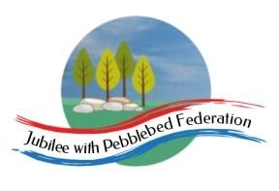
Year 1
Learning from Home

Year:  Week beg:  29/3/2021 | Lesson One | Lesson Two | Lesson Three | Lesson Four | Lesson 5
Monday | Maths  Find pairs to 8 and 9 | English  To listen to a story and respond | Reading  Log in to Bug Club and read a book from your ‘library’. https://www.activelearnprimary.co.uk/login?c=0  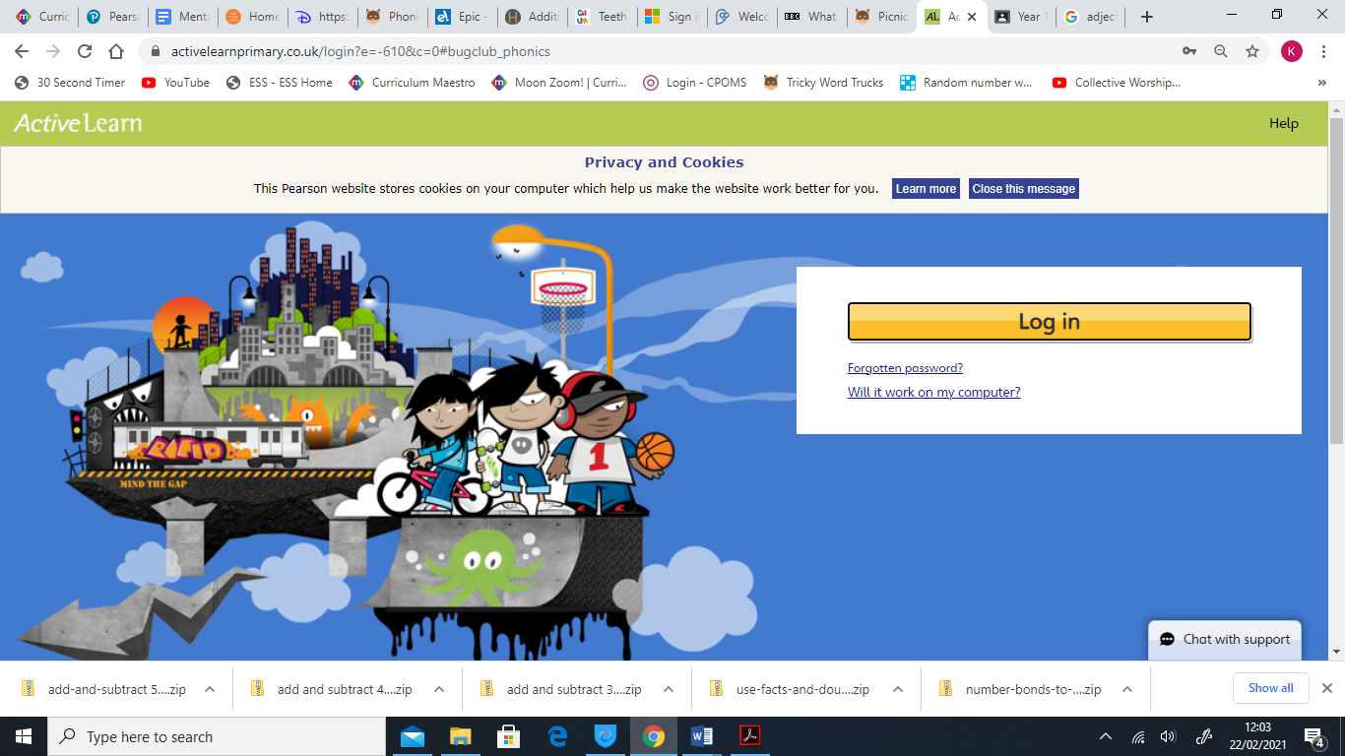 | Phonics  Recap of phase 3,4 and 5 sounds, all phase 3,4 and 5 tricky words and alien/real words. | PE  https://youtu.be/VHbQD7aZQxA
Tuesday | Maths  Relate addition and subtraction number facts | English  To recall the story of ‘The Clocktower’. |  |  | Art/DT – make an easter card.
Wednesday | Maths  Find doubles and near doubles | English  To use adjectives to describe |  |  | Science – design a poster of how to keep your teeth healthy.
Thursday | Maths  Add 10, then small multiples of 10 to 2-digit numbers. | English,  To use ‘and’ in a sentence. |  |  | RE: read the Easter story.
Please be aware that your home filter may allow unsuitable links to pop up when watching any YouTube videos.

