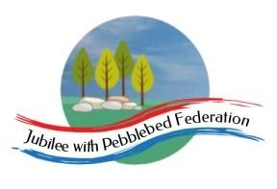
Learning
from Home

Year: 4  Wk beg:  1.2.21 | Lesson One | Lesson Two | Lesson Three | Lesson Four
Monday  The theme for this week’s learning behaviour is interdependence!  Our learning animal this week is a penguin! 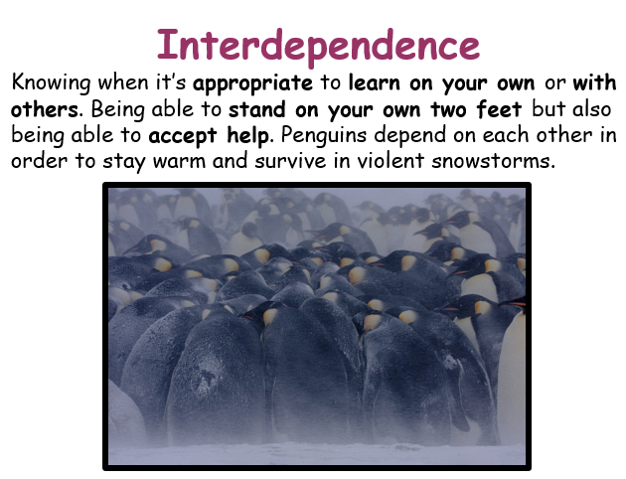 | English  A Walk in London  Non Fiction  Information Text  LO: To understand how the author has captured the reader’s attention.  We have looked at some of the ways that the author of A Walk in London has captured our attention.  To help us further understand all of the techniques he has used, I have made a chart that shows us how the author has done this with some examples. These are the ‘special ingredients’ that he has used to create an exciting guide book about London.  Your task today is to read the book and to find some more examples of the ‘ingredients’ that make the book exciting to read.  Go to Google Classroom and read through the chart I have attached for today’s lesson.  Look specifically at the statements I have made with bullet points (the second column).  Find examples to show the show the statements are true, I have given you some to start you off. | Maths  Times tables  LO: I can explore calculations and complete times tables on a multiplication grid  Go to Google Classroom  Power point  DAY 1 | Spelling  LO: To read and spell new words  This week we are looking at word families.  We are looking at rhyming strings and suffixes which change the meanings of root words.  Go to Google classroom to find your spelling work this week. | Science  Living Things and their Habitats  How are things classified?  LO: To create and use a classification key to name a variety of living things in the wider environment.  Some living things are plants, some are animals. Some things live in water and some things live on land. There are some insects. Some living things are big and some are small.  Watch this link:  https://www.bbc.co.uk/bitesize/topics/zxjj6sg/articles/z9cbcwx  Go to Google Classroom and look at the animals sheet, which I have attached for this lesson.  Play Guess Who with a member of your family.  You pick an animal or plant from the sheet and your family member asks you questions to begin to identify what it is! You can only answer yes or no!  Task  Write classification key that will identify all the living things from the sheet.  Can you use scientific language: habitat, vertebrate, invertebrate, mammal?  Draw the living thing at the end of the corresponding branch.  Can you demonstrate your learning by telling a member of your family?!
Tuesday | English  LO: To explore Word Classes.  Follow the link for the online lesson.  https://classroom.thenational.academy/lessons/to-explore-word-class-6cu3je  or if you are using the Home Learning Pack you will find a written task with a task guide to help you. | Maths  Measures and Data  LO: Collect and represent data in pictograms.  Go to Google Classroom for lesson and sheets.  For further information, another task (if you want to do more) and a great fun video about Pictograms follow this link to BBC Bitesize.  https://www.bbc.co.uk/bitesize/articles/z493hcw | RE  Diwali  LO: To understand how Hindus celebrate in Britain today.  Research how Hindus celebrate Diwali in Britain today. Use the internet to help you. Below are some useful links:  https://www.bbc.co.uk/bitesize/clips/z8rxn39  https://www.bbc.co.uk/bitesize/articles/zw7n6g8  https://www.bbc.co.uk/bitesize/clips/zn9k2hv  https://www.bbc.co.uk/bitesize/clips/z787tfr  Focus on: what matters most at Diwali and what is good for Hindu families and communities about taking part in Diwali celebrations.  Present your research as a factfile | PE  Workout with Joe Wicks!  https://www.youtube.com/watch?v=xbVr38Bhe7E
Wednesday | English  A Walk in London  Non Fiction  Information Text  LO: To research and collect information about interesting places to visit in Exmouth.  We will begin creating our own page(s) for our very own book.  We will be writing about a trip to Exmouth! We are going to write our own journeys, packed with information about the history of Exmouth. This will be written in the same style as A Walk in London and  we will use the same ‘special ingredients’ technique!  Today, you will research some exciting places to visit and begin to choose places in Exmouth that you would like to include for your page. You may know lots of places and have visited them. You may even have photos of you at those places, which you could include too.  You will need to choose 3-5 different places. In your book, you will be the child character and your parent will be the adult, like A Walk in London.  https://www.visitexmouth.org/listing-category/do/  https://www.tripadvisor.co.uk/Attractions-g551673-Activities-Exmouth_Devon_England.html | Maths  Exploring Factors  LO: I can find and compare factors of numbers up to 40  Google Classroom  Day 2  Multiplication and  division power point | Topic Blue Abyss  LO: To find out about Cornelius Drebbel,  who he was and what he did.  Englishman Cornelis Drebble (1572–1633) built the first submarine by waterproofing a wooden, egg-shaped boat with leather and coating the whole thing in wax..  Go to this BBC site and read about Cornelius Drebbel.  http://www.bbc.co.uk/history/historic_figures/drebbel_cornelis.shtml  Task  Record three facts about Cornelius Drebbel and draw or paint a picture of a submarine  Go to Google Classroom for pictures of submarines and a recording sheet for your fact finding about Cornelius Drebble. | Mental Health  10 A DAY  LO: To understand that food can change physical and mental health and that feelings can affect your food choices.  http://archive.foodafactoflife.org.uk/VideoActivity.aspx?siteId=19&sectionId=131&contentId=830&titleId=832  Select some videos to watch about healthy eating and play the game.
Thursday | English  A Walk in London  Non Fiction  Information Text  LO: I can map the journey I take around Exmouth in the order I visit them.  Today, you will start to ‘shape’ your day out in Exmouth by mapping out the places you are visiting in your book.  Choose a starting point. You could have taken a bus there or gone in a car and start your journey by getting out of the car or off the bus once you have arrived at your first interesting place.  Use the map of Exmouth and mark the places on there.  You will draw pictures of you and your parent in that place and must create conversation between you and them that relates to that place.  Perhaps you could ask a question and your parent answers it. How can you show how you feel, what might you say?  You may have real photos of you in some of the places you are planning to include. We can include these too!  Go to Google Classroom. | Maths  Exploring Factors  LO: I can find the factors of numbers that occur multiple times on a multiplication grid.  Google Classroom  Day 3  Multiplication and division power point | TOPIC Blue Abyss  Design & Technology  LO: To design and make a submarine from  junk materials.  Submarines glide through waters beneath the surface of the ocean. They are lean, mean, military machines and they can stay submerged for weeks or even months at a time.  How do submarines work?  The ‘submarine’ sinks because, when the bottle is squeezed, the increased pressure squashes the air bubble inside the straw. Squashing the air bubble increases its density above that of the surrounding water, making it sink. When the bottle is released, the air bubble expands again and its density decreases, making it rise.  Watch these links below and find out!  https://www.youtube.com/watch?v=uP0alCgUzlI  https://www.youtube.com/watch?v=c3W937dORLI  https://www.youtube.com/watch?v=I7pGRCbID_s  Model making  We are going to make our own submarines!  Look in your recycling bin to find some ‘junk’ materials to create your own model submarine.  Watch these clips to give you some ideas.  Please send in a photo and we can add it to our classroom display.  https://www.youtube.com/watch?v=YdXj2cds1iw  https://www.youtube.com/watch?v=DP4t99DTBmo | Art Blue Abyss  LO: To recreate a piece of art by a famous artist.  Look at The Great Wave by Katsushika Hokusai.  Trace over a print of the piece of work.  Transfer onto a piece of paper  Give colour using paint.  Or recreate this by using collage materials to create a collage.  Go to Google Classroom to find a larger version.  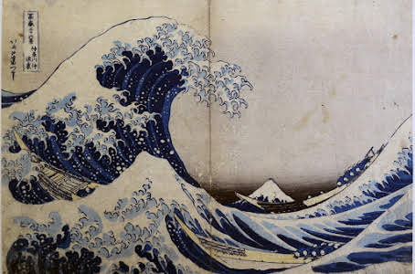
Friday | English  A Walk in London  Non fiction  Information Text  LO: I can begin to write my ideas about the places in my book.  Today, you will begin to write some conversation between you and your parent for the first places you will visit in your book. We will call it A Walk in Exmouth.  . | Maths  Problem solving and reasoning  LO: To solve multiplication and division problems  Google classroom  Problem solving and reasoning questions | PE  Joe Wicks workout  https://www.youtube.com/watch?v=uqLNxJe4L2I | Game Time  Go to:  https://www.ictgames.com/mobilePage/index.html  and select from Literacy or maths games to play on  Play a board game or a card game with a family member

