Earth and Sun
Earth is tilted at an angle of 23 ½º. Look at any globe and you will see this tilt.
The tilt is important as it creates changes in the amount of daylight throughout the year as well as changes in temperature and the angle/height of the sun during the day.
You will know that in our classroom in December and January, the sun is low in the sky at midday. The amount of daylight is short and it is cool/cold.
Hopefully, we will be back soon and you will see that at midday*, the sun is much higher in the sky and we have a much longer amount of daylight.
(* Note that we put the clocks forward in March so the sun it at its highest at 1 p.m. not 12 noon.)
If you have a torch, you can do this simple investigation. You will need a fairly dark room.
Shine your torch on the floor at various angles starting with it directly overhead. Move the torch at various angles.
Look at how the light spreads out as the angle get smaller and smaller. (see diagram below)

____________________________________________________________________
When the torch is overhead (position 1) the light is concentrated over a small area. It is very bright.
As the torch changes position, the light is spread out over a larger area and becomes weaker.
When the torch is almost parallel to the floor, the light is spread out over a very large are and is very weak.
The same happens with the sun. When it is higher in the sky (summer), the rays are concentrated over a smaller area and the ground heats up more.
When the sun is lower in the sky (winter), its rays are spread out over a larger area and the ground does not heat up as much.
Because Earth is tilted, the effect of this is greater. In summer, Earth is tilted towards the sun and this makes the sun’s rays more concentrated. Conversely, in winter, Earth tilts away from the sun and the sun’s rays are spread out over an even greater area.
If you have a globe or a ball, you can try the torch investigation with it. You will be able to see how the light spreads out depending on where you are on the planet.
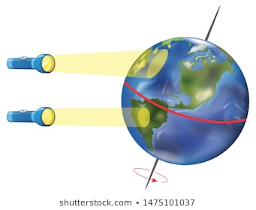

Imaginary lines of latitude. These are lines that go around the world horizontally.
Find out the names of these five imaginary lines of latitude.
Try to find out what the latitude of each of these lines is.
Do you notice anything special about some of the latitudes?

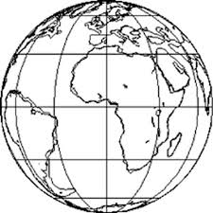

The lines of latitude are as follows going from north to south.
Arctic Circle – 66 ½ ºN
Tropic of Cancer – 23 ½ ºN
Equator - 0º
Tropic of Capricorn – 23 ½ ºS
Antarctic Circle – 66 ½ ºS
You know that the Earth’s tilt is 23 ½º so the numbers are important. The tropics are 23 ½º N and S of the equator. At these latitudes on certain days of the year, the sun is directly overhead at midday.
Do you know which days these are? Can you find out?
The Arctic and Antarctic circles are 23 ½ º less than 90º. At these latitudes on certain days of the year, the sun does not rise at all (always night) and on other days it never sets (always day).
Do you know which days these are? Can you find out?

Answers
On June 21st, the sun is overhead at midday at the Tropic of Cancer (north). For the UK, this represents our ‘longest day’ when we have the most amount of daylight.
On December 21st, the sun is overhead at the Tropic of Capricorn (south). For the UK, we have our ‘shortest day, when we have the least amount of daylight.
On June 21st, the sun does not rise at the Antarctic Circle – it is mid-winter here. It does not set at the Arctic Circle – it is mid-summer.
On December 21st, the sun does not rise at the Arctic Circle and does not set at the Antarctic Circle.

This diagram might help you to see this.
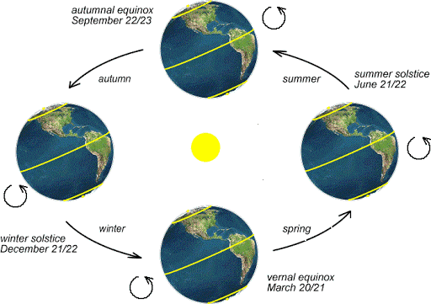
On March 21st and September 21st, the sun is overhead at midday at the equator. This represents spring and autumn respectively. The times are the spring equinox and autumn equinox.
Can you find out what is special about the amount of daylight and darkness on these dates?
Can you think how the world would be different if it did not tilt or if the tilt was less? (This has occurred during the history of Earth and will happen again. Not for several million years though – and it will be gradual so don’t worry.)
No tilt would mean that the angle of the sun would not change for a particular place throughout the year. There would be no seasons. The amount of daylight and darkness would not change throughout the year – we would have 12h of each, every day. That’s not so bad but I do like the long evenings in the summer.
The lack of seasons (short days and long days) affects the growth of plants. Many need longer days to flower, others need cold spells. The climate of a place would not really change too much from year to year – same temperature. This is fine if the temperature is mild – ours would be but not so good if you lived further towards the poles. Here it would be cold all year as the angle of the sun would be low. Winters would be warmer leading to melting of the ice.
This is the case for places around the equator – their daylight remains the same throughout the year roughly 12 hours. Their temperature is pretty much the same at about 28ºC (depending on how high the place is).

