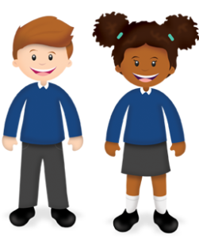
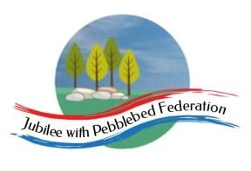
Year 1
Learning from Home

Year:  Week beg:  25/1/2021 | Lesson One | Lesson Two | Lesson Three | Lesson Four | Lesson Five | Lesson Five
Monday | Maths  Google Classroom – Partition 10 into pairs | English  Google Classroom – Compose sentences orally. Draw story map of Bird’s Bad Birthday. | Reading  Log in to Bug Club and read a book from your ‘library’. https://www.activelearnprimary.co.uk/login?c=0  Google Classroom - Phonics | Phonics  Letter C: Read and write words ‘cup, cactus, camera, cube’. | RE  https://www.youtube.com/watch?v=7po2EZ4Y-KU ) | PE  Youtube: PE with Joe Wicks
Tuesday | Maths  Google Classroom – Know number bonds to 10 | English  Google Classroom – use punctuation correctly. Plan sentences to match story map. | Reading  Log in to Bug Club and read a book from your ‘library’. https://www.activelearnprimary.co.uk/login?c=0  Google Classroom - Phonics | Phonics  Digraph ‘ch’ Read and write words ‘school, choir and chaos’. | Science  Draw and label the main parts of the human body. | Mental Health –  Drink water – making ice lollies
Wednesday | Maths  Google Classroom – Know number bonds to 10 | English  Google Classroom – Read writing to check for punctuation. Write sentences to match story map. | Reading  Log in to Bug Club and read a book from your ‘library’. https://www.activelearnprimary.co.uk/login?c=0  Google Classroom - Phonics | Phonics  Digraph ‘ck’. Read and write words ‘sock, clock and trick’. | PSHE  Google Classroom – Select words to describe feelings | History  Google Classroom – describe an object. Compare it to how the object would have been in the past.
Thursday | Maths  Google Classroom – Addition and subtraction of number bonds to 10  Maths  Google Classroom – Quiz! | English  Google Classroom – Say out loud what I am going to write. Plan your own version of the story. | Reading  Log in to Bug Club and read a book from your ‘library’. https://www.activelearnprimary.co.uk/login?c=0  Google Classroom - Phonics | Phonics  Letter K. Read and write words ‘kennel, king and shark’. | PE  Youtube, PE with Joe Wicks | Mental Health –  Eat healthy food
Friday |  | English  Google Classroom – Compose sentence out loud first: draw up your new story map! | Reading  Log in to Bug Club and read a book from your ‘library’. https://www.activelearnprimary.co.uk/login?c=0 | Phonics  Read and write the tricky word sentence ‘She could be going out’. ’  got many. | Collective Worship  Google Classroom | Story time  Google Classroom – choose a video of Miss Thornton reading a story to watch.

Please be aware that your home filter may allow unsuitable links to pop up when watching any YouTube videos.
What have you ‘questioned’ this week? Send me a photo for our display at school!
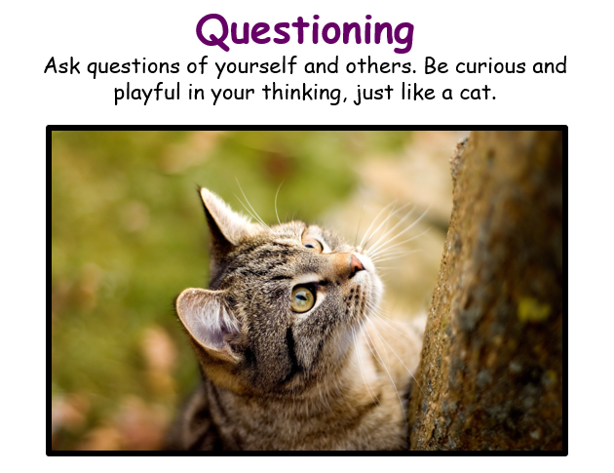

__________has behaved like a ‘Cat’ at home by…..

