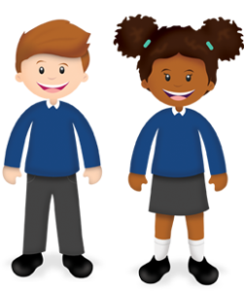
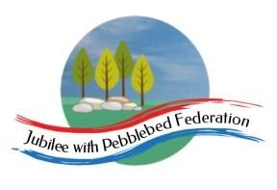
Year 1
Learning from Home

Year:  Week beg:  8/2/2021 | Lesson One | Lesson Two | Lesson Three | Lesson Four | Lesson Five  RE  To think about the Shabbat and links between objects that are related to the Shabbat. https://www.bbc.co.uk/bitesize/clips/zs2hyrd | Lesson Five
Monday | Maths  Google Classroom – One more/one less. | English  Google Classroom – Become familiar with key story and re-tell it. Read ‘How to Wash a Woolly Mammoth’ with actions. | Reading  Get Epic, Code: wjn5693 | Phonics  - Phoneme /j/ written as 'g(e)', 'g(i)', 'g(y). (danger, giraffe, giant). |  | PE  https://youtu.be/VHbQD7aZQxA
Tuesday | Maths  Google Classroom – Missing numbers. One more/one less. | English  Google Classroom – Explain understanding of what is read to me. Using a toy, follow instructions in story. | This week we will try a new reading website called ‘Get Epic’.  Click on link or copy and paste into your web browser.  https://www.getepic.com/book/73887057/bathtime-for-biscuit?utm_source=t2t&utm_medium=link&utm_campaign=content&share=31358210534  Once you reach the page with the cover, you should be able to start reading. If not, click on the ‘class code’ at the top and enter: wjn5693 | Phonics  - Phoneme /j/ written as 'dge'. (bridge/hedge). | Art  Paint a picture of your family. | Mental Health –  http://www.littleham.devon.sch.uk/website/mental_health/535426
Wednesday | Maths  Google Classroom – Counting in 10s. | English  Google Classroom – Explain what is read to me. Be the ‘Zoo Keeper’ and explain how to wash a woolly mammoth. |  | Phonics  Apostrophe in “I'm”, “I'll” and “I've” | PSHE  Google Classroom – Google Classroom – draw a picture of a change such as a new school year or a new house. | DT  Make a Valentine’s day card.
Thursday | Maths  Google Classroom – Finding 10 more.  Maths  Google Classroom – Counting in ones and tens. | English  Google Classroom – Write sentences by saying it out loud first. Create sentence to match empty page of the book. |  | Phonics  Recap of all phase 3 and phase 5 sounds. | PE  https://youtu.be/VHbQD7aZQxA | Mental Health –  http://www.littleham.devon.sch.uk/website/mental_health/535426
Friday |  | English  Google Classroom – Order the instructions. |  | Phonics  Read the phase 5 tricky words and sounds from home learning pack. | Collective Worship  Google Classroom | Story time  Google Classroom – choose a video of Miss Thornton reading a story to watch.

Please be aware that your home filter may allow unsuitable links to pop up when watching any YouTube videos.
Who have you worked with this week? Send me a photo for our display at school!

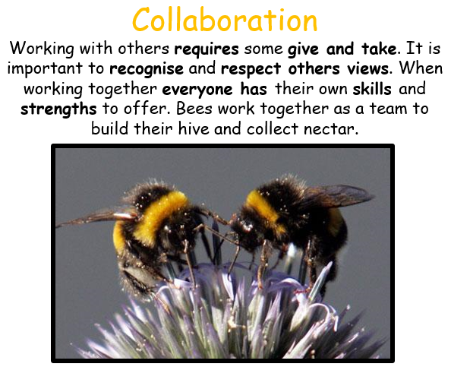

__________has behaved like a ‘Bee’ at home by…..

