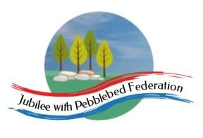
Learning
from Home

Year: 4  Wk beg:  22.3.21 | Lesson One | Lesson Two | Lesson Three
Monday | English  https://classroom.thenational.academy  /lessons/to-identify-the-main-characters-and-the-setting-in-a-visual-narrative-c8w68t?activity=video&step=1 | Maths  https://classroom.thenational.academy  /lessons/describing-coordinate-positions-on-a-grid-6hgpat | Mental health  meditation  https://www.youtube.com/  watch?v=mZO-R7iuCNo
Tuesday | English  https://classroom.thenational.academy  /lessons/to-investigate-suffixes-past-and-present-tense-6nhkjc | Maths  https://classroom.thenational.academy  /lessons/translating-simple-shapes-6hjpat | PE  https://www.youtube.com/  watch?v=pJGqlIa4Dbw
Wednesday | English  https://classroom.thenational.academy  /lessons/to-explore-simple-sentences-cmwp8r | Maths  https://classroom.thenational.academy  /lessons/reflecting-simple-shapes-6mu3ec | History  https://www.bbc.co.uk/bitesize  /topics/ztyr9j6/articles/zjcxwty  https://www.natgeokids.com/  uk/discover/history/general-history/  10-facts-about-the-vikings/
Thursday | English  https://classroom.thenational.academy  /lessons/to-sequence-and-retell-the-opening-6nhked | Maths  https://classroom.thenational.academy  /lessons/solving-practical-coordinate-problems-part-1-c9h3ec | Art  https://www.youtube.com/  watch?v=eYlPYEQil54
Friday | English https://classroom.thenational.academy  /lessons/to-develop-a-rich-understanding-of-words-associated-with-night-time-60r3gc | Maths  https://classroom.thenational.academy  /lessons/solving-practical-coordinate-problems-part-2-6hh34e | Games  ictgames.com

