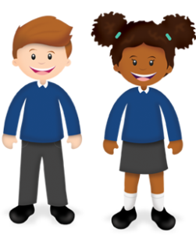
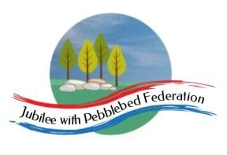
Year 1
Learning from Home

Year:  Week beg:  18/1/2021 | Lesson One | Lesson Two | Lesson Three | Lesson Four | Lesson Five | Lesson Five
Monday | Maths  Google Classroom – Find 1 more/1 less than any number up to 20. | English  Google Classroom – Capital letters and full stops: dictation sentences. | Reading  Log in to Bug Club and read a book from your ‘library’. https://www.activelearnprimary.co.uk/login?c=0  Google Classroom - Phonics | Phonics  Google Classroom video – ‘ear’ written as ‘ere’ and ‘eer’: cheer, mere. | RE  https://classroom.thenational.academy/lessons/where-do-jews-worship-today-68wk8r | PE  Youtube: PE with Joe Wicks
Tuesday | Maths  Google Classroom - Find 2 more/less than any number up to 20, recording the hops on a beaded line. | English  Google Classroom – Compose a sentence out loud first: finish the sentences | Reading  Log in to Bug Club and read a book from your ‘library’. https://www.activelearnprimary.co.uk/login?c=0  Google Classroom - Phonics | Phonics  Google Classroom – Read words: ‘here, sneer, sheer, sphere’. | Science https://classroom.thenational.academy/lessons/how-can-i-describe-an-object-c9h38c. Describe an object in your house. | Mental Health –  Do something you’re good at and share it with your family. https://www.youtube.com/watch?v=UdielkLGvAs
Wednesday | Maths  Google Classroom - Add 2, 3 or 4 by counting on. | English  Google Classroom – Using a question mark | Reading  Log in to Bug Club and read a book from your ‘library’. https://www.activelearnprimary.co.uk/login?c=0  Google Classroom - Phonics | Phonics  Google Classroom video – ‘air’ as ‘are’ and ‘ear’. | PSHE  Google Classroom – make a list of what parents must provide for their children. | Geography  Google Classroom – drawing out the weather symbol for today.
Thursday | Maths  Google Classroom – Realise that addition can be done in any order.  Maths  Google Classroom – Quiz! | English  Google Classroom – Read my writing to check it makes sense: list animals and presents | Reading  Log in to Bug Club and read a book from your ‘library’. https://www.activelearnprimary.co.uk/login?c=0  Google Classroom - Phonics | Phonics  Google Classroom – Read words ‘wear, square, swear, hare’. | PE  Youtube, PE with Joe Wicks | Mental Health –  Draw how you are feeling today.
Friday |  | English  Google Classroom – Compose sentence out loud first: what might animal say when it gets the present? | Reading  Log in to Bug Club and read a book from your ‘library’. https://www.activelearnprimary.co.uk/login?c=0  Google Classroom - Phonics | Phonics  Google Classroom – Read and write the sentence ‘Clare and Karen share their lunch.’  different toys,  but Joy has not  got many. | Collective Worship  Google Classroom – see Mrs Padbury’s video on Perseverance. | Story time  Google Classroom – choose a video of Miss Thornton reading a story to watch.

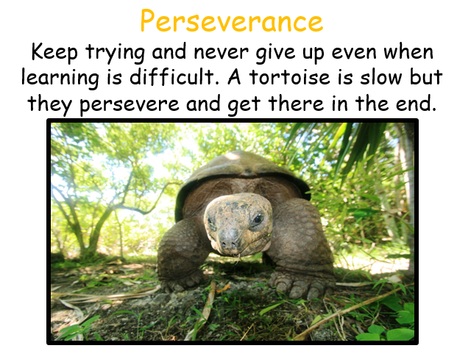

__________has behaved like a ‘Tortoise’ at home by…..

What have you ‘persevered’ with this week? Send me a photo for our display at school!

