**Movement number cards**

|  |  |  |
| --- | --- | --- |
| **0**    **standing star** |  | **1**    **straight legs jump** |
|  |  |  |
| **2**    **flap your wings** |  | **3**    **flick a leg** |

|  |  |  |
| --- | --- | --- |
| **4**    **overhead clap** |  | **5**    **wave** |
|  |  |  |
| **6**    **aeroplane wings** |  | **7**    **tumbling hands** |

|  |  |  |
| --- | --- | --- |
| **8**    **knees up jump** |  | **9**    **run on the spot** |
|  |  |  |
| **10**    **spin round once** |  |  |

**Kandinski paintings**

**1**

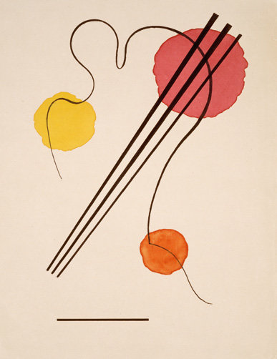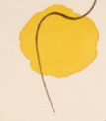

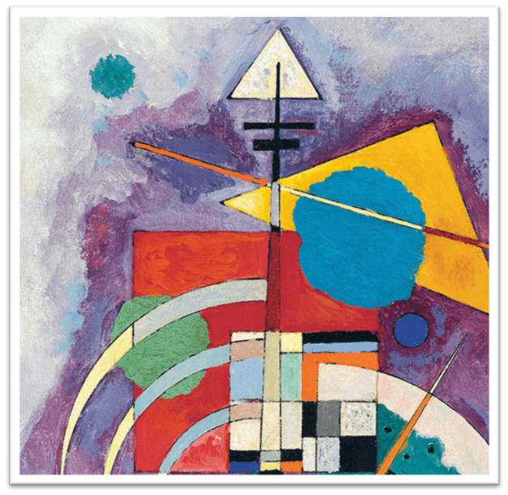

**2**

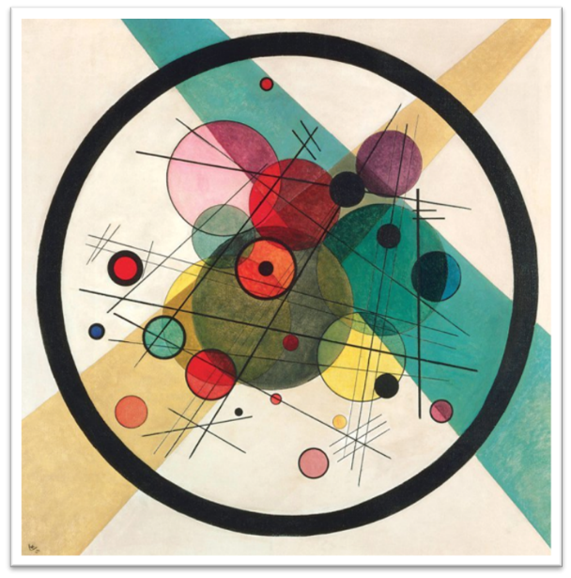

**3**

**Sample painting**

**Kandinsky’s circles colouring**

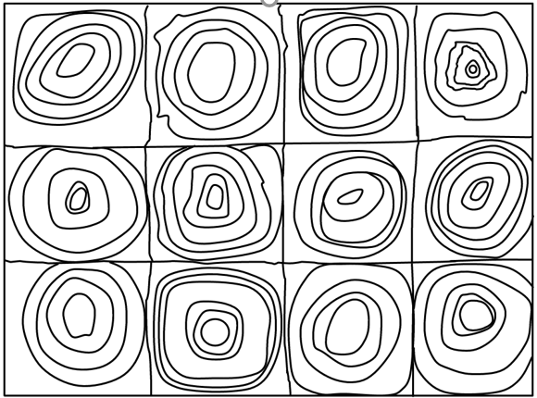

**Snake spiral template**

Enlarge to A3 if desired

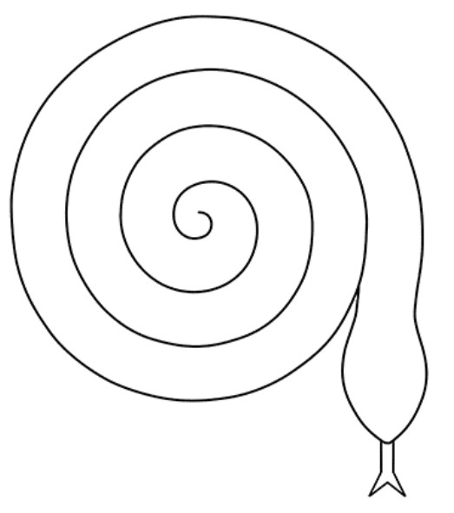

**How to make a spiral number snake**

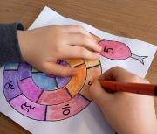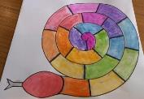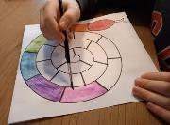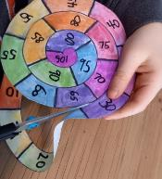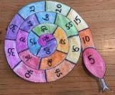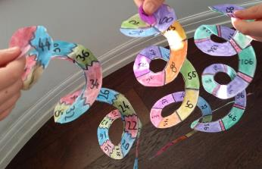

1. Hang and enjoy!
2. Decide on the number pattern you are going to use.  
   Write the numbers in pen.
3. Carefully cut out your snake, then cut all the way to the tail, following the curved line.
4. Create segments on your snake and decide on how you will decorate it.

**Mindfulness Snake Colouring**

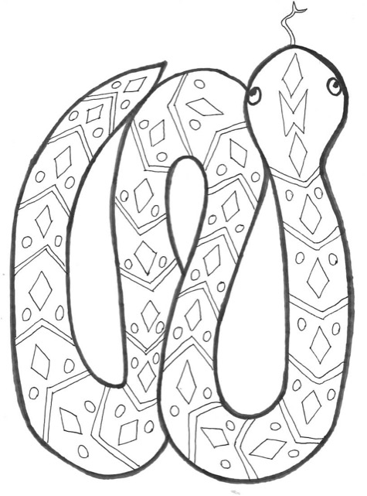

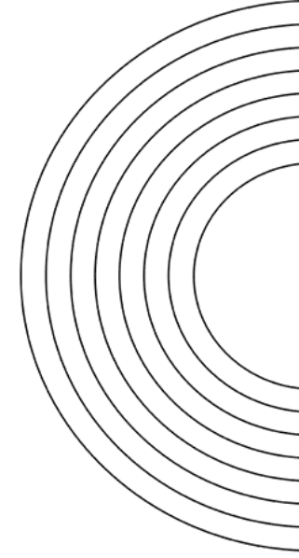**Rainbow addition**

Complete the additions, then colour the rainbow using the colour key to guide you.

56 + 10

84 + 9

**Colour key**

4 + 7 +10

23 + 7

17 + 17

12 + 7

89 + 11

|  |  |
| --- | --- |
| **21** |  |
| **100** |  |
| **34** |  |
| **66** |  |
| **93** |  |
| **19** |  |
| **30** |  |

**Pairs to 10 colouring sheets**

