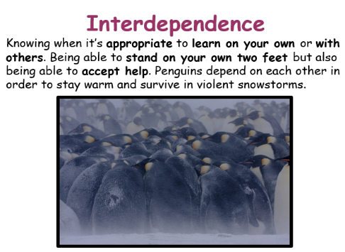
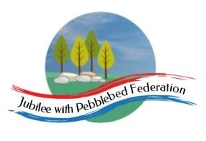
Learning
from Home

Year: Reception  Wk beg: 01/02/2021 | Lesson One | Lesson  Two | Lesson  Three | Lesson  Four | Lesson  Five
Collective Worship/Family Mental Health and Well-being | Collective Worship: Choose a time to watch Mrs Padbury’s Collective Worship on Interdependence – Google Classroom  Mental Health and Well-Being: Session 3 – Express Yourself http://www.littleham.devon.sch.uk/website/mental_health/535426
Monday 1st February | Name Practice  Practice writing your name on your name card. You will find this in your child’s home learning pack.  Please encourage correct pencil hold – ‘nip, flip and grip’ and letter formation.  Please make sure your child can form all the letters correctly in their name. | Reading  Log onto Bug Club and pick a book to share. Ask your child questions about the story.  https://www.activelearnprimary.co.uk/login?c=0  Log in details are at the front of your child’s reading record.  Then practice reading some of the sound button words in their home learning pack.  e.g. s-a-t sat | Maths  Watch and join in with the shapes song from www.YouTube.com.  Look at the pictures of a square, rectangle, circle and triangle. Name each and discuss similarities and differences.  Now describe a shape and see if your child can point to it and name it. For example, show me a shape that has straight sides. Show me a shape that has curved sides. Show me a shape that has 4 corners. Show me a triangle. | Phonics  Review all letter sounds learnt so far – see flash cards in home learning pack + j v w x y z zz qu ch sh th ng ai ee igh  Learn the sound oa  https://www.youtube.com/watch?v=rrGadCz2A1o  Then practice reading these words:  fight  flight  night  light  oak  oats  coat  road  We have learnt all the sounds in these words so see if your child can sound talk them e.g. f-igh-t | Literacy  Talk about what Little Red Riding Hood might have put in the basket for Grandma.  Cut and stick some of these into the basket. You can use the sheets on google classroom or in your paper pack. You may want to find, print or draw some of your own also.  Help your child to label some of these items. Get them to listen carefully to the sounds they hear in the words. You might get your child to identify and write the first sound and then you write the rest. Or they may be able to hear more sounds and try to write the whole word. It doesn’t matter if the words are not spelt correctly we just want them to try to use their sound knowledge to start writing.
Tuesday  2nd February | Name Practice  Practice writing your name on your name card. You will find this in your child’s home learning pack.  Please encourage correct pencil hold – ‘nip, flip and grip’ and letter formation.  Please make sure your child can form all the letters correctly in their name. | Reading  Log onto Bug Club and pick a book to share. Ask your child questions about the story.  https://www.activelearnprimary.co.uk/login?c=0  Log in details are at the front of your child’s reading record.  Then practice reading some of the sound button words in their home learning pack.  e.g. s-a-t sat | Maths  Watch and join in with the shapes song from www.YouTube.com.  Next review shape names from yesterday.  Now go on a shape hunt around your home or whilst out on your daily exercise. Can you see/find any squares, circles, rectangles or triangle shapes? Can you see any shapes inside other shapes? Draw what you find or take some photos and share with us at school. | Phonics  Review all letter sounds learnt so far – see flash cards in home learning pack + j v w x y z zz qu ch sh th ng ai ee igh oa  Learn the sound oo  https://www.youtube.com/watch?v=VQxqTmiDmIQ  Then practice reading these words:  foam  loaf  goat  toad  zoo  food  moo  boot  We have learnt all the sounds in these words so see if your child can sound talk them e.g. l-oa-f | Handwriting  Help your child to practise writing the letters that make the sounds oa and oo.  Try to encourage your child to hold the pen/pencil correctly. Look at the nip, flip and grip poster if you feel your child needs help with their pencil grip.  Handwriting sheets – On Google Classroom
Wednesday  3rd February | Name Practice  Practice writing your name on your name card. You will find this in your child’s home learning pack.  Please encourage correct pencil hold – ‘nip, flip and grip’ and letter formation. | Reading  Log onto Bug Club and pick a book to share. Encourage your child to predict what will happen next.  https://www.activelearnprimary.co.uk/login?c=0  Practice reading and writing the tricky words – to, I, no, go, into, the | MATHS  REVIST: To have a sense of how long a minute is.  INNER PEACE.  This activity is about finding a quiet place. Choose a cuddly toy which will help meditate for a minute. Sit cross-legged, hands on knees, first finger touching thumb, eyes closed breathing slowly. Start timing for a minute and see when your child thinks that a minute is over by opening their eyes. How close did you get?  Try again.  Play the minute song and see how much tidying foe example can be done.  https://youtu.be/971iR4I5FBE | RE THE CREATION.  Discuss that Christians believe that God created the Earth. (The seven days idea links with the Maths we have been learning).  Play the video clip and talk about what happened on each of the days.  https://youtu.be/teu7BCZTgDs  Then draw and colour your favourite creatures, including trees etc in the background.  There is also a printed picture for Home Learning Packs, as well as a PDF on Google Classroom to colour. | PE  If you have an opportunity to get outside and get active, including on a bike, then that would be great!  Setting up an obstacle race in a garden if you have got one, or timed runs etc in a park.  Being active for one minute bursts would be useful, in linking with our Maths using time. Asking the children to do an aerobic activity for what they think is a minute to get a sense of time. Video clips will be included here and Google Classroom.  https://youtu.be/fgxR1PiEiDk  https://youtu.be/2X1p0Yd6WAo
Thursday  4th February | Name Practise  Practice writing your name on your name card. You will find this in your child’s home learning pack.  Please encourage correct pencil hold – ‘nip, flip and grip’ and letter formation.  Please make sure your child can form all the letters correctly in their name. | Reading  Log onto Bug Club and pick a book to share. Encourage your child to predict what will happen next.  https://www.activelearnprimary.co.uk/login?c=0  Then practice reading some of the sound button words in their home learning pack.  e.g. s-a-t sat | Maths  Watch and talk about this shape song https://www.youtube.com/watch?v=WTeqUejf3D0  Choose a shape picture and follow the key to know the right colour for each shape.  Encourage your child to:  - Name the shapes  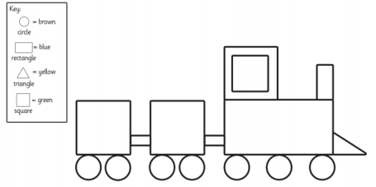  - Describe the shapes - how many corners/sides? | Phonics  Review all letter sounds learnt so far – see flash cards in home learning pack. + j v w x y z zz qu ch sh th ng ai ee igh oa oo(long)  Learn the sound oo (short)  https://www.youtube.com/watch?v=MDysETvGN_I&feature=youtu.be  Then practice reading these words:  fool  stool  spoon  roof  cook  good  hood  hook  We have learnt all the sounds in these words so see if your child can sound talk them e.g. h-oo-k | Literacy  Draw a picture of Grandmother’s house in the woods. Extend by also encouraging your child to draw some of the main characters from the story such as Little Red Riding Hood and the Wolf.  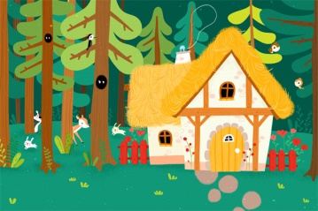  Encourage them to take care with their drawings and to include important features such as the roof, door and windows for the house and facial features and body parts for the characters.
Friday 5th February | Name Practice  Practice writing your name on your name card. You will find this in your child’s home learning pack.  Please encourage correct pencil hold – ‘nip, flip and grip’ and letter formation.  Please make sure your child can form all the letters correctly in their name. | Reading  Log onto Bug Club and pick a book to share. Ask your child to share their favourite page with you.  https://www.activelearnprimary.co.uk/login?c=0  Then practice reading some of the sound button words in their home learning pack.  e.g. s-a-t sat | Maths  Watch and talk about this shape song https://www.youtube.com/watch?v=WTeqUejf3D0  Choose a shape picture to make (your grown-up will need to cut out the shapes beforehand).  Have a go at making the picture using the shapes.  - How many different shapes have you used in your picture?  - What shape is this? What makes it a triangle?  - What makes this shape a square?  - Can you fit a square inside the circle? | Phonics  Review all letter sounds learnt so far – see flash cards in home learning pack. + j v w x y z zz qu ch sh th ng ai ee igh oa oo  Learn the sound ar  https://www.youtube.com/watch?v=IUHj1V-KYeg&feature=youtu.be  Then practice reading these words:  cook  hood  hook  took  book  art  jar  park  start  We have learnt all the sounds in these words so see if your child can sound talk them e.g. p-ar-k | Handwriting  Help your child to practise writing the letters oo and ar  Try to encourage your child to hold the pen/pencil correctly. Look at the nip, flip and grip poster if you feel your child needs help with their pencil grip.  Handwriting sheets – On Google Classroom
Please be aware that your home filter may allow unsuitable links to pop up when watching any YouTube video.

We would love to see any photos of the learning you are doing at home. Please send these to YRteacher@littleham.devon.sch.uk

