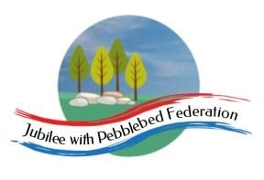

Year 5 Learning from Home Grid
Week Beginning 1.2.2021
Learning Behaviours
In school we are really thinking about:
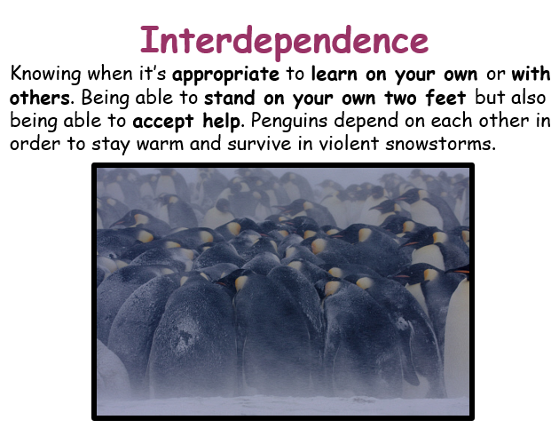
Please ensure that you monitor any YouTube clips for ads and ensure that your children only click on the links to the videos that I have included.
Monday | Collective Worship:  Follow the link to Mrs Padbury’s Collective Worship on Google Classroom  PE:  "SUPER FITNESS CHALLENGES FROM YOUR FRIENDS IN SCHOOL.”  https://youtu.be/oj5H58SdA8c  Reading  History VIP: Mary Anning  https://classroom.thenational.academy/lessons/to-introduce-the-context-and-genre-of-a-text-68uk4e  Maths:  From last week’s challenge, practice learning a times table you are less confident in. Then take the challenge of the PDF Times Table task here. You can complete all of it and record the time it took you to complete, or set yourself a time (Eg. 20 minutes) and see how many of the questions as you can and fill in. I have included the answers to check afterwards, but no peeking until you have finished! You can do the questions in any order you want to.  Living things and their habitats:  Continue with the back to back books from last week, or the Power points, whichever you prefer. Feel free to make further notes. In class, we made a start on these options last week and will aim to complete them by half-term. (I will put a back to back booklet in the Home learning packs which are collected).  Do check Google Classroom for further information.  Science:  Understand how a pulley works. I have left this task here from last week, as we didn’t get time to do it in class and I can only see that one person managed to complete it last week).  Use the sheet as a basis for the experiment and record findings. Focus on Prediction, method and results.  Where else might you find pulleys?  Why are they useful? Look around at home where pulleys are used. Research where pulleys have been used too. (PDF on Google classroom).  EXTENSION:  PULLEY VIDEO  https://www.bbc.co.uk/teach/class-clips-video/science-physics-ks2-ks3-will-pulleys-let-9-year-olds-beat-Britain%E2%80%99s-strongest-man/zvm4d6f  An extension activity will be added to Google Classroom as well.  Design your own mechanism using pulleys and label on a piece of paper if you haven’t completed the previous task.  French:  RECAP: Try last week’s lesson and have a chance to complete the task.  To learn the parts of the body. (The face).  Watch the video. ( More than once if you like).  https://youtu.be/UNCEy-g8qEM  On a piece of paper, draw your face and see if you can label the different parts in French?  Then watch the video again.  Then try the next video clip Alexa Parts of the Body Part 2. Then draw a simple outline of the body and label in French. Try to test yourself!  https://youtu.be/VfEe5-f_gwA
Tuesday | Reading:  History VIP: Mary Anning  https://classroom.thenational.academy/lessons/to-answer-retrieval-questions-6gv32c  English:  What are the features of a biography? Watch the clip:  https://www.google.com/search?q=https%3A%2F%2Fwww.youtube.+com%2Fwatch%3Fv%3DMLmIw8x-HJk&rlz=1C1GCEA_enGB865GB865&oq=https%3A%2F%2Fwww.youtube.+com%2Fwatch%3Fv%3DMLmIw8x-HJk&aqs=chrome.0.69i59j69i64j69i58.453087j1j4&sourceid=chrome&ie=UTF-8  Then read the biography, finally complete the activity on Google Classroom or in your pack.  Maths:  Reading timetables using the 24 hour clock and calculating time intervals  History:  To explore the trial and judgement of Anne Boleyn. Work through the PowerPoint and video clip on Google Classroom or in your paper pack and then think about what Anne’s uncle said to her at the end of her trial. What would she have said to him? Write a short response – you can type this directly on to the sheet and send it back to me on Google Classroom or write it on the sheet in your paper pack!  PSHE:  Money Matters  https://classroom.thenational.academy/lessons/employment-71h3ct
Wednesday | Reading:  History VIP: Mary Anning  https://classroom.thenational.academy/lessons/to-answer-language-questions-part-1-6hhkec  English:  Women in Science – Listen to me read the introduction, read the introduction for yourself and then create your own glossary – all of this can be found in Google Classroom or in your paper pack.  Collective Worship:  Exmouth Coastal Churches  https://www.youtube.com/watch?v=ibcdh2V0VtQ&list=PLqWt6-qhTKHF_Yb18Npn-Ni0kRTQ-9-yp  Look at the playlist on the side for the Collective Worship for this week  Maths:  Calculating time intervals using the 24 hour clock  Art:  Explore the Clothes in Tudor Times PowerPoint (you can find this on Google Classroom or in your paper pack. Use the information to draw a detailed Tudor costume. Look carefully at the detail and design, try to copy this in your own work using a variety of sketching, shading and colouring techniques.  Mental Health:  Please find this week’s work in Google Classroom in the Family Mental Health and Wellbeing Folder, you can also find it by following the link:  http://www.littleham.devon.sch.uk/website/mental_health/535426  Try week 1 or Week 2 please.  Also this week: Think about our 10 a day, this week our focus is eat well. Please can you keep a diary of what you eat from today until Sunday ready for an activity next week.
Thursday | Reading:  History VIP: Mary Anning  https://classroom.thenational.academy/lessons/to-answer-language-questions-part-2-64wk0c  English:  You are going to create a 30 second speech about Mary Anning. Read the extract about her, what is the most important information? To help you, you can write down no more than 6 sentences but they cannot be copied from the text. When you have practiced your speech, please send me the written version and perform your speech to someone at home!  Collective Worship:  ICE Exeter  https://www.youtube.com/watch?v=Y4vAeW-M3qM&feature=youtu.be  Maths:  Finding the perimeters of rectangles and composite shapes  Outdoor Learning:  On your daily walk go on a tiny treasure hunt – see the sheet on Google Classroom or in your pack for more details – can you think of other treasures to add? If you can take a photo of your tiny treasures and send it to:  Y5Teacher@littleham.devon.sch.uk
Friday | Reading:  History VIP: Mary Anning  https://classroom.thenational.academy/lessons/to-make-inferences-based-on-a-text-70r3ad  English:  https://www.loom.com/share/6a843f7c61424f56aef37fc18d5a1f5b  Watch the lesson that I have recorded. Research information for your own biography about an inspirational person fill in the information on your activity sheet from Google Classroom or in your Paper Pack.  Maths:  Calculate the missing lengths of sides to find the perimeter  ICT:  Importing and editing videos  https://classroom.thenational.academy/lessons/importing-and-editing-video-6xk3ac  RE:  Why do Christians believe Jesus was the Messiah?  If you can, watch this short video clip:  https://www.youtube.com/watch?v=2oKlvyFha2c#  Work through the PowerPoint on Google Classroom or in your pack and then answer these questions:  Was Jesus the Messiah?  Why do Christians believe that the world needed a saviour?  If God sent a new messenger to Earth now what would the messenger say?  If Jesus was born now what would he be like and what would his message be to us?

