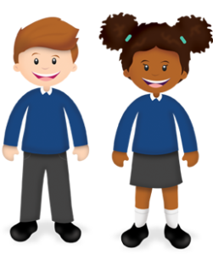
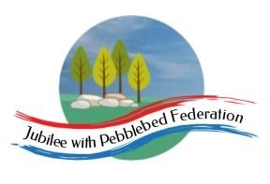
Learning
from Home

Year: 2  Wk beg: 28/09/20 | Lesson One | Lesson Two | Lesson Three | Lesson Four
Monday | Maths  https://classroom.thenational.academy/lessons/sequencing-numbers-to-50-cmtkjt | English  https://classroom.thenational.academy/lessons/to-listen-to-and-respond-to-a-story-6gvpad | Reading  Please use Bug Club Password supplied to access texts set by Mrs Hooper for your child. | PE  https://www.youtube.com/watc h?v=L_A_HjHZxfI
Tuesday | Maths  https://classroom.thenational.academy/lessons/grouping-and-counting-in-tens-60t3ee | English  https://classroom.thenational.academy/lessons/to-tell-a-story-from-memory-60uk2t | Reading  Please use Bug Club Password supplied to access texts set by Mrs Hooper for your child. | Geography  https://classroom.thenational.academy/lessons/what-can-you-find-in-the-united-kingdom-60u68d
Wednesday | Maths  https://classroom.thenational.academy/lessons/exploring-tens-and-ones-cru38d | English  https://classroom.thenational.academy/lessons/to-explore-the-main-moods-in-the-story-61k3ac | Reading  Please use Bug Club Password supplied to access texts set by Mrs Hooper for your child. | Science  https://classroom.thenational.academy/lessons/how-can-i-describe-an-object-c9h38c
Thursday | Maths  https://classroom.thenational.academy/lessons/introducing-place-value-ctjkgd | English  https://classroom.thenational.academy/lessons/to-use-the-past-tense-ed-6xhp6d | Reading  Please use Bug Club Password supplied to access texts set by Mrs Hooper for your child. | History  https://classroom.thenational.academy/lessons/what-was-life-like-in-the-17th-century-6dk3ed
Friday | Maths  https://classroom.thenational.academy/lessons/using-place-value-with-numbers-to-50-6muk4r | English  https://classroom.thenational.academy/lessons/to-use-the-past-tense-ed-6xhp6d | Reading  Please use Bug Club Password supplied to access texts set by Mrs Hooper for your child. | Music  https://classroom.thenational.academy/lessons/understanding-pulse-cdk38c

