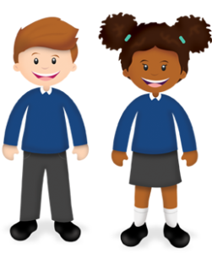
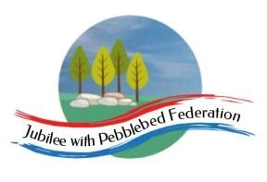
Year 1
Learning from Home

Year:  Week beg:  22/2/2021 | Lesson One | Lesson Two | Lesson Three | Lesson Four | Lesson Five | Lesson Five
Monday | Mental Health Day! Choose your favourite movie, game, book or bake a cake!  Log onto ‘Get Epic’.  Click on link or copy and paste into your web browser.  https://www.getepic.com/book/73887057/bathtime-for-biscuit?utm_source=t2t&utm_medium=link&utm_campaign=content&share=31358210534  Once you reach the page with the cover, you should be able to start reading. If not, click on the ‘class code’ at the top and enter: wjn5693
Tuesday | Maths  Google Classroom – Find ways to pay amounts up to 20p. | English  Google Classroom – To identify a verb. |  | Phonics  Review phase 5 sounds from your home learning pack. | Geography  Draw a picture of things you might see in Spring. For example, daffodils, lambs, baby rabbits, chicks, eggs. | Mental Health –  http://www.littleham.devon.sch.uk/website/mental_health/535426
Wednesday | Maths  Google Classroom – Find totals of single-digit prices using known facts or counting on. | English  Google Classroom – To use a verb. |  | Phonics  Review phase 3 tricky words. | PSHE  I know who my friends and family are – draw picture and write names. | History - Research when Woolly Mammoths lived. https://www.natgeokids.com/uk/primary-resource/woolly-mammoth-primary-resource/
Thursday | Maths  Google Classroom – Add 10p and 20p to 2-digit amounts of money.  Maths  Google Classroom – Quiz! | English  Google Classroom – To use punctuation including question marks. | Reading  Log in to Bug Club and read a book from your ‘library’. https://www.activelearnprimary.co.uk/login?c=0  Google Classroom - Phonics | Phonics  Review Phase 4 and 5 tricky words. | PE  https://youtu.be/VHbQD7aZQxA | Mental Health –  http://www.littleham.devon.sch.uk/website/mental_health/535426
Friday |  | English  Google Classroom – |  | Phonics  Alien vs real words. | Collective Worship  Google Classroom | Story time  Google Classroom – choose a video of Miss Thornton reading a story to watch.

Please be aware that your home filter may allow unsuitable links to pop up when watching any YouTube videos.
Who have you worked with this week? Send me a photo for our display at school!

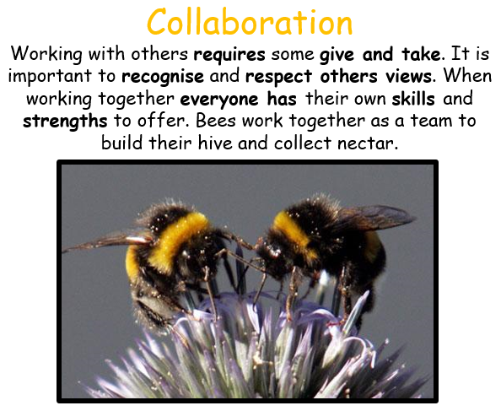

__________has behaved like a ‘Bee’ at home by…..

