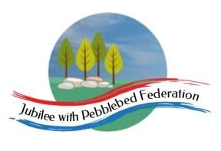
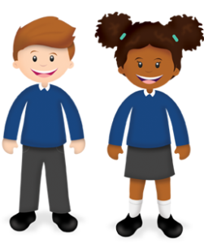
Learning
from Home

Year: Reception  Wk beg: 12/10/20 | Lesson One | Lesson Two | Lesson Three | Lesson Four | Lesson Five
Monday | Name Practise  Support your child to order the letters of their name using the letter cards in their home learning packs, or magnetic letters if you have them. Then get them to have a go at writing their name. Try to encourage your child to hold the pen/pencil correctly. | Reading  Share your child’s Lilac reading book. This can be one from their book bag or from Bug Club. Login details in reading record. | Maths  Using your numeral cards, show your child a number. Can they give you the same number of objects.  E.g. Show 6. Give me 6 cars? Repeat with different numbers. | Phonics  Listen carefully as you sound out these words: pin, sat, tap, net. How many letter sounds are in each word? Try counting on your fingers.  e.g. ‘c-a-t’, 1,2,3’ | Literacy  Watch Alphablocks – Series 2 on CBeebies  Look at how the Alphablocks work together to make words.  e.g. p-a-t = pat
Tuesday | Name Practise  As Monday | Reading  Share your child’s class library book from their book bag or share a story that you have at home. | Maths  Watch Number BLOCKS on CBeebies.  Start on series one – ‘one’. | Phonics  With a grown up, play a listening game about a visit to a farm. ‘I went to the farm and I saw…’ instead of saying the animal name, split the word up into 3 letter sounds. ‘…. And I saw a d-o-g’. | Understanding the World  Watch ‘Let’s Play’ on CBeebies – At the moment, we have building work outside our classroom. Found out what it would be like to be a builder.  https://www.bbc.co.uk/iplayer/episode/b01nzpx8/lets-play-series-1-5-builder
Wednesday | Name Practise  As Monday | Reading  Share your child’s Lilac reading book. This can be one from their book bag or from Bug Club. Login details in reading record. | Maths  Using your numeral cards, show your child a number. Can they copy an action that many times?  E.g. Show 8. Clap 8 times. Repeat with different numbers. | RE  Can they draw a picture of an object or person that is special to them | Fine Motor  Have a go cutting using scissors. Draw straight lines across paper. Encourage them to cut along the lines and hold their scissors correctly.
Thursday | Name Practise  As Monday | Reading  Share your child’s class library book from their book bag or share a story that you have at home. | Maths  Watch Number BLOCKS on CBeebies.  Start on series one – ‘another one’. | Phonics  Robbie the Robot can only speak by saying the sounds of each word. Can you work out what Robbie is saying? Blend the sounds together to say the words  c-ar b-oa-t  b-u-s v-a-n  c-oa-ch t-r-ai-n | Literacy  Watch Alphablocks – Series 2 on CBeebies  Look at how the Alphablocks work together to make words.  e.g. p-a-t = pat
Friday | Name Practise  As Monday | Reading  Share your child’s Lilac reading book. This can be one from their book bag or from Bug Club. Login details in reading record. | Maths  As Monday | Phonics  Emma the Explorer has a list of things she needs to take on her next adventure. Can you help Emma to work out what she needs to pack in her bag?  m-a-p  c-u-p  h-a-t  p-e-n  t-or-ch | Art  Get your paints or pens out. Draw or paint a picture of your house.  What does it look like?  Encourage them to think about what shape are the windows, doors and roof.

