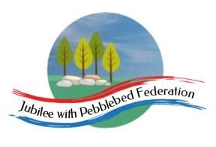
Learning
from Home

Year: 4  Wk beg:  22.2.21 | Lesson One | Lesson Two | Lesson Three | Lesson Four
Monday  The theme for this week’s learning behaviour is empathy and listening!  Our learning animal this week is a rabbit!  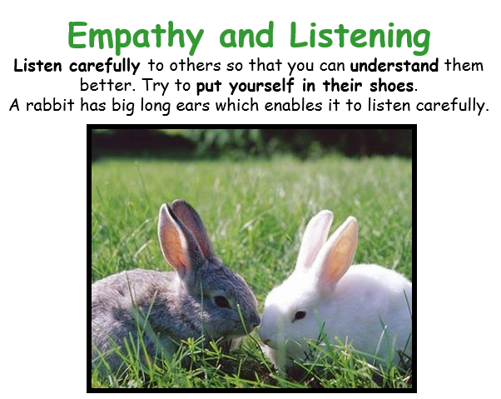 | Mental Health  Get away from screens today by choosing a challenge from the list! | and | Wellbeing Day
Tuesday | English  LO: To explore the functions of fronted adverbials.  Follow this link for the online lesson. There are also some worksheets on Google Classrooms if you would like to practise what you have learned.  https://classroom.thenational.academy/lessons/to-explore-the-functions-of-fronted-adverbials-60u68e | Maths  LO: Find time intervals using the 24-hour clock.  Go to Google Classrooms for the powerpoint lesson and worksheet.  If you are using the home learning pack there are slides to follow and a worksheet for the task. | RE  LO: To think about how Mary felt during Holy Week.  Elicitation Task Discuss the Easter story, what happened? What were the main events Three crosses: a palm cross, a crucifix and a plain cross. Which cross links to which aspect of Holy Week?. Why are they different? Retell the story of Holy Week using: Matthew 21:7–11, Luke 23:13–25, 32–48, Luke 24:1–12. After each reading stop and discuss what Mary might think about this. How does she feel and how did the disciples feel? What do people think about her son at this part of the story? What was surprising about the events, to her and to the disciples? Which cross matches to this part of the story? Why does it match? Come up with some questions to ask Mary. | PE  Home Workout  https://www.youtube.com/watch?v=oc4QS2USKmk
Wednesday | English  The King of the Birds  Fiction  Elicitation task  This English unit we are going to be working on is a story about a group of animals who can’t decide who should be king. They have a competition to see who can fly the highest and whoever does should become king. However, there is an unusual twist, and an unexpected animal becomes king.  LO: To write a story about an animal becoming king or Queen in an unusual way.  Briefly plan what you will write about.  - Choose an animal  - Decide how it has come about that the group of animals are fighting to be king or queen.  - Decide how they agree on who is crowned the king or queen.  - How is it unusual?  - Think about what the characters might say. | Maths Fractions- linking fractions and division  LO: To count in ¼ s, 1/8s and 1/0s along a number line  Google classroom Power point Day 1 | Topic Traders and Raiders  LO: To understand significant dates in history between AD 410 AND 1066  This half term, we begin a new history based learning project. We will be learning about the period in British history spanning from the Anglo-Saxons through to the end of the Vikings in England.  Watch this BBC Bitesize clip and read through the page on both the below websites:  https://www.bbc.co.uk/bitesize/topics/zxsbcdm/articles/z23br82  https://www.history.org.uk/resource/3865  Go to Google Classroom to find further resources for this lesson.  Task Create a time line using the significant dates and matching pictures provided.
Thursday | English  The King of the Birds  Fiction  LO: To read and learn part of the story  Read through the story  Go to Google Classroom. | Maths Fractions- linking fractions and division  LO: To find unit and non-unit fractions  Google Classroom  Power point Day 2 | Topic Traders and Raiders  LO: To find out where the Saxon raiders settled in Britain  In this lesson, we will find out about towns and villages whose names have derived from Saxon words.  Go to this website and read the information about suffixes for names of UK towns and villages. It explains the origin of names given to places by Saxons.  http://www.localhistories.org/names.html  Go to Google classroom and print out the map I have provided. If you can do this, then locate 5 towns which have derived from Saxon words  and mark them on a UK map.  Research the history of Littleham. –ham is an Anglo-Saxon name. | SPAG  LO: To understand that some words sound the same but have different spellings  LO: I can read and spell words with the –tion, -sion, -cian suffix  This week, we are looking at homophones. These are words that sound the same but have a different spelling pattern and have a different meaning.  Go to Google Classroom to find the homophone Power Point for this lesson. This is for reading only and choosing the correct spelling for the right question  The above suffixes are homophones and relate the homophone power point
Friday | English  The King of the Birds  Fiction  LO: To create questions for an interview with the wren  Read through the story again (Google Classroom) and pick out some words and phrases that you like. Can you identify the words that rhyme at the beginning?  Write down four words that you are not sure of the meaning of.  e.g deliberation, conference, consideration (you can use these or find your own)  Look up the meanings of your chosen words and record the definitions.  Can you spot where the characters are talking? How do you know? Which bit of punctuation is used to show speech?  Write four questions for an interview with the wren when it has been decided that the wren should become king. | Maths Fractions- linking fractions and division  LO: To find unit and non unit fractions of amount.  Google Classroom  Power point Day 3 | PE  PE workout  https://www.youtube.com/watch?v=5if4cjO5nxo | Game Time  Go to:  https://www.ictgames.com/mobilePage/index.html  and select from Literacy or maths games to play on  Play a board game or a card game with a family member.

