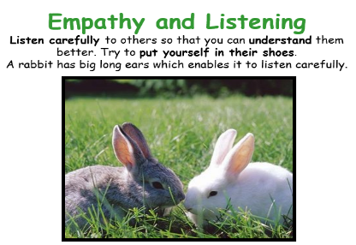
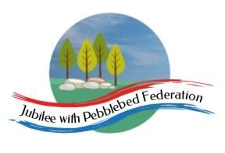
Learning
from Home

Year: Reception  Wk beg: 22/02/2021 | Lesson One | Lesson  Two | Lesson  Three | Lesson  Four | Lesson  Five
Collective Worship/Family Mental Health and Well-being | Collective Worship: Read and talk about The Story of Jonah – see Google Classroom  Mental Health and Well-Being: http://www.littleham.devon.sch.uk/website/mental_health/535426
Monday 22nd February | Littleham Health and Well-being day  Have fun completing some of the challenges with your family. Please send at least one photograph to the class email or upload to Google Classroom. YRteacher@littleham.devon.sch.uk
Tuesday  23rd February | Name Practice  Practice writing your name either on a piece of paper or your name card.  Please encourage correct pencil hold – ‘nip, flip and grip’.  Make sure your child can form every letter correctly and without a visual.  Extend by encouraging your child to write the letters smaller and on a line. | Reading  Log onto Bug Club and pick a book to read to your grown up. Ask your child questions about the story and to sound talk the words.  https://www.activelearnprimary.co.uk/login?c=0  Practice reading some of the sound button words in their home learning pack.  e.g. h-u-ff huff  Or read and write the tricky words on their key ring. | Maths  Watch and join in with Ten in the bed  https://www.bbc.co.uk/teach/school-radio/nursery-rhymes-ten-in-the-bed/z7bnmfr  Use number cards 1 to 5/10/15 depending on how confident your child is with their numbers. Shuffle cards and share out between you.  The 1st player turns over a card and puts it in the middle of the table. Explain that we are creating a number track!  The next player turns over their card and puts it either before or after the card on the table, depending on whether their number is smaller or larger than the card on the table. Depending on the number, they decide how close to put it to the number already there. Continue until all cards have created a number track. Count along the line to check. | Phonics  Review all letter sounds learnt so far – see flash cards in home learning pack + j v w x y z zz qu ch sh th ng ai ee igh oa oo ar  Learn the sound or  https://www.youtube.com/watch?v=33kvsqyOYdg  Then practice reading these words:  dart  bark  arm  star  for  pork  cord  corn  We have learnt all the sounds in these words so see if your child can sound talk them e.g. d-ar-t  Finally complete the ‘or’ Bug Club worksheet. | Literacy  This week we will be creating our own magic potions in school. If you could create a magic potion what would it do?  Today we will be focusing on words that rhyme.  Model writing a list of ingredients for a potion that rhyme with at.  Cat, hat, bat, rat, mat.  Now play the odd one out game. Look at the strips of 4 pictures. Say aloud together several times. Can they spot the word that doesn’t rhyme?
Wednesday  24th February | Name Practice  Practice writing your name either on a piece of paper or your name card.  Please encourage correct pencil hold – ‘nip, flip and grip’.  Make sure your child can form every letter correctly and without a visual.  Extend by encouraging your child to write the letters smaller and on a line. | Reading  Log onto Bug Club and pick a book to read to your grown up. Ask your child questions about the story and to sound talk the words.  https://www.activelearnprimary.co.uk/login?c=0  Practice reading some of the sound button words in their home learning pack.  e.g. h-u-ff huff  Or read and write the tricky words on their key ring. | Maths  Which months are in Spring?  We have been focusing on which months are in Winter in class.  As next month is March, so we will focus on that and the months of Spring. March, April and May. Use the song to identify those months. Also, re-visit which month your birthday is in and what it is like.  Activity - Draw and colour in the empty March balloon in the paper packs. Take a look outside, to see if there are any early signs of Spring.  Try the song:  https://youtu.be/Fe9bnYRzFvk | RE:  Leading up to Easter: Forgiveness  Discuss the idea of ‘Forgiveness.’  When have you had to forgive someone for doing something wrong?  How about saying sorry for something you might have done wrong? Think about when sharing hasn’t gone well.  Watch the video on Forgiveness.  https://youtu.be/FFuHL6Izk6E  On a piece of paper, draw and colour a time when you have had to forgive someone. | PE  If you have an opportunity to get outside and get active, including on a bike, then that would be great!  Setting up an obstacle race in a garden if you have got one, or timed runs etc in a park.  Being active for one minute bursts would be useful, in linking with our Maths using time. Asking the children to do an aerobic activity for what they think is a minute to get a sense of time. Video clips will be included here and Google Classroom.  https://youtu.be/fgxR1PiEiDk  https://youtu.be/2X1p0Yd6WAo
Thursday  25th February | Name Practice  Practice writing your name either on a piece of paper or your name card.  Please encourage  correct pencil hold – ‘nip, flip and grip’.  Make sure your child can form every letter correctly and without a visual.  Extend by encouraging your child to write the letters smaller and on a line. | Reading  Log onto Bug Club and pick a book to read to your grown up. Ask your child questions about the story and to sound talk the words.  https://www.activelearnprimary.co.uk/login?c=0  Practice reading some of the sound button words in their home learning pack.  e.g. h-u-ff huff  Or read and write the tricky words on their key ring. | Maths  Pick a domino. Count the number of dots and say the number.  Find the number on the 1-12 number track and match the domino underneath.  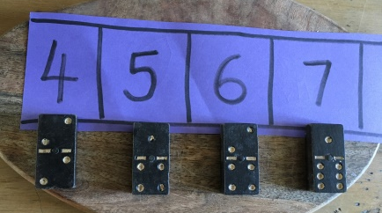  Work together until they have found a domino to match each number on the track. | Phonics  Review all letter sounds learnt so far – see flash cards in home learning pack. Focus on learning the digraphs qu ch sh th ng ai ee igh oa oo(long) oo(short) ar  Learn the sound ur  https://www.youtube.com/watch?v=Q49YSWKPyVo  https://www.bbc.co.uk/iplayer/episode/b01q0pgj/alphablocks-series-3-21-the-end  Then practice reading these words:  cork  fort  torch  fork  fur  burst  hurt  turnip  We have learnt all the sounds in these words so see if your child can sound talk them e.g. b-ur-s-t | Literacy  Write a list of ingredients you could put in your rhyming potion. Can you remember the words you thought of at the beginning of the week?  Can you write at least 3 ingredients on the potion paper provided.  In my rhyming potion, I will put in a…. (words to rhyme with 'at')  cat  hat  mat  bat  rat  Remember to use your letter formation card provided in your home learning pack.
Friday 26th February | Name Practice  Practice writing your name either on a piece of paper or your name card.  Please encourage  correct pencil hold – ‘nip, flip and grip’.  Make sure your child can form every letter correctly and without a visual.  Extend by encouraging your child to write the letters smaller and on a line. | Reading  Log onto Bug Club and pick a book to read to your grown up. Ask your child questions about the story and to sound talk the words.  https://www.activelearnprimary.co.uk/login?c=0  Practice reading some of the sound button words in their home learning pack.  e.g. h-u-ff huff  Or read and write the tricky words on their key ring. | Maths  Practice ordering numerals 0-20 from your home learning pack or using the resources provided.  Can you order the numbers from smallest to largest number?  Encourage your child to count along their number track when they have completed it – ensuring they pronounce teen numbers correctly. | Phonics  Review all letter sounds learnt so far – see flash cards in home learning pack. Focus on learning the digraphs qu ch sh th ng ai ee igh oa oo(long) oo(short) ar ur  Learn the sound ow  https://www.youtube.com/watch?v=GJtvjxBYg7I  https://www.bbc.co.uk/iplayer/episode/b01q0py1/alphablocks-series-3-22-how-now-brown-cow  Then practice reading these words:  curl  turf  surf  church  how  cow  town  growl  We have learnt all the sounds in these words so see if your child can sound talk them e.g. t-ow-n | Handwriting  Help your child to practice writing the letters that make the sounds ur and ow.  Try to encourage your child to hold the pen/pencil correctly. Look at the nip, flip and grip poster if you feel your child needs help with their pencil grip.  Make sure that your child is forming the letters correctly and correct them if needed.  Handwriting sheets – On Google Classroom
Please be aware that your home filter may allow unsuitable links to pop up when watching any YouTube video.

We would love to see any photos of the learning you are doing at home. Please send these to YRteacher@littleham.devon.sch.uk
Please let us know if you need any additional resources to help your child to complete their learning with you at home.

