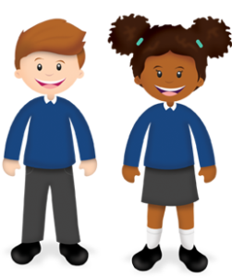
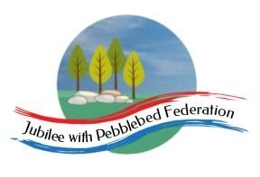
Learning
from Home

Year: 5  Wk beg: 12.10.2020 | Lesson One | Lesson Two | Lesson Three | Lesson Four
Monday | SPAG  https://classroom.thenational.academy/lessons/to-explore-simple-and-compound-sentences-6hk3ed  Practise some of your own sentences | MATHS  https://classroom.thenational.academy/lessons/rounding-2-and-3-digit-numbers-to-the-nearest-10-6gu3er  Create problems to solve. | SCIENCE  https://classroom.thenational.academy/lessons/what-are-forces-6dh3ec  Can you find examples of Levers at home, draw and label the lever and pivot and try to explain what is happening? | PE  Create your own workout programme, which you can present to the class, as a warm up session. E.g. Different pathways, star jumps, an imaginative 1 minute aerobic exercise. A stopping and starting routine. Be creative!
Tuesday | SPELLING  https://classroom.thenational.academy/lessons/to-investigate-suffixes-ate-en-ify-ise-6xj62t | ENGLISH  https://www.bbc.co.uk/bitesize/articles/zkpvbdm  Activity 1 | MATHS  https://classroom.thenational.academy/lessons/rounding-6-digit-numbers-to-the-nearest-100-000-and-10-000-6nhpcd | HISTORY  https://www.bbc.co.uk/bitesize/topics/zg87xnb/articles/zvmkhbk  What did a Pharaoh do? Write a job advert advertising the role of Pharaoh.
Wednesday | SPELLING  https://classroom.thenational.academy/lessons/to-practise-and-apply-knowledge-of-suffixes-ate-en-ify-ise-suffixes-including-a-test-60r30e | ENGLISH  https://www.bbc.co.uk/bitesize/articles/zkpvbdm  Activity 2 | MATHS  https://classroom.thenational.academy/lessons/rounding-6-digit-numbers-to-the-nearest-1000-10-000-and-100-000-65gked | PSHE  https://classroom.thenational.academy/lessons/we-are-a-jigsaw-6cv3ed
Thursday | SPELLING  https://classroom.thenational.academy/lessons/to-practise-and-apply-knowledge-of-suffixes-ic-al-and-ity-tion-ness-including-test-65jk6d | ENGLISH  https://www.bbc.co.uk/bitesize/articles/zkpvbdm  Activity 3 | MATHS  https://classroom.thenational.academy/lessons/what-is-a-fraction-70rkjc | GEOGRAPHY  https://www.bbc.co.uk/bitesize/clips/zwfcd2p  Make your own map of Exmouth.
Friday | READING  Independent Reading-  Read your reading book or a book at home and write a book review about it. | ENGLISH  https://www.bbc.co.uk/bitesize/articles/zkpvbdm  Write your recount up in your best handwriting, you can add pictures as well! | MATHS  https://classroom.thenational.academy/lessons/representing-fractions-cthked | MFL  https://www.bbc.co.uk/bitesize/topics/zjcbrj6/articles/z634kmn

