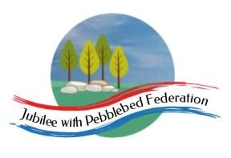
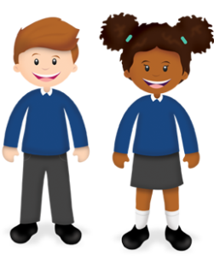

Year 2 Learning from Home Grid
Week Beginning 01.03.21

Think about how we can develop your child’s learning behaviours. This week we are looking at learning to solve problems in an orderly or systematic way.  Tell Mrs Hooper how your child has shown this behaviour this week either by email or returning the slip. | 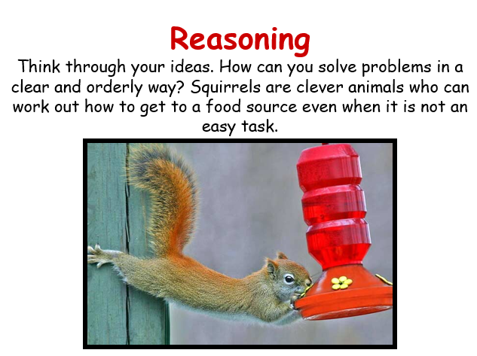
Monday
Reading (30 Mins)
Read the book you have been sent in your home learning pack, these are the sounds you are working on. There is also a book specific to you on Bug Club as well as phonic games you can play.

Phonics (30 Mins)
Sound ou as in shout, log into the bug club lesson in your Bug Club account there is a lesson and games you can join in with. When you complete the lesson and play the games you can earn coins.

Now complete worksheet 1 from the pack you have been given or online in bug club, If you can’t type on the sheet online you can write the answers in a list and send it to me by email at Y2Teacher@littleham.devon.sch.uk

English (30 Mins)
Ready for coming back to school next week this week I have set tasks that will practise and rehearse key skills that we should all be using all the time. For this first day you have an activity that revises reading a sentence out loud and practising it before you write it. You will need to reorder the words to find a sentence that makes sense and write it. Please remember to think about and take time with your handwriting and punctuation, this is a beauty contest not a race !
If you are online learning the best idea this week is to do the exercises on paper and send a photograph to Y2Teacher@Littleham.devon.sch.uk alternatively you could type the answers and email those.

Maths (30 Mins)
It would be great to practise skills before we all come back together again next week.
Number stories
In this first task of the week you need to look at the numbers and reason what signs need to be added to make the number sentence make sense.

Tuesday
Reading (30 Mins)
Read the book you have been sent in your home learning pack, these are the sounds you are working on. There is also a book specific to you on Bug Club as well as phonic games you can play.

Phonics (30 Mins)
Sound oy as in toy, log into the bug club lesson in your Bug Club account there is a lesson and games you can join in with. When you complete the lesson and play the games you can earn coins.

Then you should be able to complete worksheet 2 in your pack.

English (30 Mins)
First of all share supermovers granny with your grown up on this link : https://www.bbc.co.uk/teach/supermovers/ks1-english-capital-letters-full-stops/zjmrhbk

This should help to remind you where to use capital letters in the sentences on the activity sheet. You will need to remember that names have capital letters too.

Maths (30 Mins)
Balloon Puzzle
Read the instructions about ballons carefully. Can you find all the different combinations ? how do you know if you have found them all ?
Running Race
For the running race you need to complete row so that the numbers being carried by the runners have a difference greater than 2 between each runner.

Science (30 Mins)
We are going to learn all about animals and the their habitats. This first video is about living and non living things.

https://classroom.thenational.academy/lessons/what-are-the-characteristics-of-living-things-70u30c

Wednesday
Reading (30 Mins)
Read the book you have been sent in your home learning pack, these are the sounds you are working on. There is also a book specific to you on Bug Club as well as phonic games you can play.

Phonics (30 Mins)
Learning to read and understand the sounds ou and oy in a text. Log into the bug club lesson in your Bug Club account there is a lesson and games you can join in with. When you complete the lesson and play the games you can earn coins.
Then you should be able to complete activity sheet 3.

English (30 Mins)
Watch super granny again , listen carefully to which words should have capital letters. https://www.bbc.co.uk/teach/supermovers/ks1-english-capital-letters-full-stops/zjmrhbk

Now you can complete the activity by sorting out which proper nouns go in which list.

Maths (30 Mins)
Number Triangles
Can you rearrange the numbers on each side of the triangle so that each line adds up to 6 ?
Juggling Clowns
Complete the activity and then have a go at the challenge on a separate piece of paper.

Collective Worship (15 Mins)
Please log into you Google classrooms account to view the Collective Worship from Mrs Padbury.
Thursday
Reading (30 Mins)
Read the book you have been sent in your home learning pack, these are the sounds you are working on. There is also a book specific to you on Bug Club as well as phonic games you can play.

Phonics (30 Mins)
Practice the sounds you have been learning this week by playing the practice games on your Bug Club account.

English (30 Mins)
Today you are practising when and how to use and or but. You need to complete the sentences so that they make sense. Please remember to think about your use of punctuation and your handwriting.

Maths (30 Mins)
Show offs / Is it true ?
You need to think about and experiment with numbers to decide if the facts are true or false.

Geography (30 Mins)
Use the map to answer the true or false questions.

Friday
Reading (30 Mins)
Read the book you have been sent in your home learning pack, these are the sounds you are working on. There is also a book specific to you on Bug Club as well as phonic games you can play.

Phonics (30 Mins)
Enjoy the assessment game assigned to you in Bug Club using the log on code you have been given. You earn points for each game to spend in the Bug Club shop.

English (30 Mins)
Again you have chance to practise using and or but. These joining words are so important to be able to use in year 2 level writing. Can you decide whether to use and or but and join the two short sentences correctly ?

Maths (30 Mins)
Check it
You have more statements to read and experiment with before you say if they are true or false.

