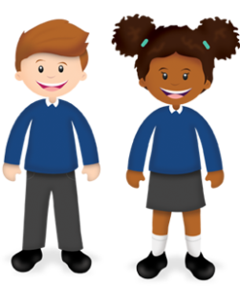
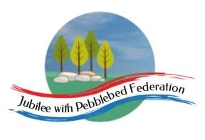
Learning
from Home

Year: 5  Wk beg: 2.11.2020 | Lesson One | Lesson Two | Lesson Three | Lesson Four
Monday | SPAG  https://classroom.thenational.academy/lessons/to-explore-simple-and-compound-sentences-6hk3ed  practise some of your own sentences | MATHS  https://classroom.thenational.academy/lessons/rounding-2-and-3-digit-numbers-to-the-nearest-10-6gu3er  Create problems to solve.  Practice your next times table. Remember the sort of games in class we do. | SCIENCE  https://classroom.thenational.academy/lessons/what-are-forces-6dh3ec  Can you find examples of Levers at home, draw and label the lever and pivot and try to explain what is happening?  Also, look for examples of linkages in toys etc., ready to talk about next week. You could bring one in with permission! | PE  Create your own workout programme, which you can present to the class, as a warm up session. E.g. Different pathways, star jumps, an imaginative 1 minute aerobic exercise. A stopping and starting routine. Be creative!
Tuesday | SPELLING  able/ible  https://classroom.thenational.academy/lessons/to-investigate-suffixes-able-and-ible-69h6at | ENGLISH  https://www.bbc.co.uk/bitesize/articles/znpbgwx  Activities 1 and 2 | MATHS  https://classroom.thenational.academy/lessons/add-and-subtract-fractions-with-the-same-denominator-6nk3jc | HISTORY  https://www.bbc.co.uk/bitesize/topics/zg87xnb/articles/z4m8pg8
Wednesday | READING  Reading for pleasure  https://classroom.thenational.academy/lessons/to-develop-reading-for-pleasure-70tket | ENGLISH  https://www.bbc.co.uk/bitesize/articles/znpbgwx  Activity 3 | MATHS  https://classroom.thenational.academy/lessons/fractions-and-decimals-70tp4c?step=2&activity=video | PSHE  https://classroom.thenational.academy/lessons/i-roll-with-my-role-65h3gr
Thursday | SPELLING  able/ible  https://classroom.thenational.academy/lessons/to-practise-and-apply-knowledge-of-suffixes-able-and-ible-including-test-cmwkcd | ENGLISH  Inference  https://www.bbc.co.uk/bitesize/articles/zh9qkty  Activities 1 and 2 | MATHS  https://classroom.thenational.academy/lessons/comparing-decimals-61j38d?step=2&activity=video | GEOGRAPHY  https://classroom.thenational.academy/lessons/why-are-rivers-important-to-people-6cv3cd
Friday | READING  Inference  https://www.bbc.co.uk/bitesize/articles/zh9qkty  Activity 3 | ENGLISH  First person account work on Website | MATHS  https://classroom.thenational.academy/lessons/improper-fractions-part-2-64upad | RE  https://classroom.thenational.academy/lessons/how-did-the-religion-of-islam-begin-74vk2r

