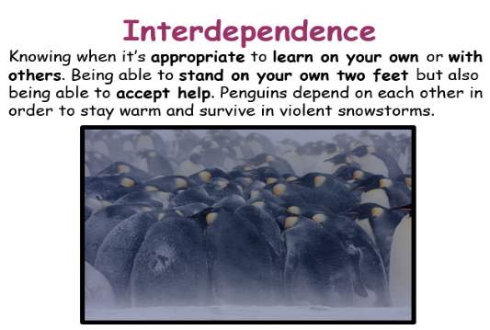
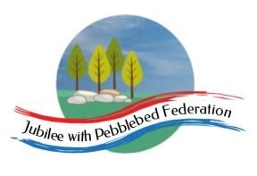
Learning
from Home

Year: Reception  Wk beg: 22/3/2021 | Lesson One | Lesson  Two | Lesson  Three | Lesson  Four | Lesson  Five
Monday 22nd March | Name Practice  Practice writing your name either on a piece of paper or your name card.  Please encourage correct pencil hold – ‘nip, flip and grip’.  Make sure your child can form every letter correctly and without a visual.  Extend by encouraging your child to write the letters smaller and on a line. | Reading  Log onto Bug Club and pick a book to read to your grown up. Ask your child questions about the story and to sound talk the words.  https://www.activelearnprimary.co.uk/login?c=0  Practice reading some of the sound button words in their home learning pack.  e.g. h-u-ff huff  Or read and write the tricky words on their key ring. | Maths  Practice writing numbers correctly.  https://www.youtube.com/watch?v=DzKqCmjVXLI  Now show your child a tin/money box, and count in 6 pennies. How much is in the tin?  Drop in one more penny. How much now? Show me 6 fingers, now show me 1 more. So, 6 and 1 makes 7. Tip out the coins and place them in a line, count and check. Repeat with different numbers up to 10. | Phonics  Review all letter sounds learnt so far – see flash cards in home learning pack. Focus on learning the digraphs qu ch sh th ng ai ee igh oa oo(long) oo(short) ar ur ow oi ear air ure er  Revisit the sounds z zz by watching the clips below:  https://www.youtube.com/watch?v=O6jgGvZ-3zQ  https://www.youtube.com/watch?v=-iiU8DudAbg  Then practice reading these words  yap  zap  zest  buzz  fizz  We have learnt all the sounds in these words so see if your child can sound talk them,  e.g. z-e-s-t zest | Literacy  Think about/look at the picture of the king or queen that you drew last week. You may want to start by drawing your own queen or king picture if this helps. Next you are going to write a caption about your king or queen. For example:  My queen has a crown.  My king is bad.  My king is good.  We have learnt the tricky word ‘my’ but your child might need help to remember how to write this. Encourage your child to sound talk the words they want to write, and then look at the alphabet to find these letters to support with writing them.  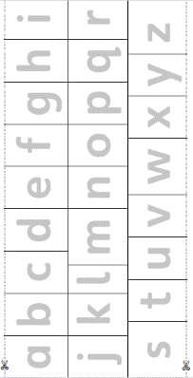
Tuesday 23rd March | Name Practice  Practice writing your name either on a piece of paper or your name card.  Please encourage correct pencil hold – ‘nip, flip and grip’.  Make sure your child can form every letter correctly and without a visual.  Extend by encouraging your child to write the letters smaller and on a line. | Reading  Log onto Bug Club and pick a book to read to your grown up. Ask your child questions about the story and to sound talk the words.  https://www.activelearnprimary.co.uk/login?c=0  Practice reading some of the sound button words in their home learning pack.  e.g. h-u-ff huff  Or read and write the tricky words on their key ring. | Maths  Practice writing numbers correctly.  https://www.youtube.com/watch?v=DzKqCmjVXLI  Show 4 soft toys and then hide them under a blanket. Say one more toy is going to hide under the blanket, how many will be under the blanket then? Show answer on their fingers, by putting up 4 fingers, then 1 more.  Record 4 + 1 = 5. Read it together: 4 add 1 equals 5, 4 and 1 makes 5. Ask: So, what is 1 more than 4?  Reveal the toys to check, modelling an efficient counting strategy.  Repeat with different numbers of toys under the blanket. | Phonics  Review all letter sounds learnt so far – see flash cards in home learning pack. Focus on learning the digraphs qu ch sh th ng ai ee igh oa oo(long) oo(short) ar ur ow oi ear air ure er  Revisit the sound qu by watching the clips below.  https://www.youtube.com/watch?v=ZRGx54lNHoM  https://www.youtube.com/watch?v=pMPjJV8fH10  Next ask your child to write these words:  zed  Zack  zip  zebra  quip  quit  quick  squid  We have learnt all the sounds in these words so see if your child can sound talk them e.g. Z-a-ck | Handwriting  Help your child to practice writing some of the curly caterpillar letters c, a & o.  Try to encourage your child to hold the pen/pencil correctly.  Make sure that your child is forming the letters correctly and correct them if needed.  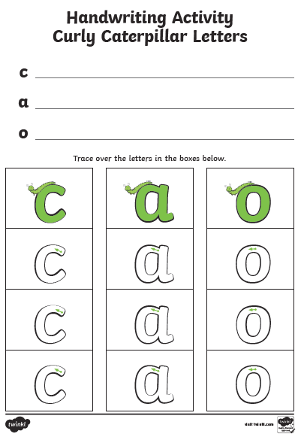
Wednesday 24th March | Name Practice  Practice writing your name either on a piece of paper or your name card.  Please encourage  correct pencil hold – ‘nip, flip and grip’.  Make sure your child can form every letter correctly and without a visual.  Extend by encouraging your child to write the letters smaller and on a line. | Reading  Log onto Bug Club and pick a book to read to your grown up. Ask your child questions about the story and to sound talk the words.  https://www.activelearnprimary.co.uk/login?c=0  Practice reading some of the sound button words in their home learning pack.  e.g. h-u-ff huff  Or read and write the tricky words on their key ring. | RE  Help your child to learn about Easter by talking through the ‘Signs of New Life at Easter’ presentation.  Now have fun drawing and colouring your own Easter Egg. You may want to use paint or collage materials, or even paint a hard-boiled egg.  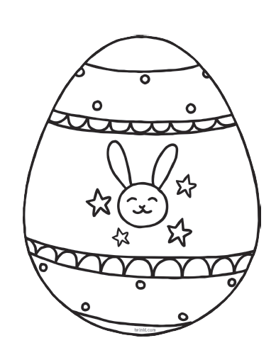 | Phonics  Review all letter sounds learnt so far – see flash cards in home learning pack. Focus on learning the digraphs qu ch sh th ng ai ee igh oa oo(long) oo(short) ar ur ow oi ear air ure er  Now practise reading and writing these tricky words:  me  be  he  my  by | PE  https://www.youtube.com/watch?v=14ou-fplEi4  https://www.youtube.com/watch?v=h5PpLvMvW2s
Thursday 25th March | Name Practice  Practice writing your name either on a piece of paper or your name card.  Please encourage  correct pencil hold – ‘nip, flip and grip’.  Make sure your child can form every letter correctly and without a visual.  Extend by encouraging your child to write the letters smaller and on a line. | Reading  Log onto Bug Club and pick a book to read to your grown up. Ask your child questions about the story and to sound talk the words.  https://www.activelearnprimary.co.uk/login?c=0  Practice reading some of the sound button words in their home learning pack.  e.g. h-u-ff huff  Or read and write the tricky words on their key ring. | Maths  Practice writing numbers correctly.  https://www.youtube.com/watch?v=DzKqCmjVXLI  Make a pretend bus using chairs and get 10 toys out.  - Child/toys play, getting on/off the bus one at a time and saying how many there will be.  - How many are on the bus now? When 1 more toy gets on, how many will be on the bus then?  - How many are on the bus now? When 1 toy gets off, there will be 1 less on toy on the bus. How many will be on the bus then? | Phonics  Review all letter sounds learnt so far – see flash cards in home learning pack.  Learn the sound ch  https://www.youtube.com/watch?v=tuzFWRkKh8A  Then practise reading these words:  quiz  quack  squid  quill  chum  chop  much  chug  We have learnt all the sounds in these words so see if your child can sound talk them e.g. qu-i-z quiz | Literacy  Look at your picture of the king or queen that you drew. This time we are going to write a caption about your king or queen can do. For example:  He can sing.  She can skip and jump.  We have learnt the tricky word ‘he’ and ‘she’, but your child might need help to remember how to write this.  Encourage your child to sound talk the words, put finger spaces between the words and a full stop of the end of the sentence.
Friday 26th March | Name Practice  Practice writing your name either on a piece of paper or your name card.  Please encourage  correct pencil hold – ‘nip, flip and grip’.  Make sure your child can form every letter correctly and without a visual.  Extend by encouraging your child to write the letters smaller and on a line. | Reading  Log onto Bug Club and pick a book to read to your grown up. Ask your child questions about the story and to sound talk the words.  https://www.activelearnprimary.co.uk/login?c=0  Practice reading some of the sound button words in their home learning pack.  e.g. h-u-ff huff  Or read and write the tricky words on their key ring. | Maths  Practice writing numbers correctly.  https://www.youtube.com/watch?v=DzKqCmjVXLI  Make a number line 1-10 or 1-20 (depending on ability) using your number flash cards from your home learning pack.  Prepare ‘one more’ and ‘one less’ number sentence cards.  Ask your child to show you ‘one more’ or ‘one less’ by picking a number sentence question and moving a toy to the correct answer on their number line.  E.g. 7+1 = 8. Child starts at 7 and moves toy to 8  6-1 = 5. Child starts at 6 and moves toy back to 5. | Phonics  Review all letter sounds learnt so far – see flash cards in home learning pack. + j v w x y z zz qu ch  Learn the sound sh  https://www.youtube.com/watch?v=7fE27v8n7Vw&feature=youtu.be  Then practice reading these words:  chat ch-a-t  chin  chest  chips  shut  dish  Josh  shock sh-o-ck | Handwriting  Help your child to practice writing some of the curly caterpillar letters q, d & g.  Try to encourage your child to hold the pen/pencil correctly.  Make sure that your child is forming the letters correctly and correct them if needed.  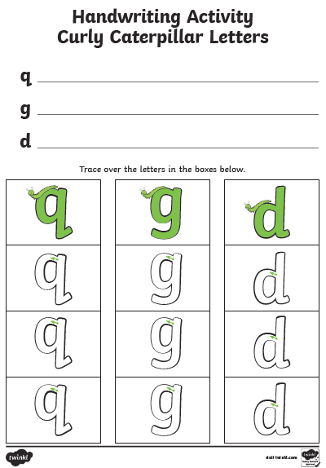
Please be aware that your home filter may allow unsuitable links to pop up when watching any YouTube video.

We would love to see any photos of the learning you are doing at home. Please send these to YRteacher@littleham.devon.sch.uk
Please let us know if you need any additional resources to help your child to complete their home learning with you at home.

