Unit 2: Partitioning numbers 1 to 6 into two sets: 5 = 2 + 3, 1 + 4 etc.
Activity 2: Five Funny Fingers
Aims: To partition 5 (or 4 or 6) into two sets  To recognise how many are missing if the total should be 5 (or 4 or 6) | You will need:  1-5 number cards, whiteboards, pens
Pedagogy: A large group of 10+ children
Preparation: Cut up cards from paper or cardboard to write the number sentences on.
What to do
- Children work in pairs. Ask each pair to show you 5 fingers altogether, e.g. one child might show 4 the other 1. Now ask them to show 5 in another way e.g. 3 and 2.
- Write the different combinations as number sentences on cards e.g. 5+0=5, 0+5= 5, 4+1=5, 1+4=5 etc. and choose pairs to show each. Point out that children who have 4 and 1 and 1 and 4 have the same numbers but have presented them in a different order.
- Now hold up 3 fingers. How many more fingers would make 5? Show this as 3+ [ ] = 5. Emphasise that 2 and 3 makes 5 and so 2 more fingers are needed to make 5.
- Now look at 6 fingers. What pairs of fingers make six? Then hold up six fingers, fold down 2, how many now? Show this as 2+[] =6, so I need 4 more fingers to make 6.
Support children who struggle by using number cards 1-5 so they only use one hand.
Challenge children by completing the activities above, then in pairs they show a number of fingers and their partner writes down the matching number on a whiteboard.
Outcomes: I understand that five can be partitioned into two sets.
I can record statements such as 3 + 2 = 5.
I recognise how many are missing in a statement like 3 + [ ] = 5.

Unit 2: Partitioning numbers 1 to 6 into two sets: 5 = 2 + 3, 1 + 4 etc.
Activity 3: Cats and Dogs
Aims: To partition 5 and 6; to show that if 3 + 2 is 5, then a set of 3 requires 2 more to be 5. | You will need: toy cats & dogs, preferably soft toys (5 of each)
Pedagogy: A large group of 10+ children
Preparation: Have the soft toys at front of the class for children to pick from
What to do:
- Tell children that the Joy family have 5 pets and some of these are cats and some are dogs. How many dogs might be living there and how many cats?
- Let’s try and find different combinations! Choose 5 children and each child picks up either a cat or a dog toy.
- Discuss how many dogs and how many cats are in this group of 5 and write the matching number sentence, e.g. 4 cats and 1 dog becomes 4 + 1 = 5.
- Repeat with other groups of 5 children, encouraging them to choose different combinations of cats and dogs. Each time match the visual cats and dogs with a number sentence.
Support children by writing down a number sentence e.g. 3+2=5 and saying 3 cats and 2 dogs makes 5 animals. Children make the number sentence using cat and dog toys.
Challenge children working as above, then pick 2 cat toys and ask them to work out how many dogs there would be. Show them this as a number sentence 2+[]=5. Repeat.
Outcomes: I understand that five can be partitioned into two sets.
I can record statements such as 3 + 2 = 5.

Unit 2: Partitioning numbers 1 to 6 into two sets: 5 = 2 + 3, 1 + 4 etc.
Activity 4: Pegs on a Hanger
Aims: To partition 5; to show that if 4 + 1 is 5, then a set of 4 requires 1 more to be 5. | You will need: trouser hanger, same coloured pegs, cloth, cubes.
Pedagogy: A group of 4-5 children
Preparation: Create a hanger with 5 or 6 pegs attached
What to do
- Show the children 5 pegs on a coat hanger. Partition the pegs into 4 and 1.
- Turn the coat hanger around to show that 4 and 1 makes 5 and that 1 and 4 also make 5. Show this as two number sentences e.g. 4 + 1 = 5 and 1 + 4 = 5. Repeat for 2 and 3 and record as 2 + 3 = 5 and 3 + 2 = 5.
- Ask children to close their eyes whilst you hide 3 pegs with a cloth. Show me 5 fingers. Now show me how many pegs you can see on the coat hanger. Record this as 3+[]=5. How many fingers are folded down? That’s how many are hiding! Complete the number sentence to show this e.g. 3+2=5. Remove the cloth to check. Repeat hiding different amounts of pegs and then move on to 6 pegs.
Support children who struggle by giving them 5 cubes. Partition the pegs and ask them to create the same partition using their cubes e.g. 4 and 1. Scribe each as a number sentence.
Challenge Use 6 pegs: Start with 4. How many more to make 6? Write it as a number sentence.
Outcomes: I understand that 5 and 6 can be partitioned into 2 sets.
I recognise that addition can be done in any order and will have the same total.

Unit 2: Partitioning numbers 1 to 6 into two sets
Play Activity 1: Farms and Zoos
Aims:  To partition 3, 4, 5 and 6 into two sets | You will need:  Selection of animals; lolly sticks; bricks
Preparation: Make 2 pens for each child and give them a basket of animals
What children do…  Provide children with a selection of farm animals and pens made from lolly sticks or bricks. Keep the number the same, e.g. 5 animals and 2 pens. How can we partition 5 cows/sheep/bears into 2 pens? Let children try different ways with different animals e.g. 3 sheep in one pen and 2 in another. Differentiate the numbers. |  |  |  | 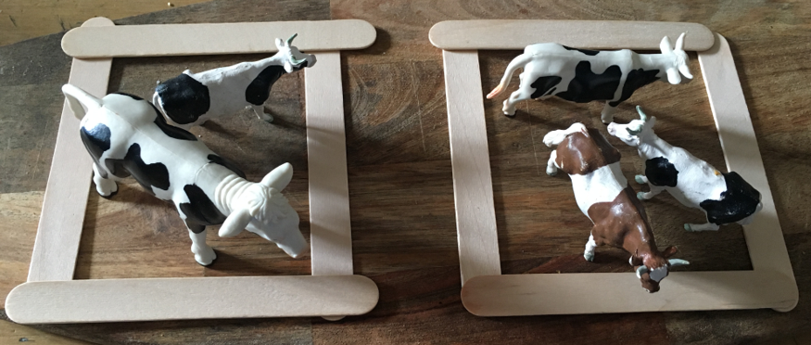
Talking points  - There are 3 in the pen. How many more must come so that we have 5?  - Four and how many more make six? |  | Evidence of learning:  Take pictures of the different ways the children have sorted the animals. More able children can record as a number sentence.
Outcomes: I can arrange 3, 4, 5 or 6 animals in two sets
I can say how many in each set make a given total, e.g. 2 and 3 make 5.
Unit 2: Partitioning numbers 1 to 6 into two sets
Play Activity 2: Construction
Aims: To partition 5 (or 4 or 6) into two sets | You will need: lots of same-sized Lego bricks; mini people/ figures
Preparation: Place two number cards and a number of Lego bricks on coloured pieces of card around the table.
What children do  Provide either 4, 5 or 6 Lego/ wooden bricks and two people for each child. They use the 5 bricks and build a tower for each person. How many does this man have? (2) How many does this lady have? (3) Challenge children to build as many different combinations of towers as they can for the 2 people – same total number of bricks each time. |  |  |  | 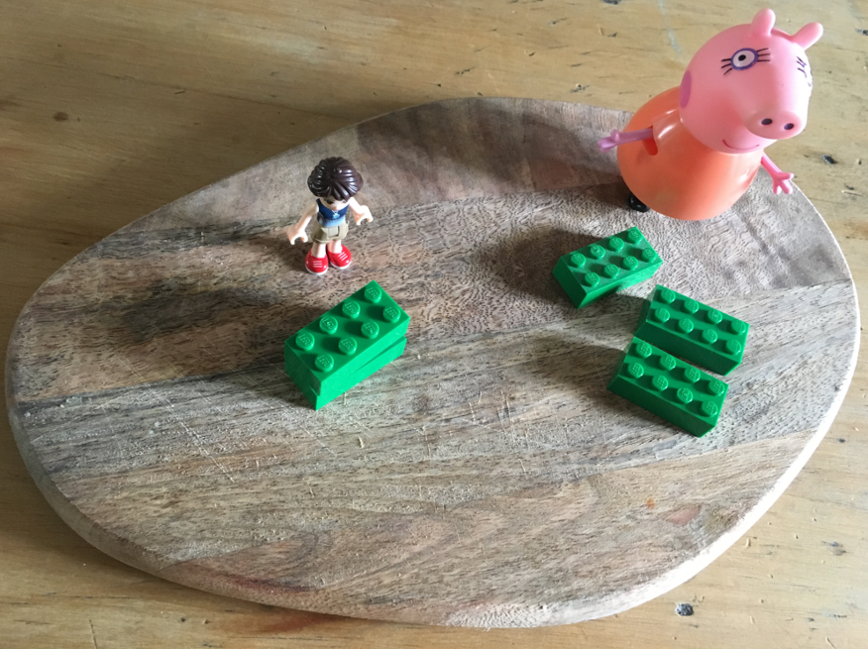
Talking points  - Which person has the most bricks in their tower?  - If she has 3 bricks, how many does he have?  - How many is 1 and 4? |  |  | Evidence of learning:  Take pictures of the different towers and the people.  Some children might write the numbers of bricks in each tower.
Outcomes: I can arrange 4, 5 or 6 Lego bricks into two sets
I can say how many in each set make a given total, e.g. 2 and 3 make 5.

Unit 2: Partitioning numbers 1 to 6 into two sets
Activity 4: COOKING Topping treats
Aims: To partition 5 (or 4 or 6) into two sets | You will need:  Rich Tea finger biscuits, raisins, dried cranberries.
Preparation: Give each child a Rich Tea finger or a sponge finger with 6 cranberries and 6 raisins or other dried fruit.
What children do  Provide children with a sponge finger or Rich Tea finger biscuit and a target number e.g. 6. They choose a combination of raisins or cranberries to create that total and line them up under one another on the sponge finger e.g. 3 raisins, 3 cranberries. | 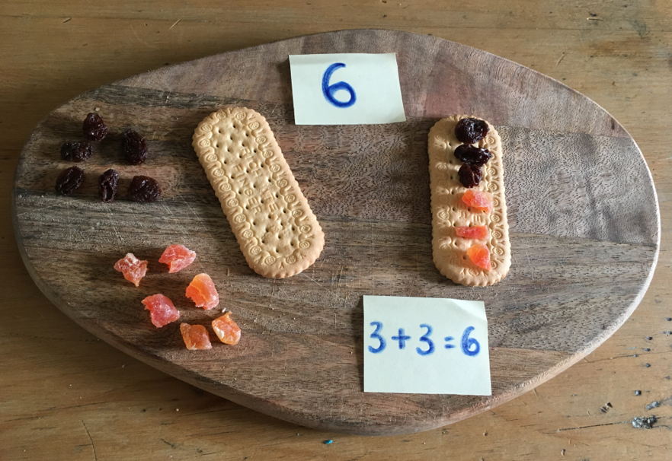
Talking points
- Can you find another way of making 6?
- If you have 5 raisins on your biscuit, how many cranberries will you need to make 6 altogether?
 | Evidence of learning: Take photos of children’s different combinations.
Outcomes: I can select two toppings to make a given total.
I can say how many of each topping make a given total, e.g. 2 and 3 make 5.

