- Read the Newspaper Article.
- Underline vocabulary that you aren’t sure about.
- Can you find any examples of opinions in the newspaper article? Can you find examples of facts?

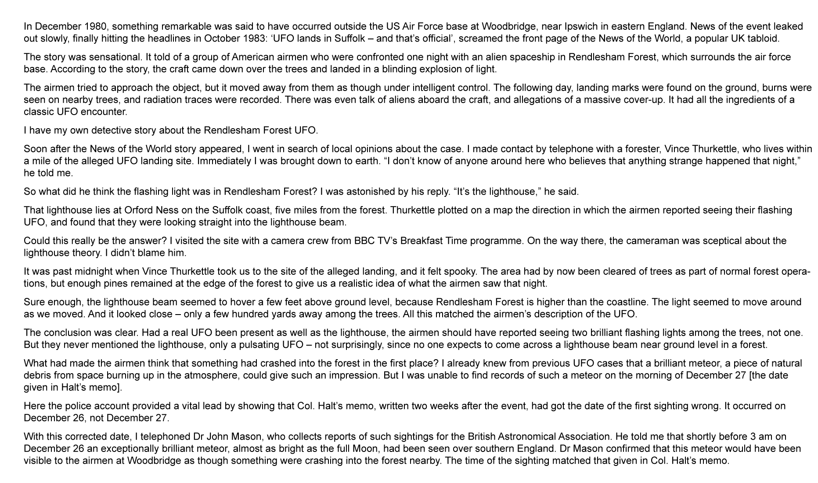

What do you think happened?

Explain why you think this.

