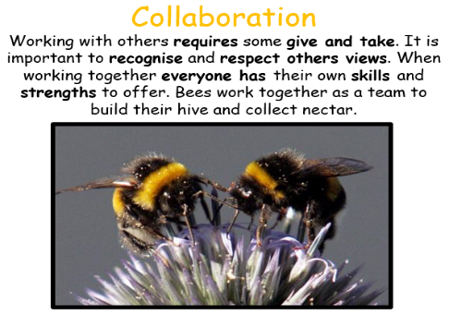
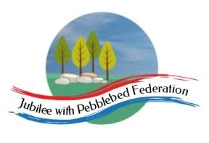
Learning
from Home

Year: Reception  Wk beg: 08/02/2021 | Lesson One | Lesson  Two | Lesson  Three | Lesson  Four | Lesson  Five
Collective Worship/Family Mental Health and Well-being | Collective Worship: Choose a time to watch Mrs Padbury’s Collective Worship on Collaboration – Google Classroom  Mental Health and Well-Being: http://www.littleham.devon.sch.uk/website/mental_health/535426
Monday 8th February | Name Practice  Practice writing your name on your name card. You will find this in your child’s home learning pack.  Please encourage correct pencil hold – ‘nip, flip and grip’ and letter formation.  Please make sure your child can form all the letters correctly in their name. | Reading  Log onto Bug Club and pick a book to share. Ask your child questions about the story.  https://www.activelearnprimary.co.uk/login?c=0  Log in details are at the front of your child’s reading record.  Then practice reading some of the sound button words in their home learning pack.  e.g. s-a-t sat | Maths  Listen to and join in with Ten Green Bottles.  https://www.bbc.co.uk/programmes/p038bdqh  Now complete the Maths Assessment in your paper pack or on Google Classroom. Please return this with this paper pack or take a photo and send to YRteacher@littleham.devon.sch.uk | Phonics  Review all letter sounds learnt so far – see flash cards in home learning pack + j v w x y z zz qu ch sh th ng ai ee igh oa oo ar  Please watch this lesson to review the sounds ch, sh, th and ng.  https://www.youtube.com/watch?v=bZ5XfHKJS_M | Literacy  Cut out the pictures and stick them in order to tell the story of Little Red Riding Hood.  Once complete can you use the story map to tell you the story? Or part of the story?  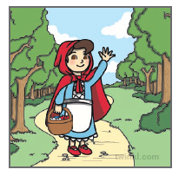
Tuesday  9th February | Name Practice  Practice writing your name on your name card. You will find this in your child’s home learning pack.  Please encourage correct pencil hold – ‘nip, flip and grip’ and letter formation.  Please make sure your child can form all the letters correctly in their name. | Reading  Log onto Bug Club and pick a book to share. Ask your child questions about the story.  https://www.activelearnprimary.co.uk/login?c=0  Log in details are at the front of your child’s reading record.  Then practice reading some of the sound button words in their home learning pack.  e.g. s-a-t sat | Maths  Start by counting on in ones. Can you count to 10? 20? How far can you go?  Next read a counting story or listen to the one Google Classroom.  Now take turns to pick up two handfuls of cubes (or something similar) and tip them onto a tray.  Without counting, decide if there are more or fewer than 10.  Count to check. | Phonics  Review all letter sounds learnt so far – see flash cards in home learning pack + j v w x y z zz qu ch sh th ng ai ee igh oa oo ar  Now go to www.phonics play.co.uk/  Username march20  Password home  This website is free to use at the moment and has lots of good phonics games for your child to play.  Once logged on go to resources, phase 3, Grab a Giggling Grapheme, start, continue, then + ch,sh,th,ng  You could try some other games also if your child has enjoyed this one. | Literacy  Help your child to write the words to match the pictures. See if they can hear all of the sounds in each word before they try to write them down. They may want to look at the alphabet mat to help them with the letter shapes. Some boxes might need two letters for the digraph ck.  Worksheet – On Google Classroom or in your paper pack.
Wednesday  10th February | Name Practice  Practice writing your name on your name card. You will find this in your child’s home learning pack.  Please encourage correct pencil hold – ‘nip, flip and grip’ and letter formation. | Reading  Log onto Bug Club and pick a book to share. Encourage your child to predict what will happen next.  https://www.activelearnprimary.co.uk/login?c=0  Practice reading and writing the tricky words – to, I, no, go, into, the | MATHS  Which month is my birthday in?  We have been focusing on which months are in Winter in class. December for Christmas, January last month and February this month.  With that in mind, we are learning which month the children were born in. Is it in the Winter, Spring etc. Also, the month before or after, as an extension.  Activity - Draw a picture of what you like to do on your birthday and write the month.  Try the song:  https://youtu.be/Fe9bnYRzFvk | RE THE CREATION.  https://youtu.be/teu7BCZTgDs  PLAY THE CREATION STORY AGAIN. WE REALLY ENJOYED IT IN CLASS.  Discuss which creatures the children like best. It could be a pet, or just a creature they like best. It can be more than one. It can be even be one from the film. If you can’t access it, then choose one you see out and about, or at home.  A piece of paper will be included in the home learning pack for the activity, as will a colouring sheet. This will be added to Google Classroom as well. | PE  If you have an opportunity to get outside and get active, including on a bike, then that would be great!  Setting up an obstacle race in a garden if you have got one, or timed runs etc in a park.  Being active for one minute bursts would be useful, in linking with our Maths using time. Asking the children to do an aerobic activity for what they think is a minute to get a sense of time. Video clips will be included here and Google Classroom.  https://youtu.be/fgxR1PiEiDk  https://youtu.be/2X1p0Yd6WAo
Thursday  11th February | Name Practise  Practice writing your name on your name card. You will find this in your child’s home learning pack.  Please encourage correct pencil hold – ‘nip, flip and grip’ and letter formation.  Please make sure your child can form all the letters correctly in their name. | Reading  Log onto Bug Club and pick a book to share. Encourage your child to predict what will happen next.  https://www.activelearnprimary.co.uk/login?c=0  Then practice reading some of the sound button words in their home learning pack.  e.g. s-a-t sat | Maths  Build a model using no more than 20 cubes or bricks.  Once finished building, count the bricks/cubes again and choose a Post-it note/piece of paper to label the number used.  - How many would you have if you added one more cube? How about if you took one cube away?  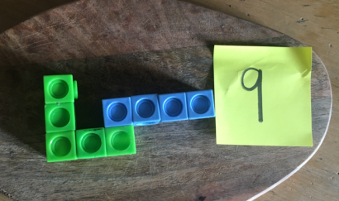  - Can you build another model with more cubes/ less cubes? | Phonics  Start by reviewing all letter sounds learnt so far – see flash cards in home learning pack or use flash cards attached + j v w x y z zz qu ch sh th ng ai ee igh oa oo (long) oo (short) ar  Review the digraphs ai ee igh oa Watch the phonics session  https://www.youtube.com/watch?v=MvaPYJ0ahVc&feature=youtu.be  Then have a go at the card-sorting activity to help practice recognition of words using the digraphs ai ee igh oa (Google Classroom/paper pack). | Literacy  Watch Mrs Land model writing a valentine's card for her Mum (on Google Classroom)  Write a Valentine's card or message for someone special.  Encourage them to have a go at writing the tricky word 'to' and to sound talk names, ‘love’ and ‘from’ independently.
Friday 12th February | Writing Assessment  Please get your child to complete the writing assessment that is in their paper pack or on Google Classroom.  They will first need to write their name independently in their best writing and then draw a picture of themselves. Encourage your child but make sure they do this on their own.  Please return this with this paper pack or take a photo and send to the class email below. | Reading  Log onto Bug Club and pick a book to share. Ask your child to share their favourite page with you.  https://www.activelearnprimary.co.uk/login?c=0  Then practice reading some of the sound button words in their home learning pack.  e.g. s-a-t sat | Maths  Choose a cup and unfold a Post-it/piece of paper to reveal a hidden number. They say the number.  - Choose a set of counting objects and count that many into the cup. Could use pasta, stones, sweets…  They repeat, choosing a new cup with a new number.  • How many have you put in your cup?  • Do you need to add more gems to reach the number on the side?  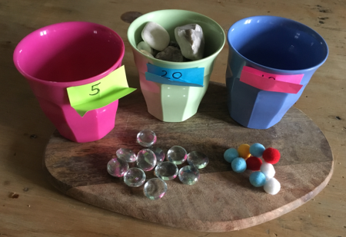  • Have you got the same number when you counted backwards? This is a good way of checking! | Phonics Assessment  Please complete the phonics assessment with your child. You can find this in your paper pack or on Google Classroom.  Start by showing your child the letter sound flashcards from their home learning packs and tick the grid if they know the sound.  There are some tricky words to try to read and some words where the sounds can be blended also.  If your child is losing concentration please do this assessment in small chunks across the day.  Please return this with this paper pack or take a photo and send to the class email below. | Handwriting  Help your child to practice writing words. Use your letter mat in their home learning pack if they need help with letter formation.  Have a go at labelling the pictures. Please share their writing with us :) YRteacher@littleham.devon.sch.uk  Worksheet – On Google Classroom or in your paper pack.
Please be aware that your home filter may allow unsuitable links to pop up when watching any YouTube video.

We would love to see any photos of the learning you are doing at home. Please send these to YRteacher@littleham.devon.sch.uk

