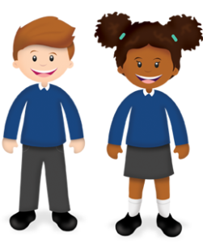
Year 5
Learning from Home

Year:  Week beg:  08/3/2021 | Lesson One | Lesson Two | Lesson Three | Lesson Four
Monday | Thinking about yourself  Work through the Back to School journal, think about how you are feeling at home and how you feel about returning to school. Please keep the journal safe and bring it with you when you return to school for me to see. |  | .PE  Try some Yoga!  Cosmic Kids - How to make a magic worry box  https://www.youtube.com/watch?v=3Rcb96N1L2k | Reading  Think of your favourite book character, what do they look like? What type of person are they? Draw a picture of them and label their personality and characteristics around the outside.
Tuesday | English, Art and Dance  Listen to the poem A Boy’s Head. Think about the talking points-what do you think? Today you will be creating a self-portrait, use the example to help you. You will only be drawing and colouring the portrait today DO NOT cut it up! | Maths and Art  Work through Day one - Bubble Bonds on the PowerPoint.  Complete the secret picture colouring sheet (mild or spicy) when you colour numbers that total 100 (mild) or 1 (spicy) it will reveal a picture – what can you see? | Project Work  We will be working on a small project about lighthouses using the video:  https://www.literacyshed.com/the-lighthouse.html  Today I would like you to watch the opening scene, where is it set? What do you think the video will be about?  Pause the film after the lighthouse keeper slams the windo shut – what does he think about the people outside having fun? Why does the author put in this scene?  What did you think of the film? Imagine you are a film critic write a review of the film. | PSHE  https://classroom.thenational.academy/units/money-matters-a4d3  If you have not looked at this unit yet start on Lesson 1, if you have been working though these during lockdown today’s lesson is Lesson 5 Bullying.
Wednesday | English and Art  Think about the poem A Boy’s Head – can you remember the eight items that the poet says are in the boy’s head? Listen to the poem, were you right? Today you are going to cut open your self-portraits at the mouth, stick them to another piece of paper and add the drawings of what is in your head. Think about thoughts, feelings, memories and questions. | Maths and Movement  Work through Day two – Movement Multiplications on the PowerPoint. Remember that multiplication and division are the inverse of each other. Look at the activity sheet and think of ways to use movement when multiplying and dividing. | Spelling  https://classroom.thenational.academy/lessons/to-investigate-suffixes-plurals-64r36d | Outdoor Learning  Have a look at the activity Living Books  Create a scene from your favourite book, please complete this activity indoors – you can use your toys etc. to make the scene!
Thursday | English  Look at the object – what could it be? Write down your ideas. It comes from a book called What do you do with an idea? Watch the video of the book being read: https://www.youtube.com/watch?v=mSfNv0-SgJM  What is the book about? What are the three most important things that someone could learn from this book? Please record your answers to these questions. | Maths and Design Technology  Work through Day three – 3-D sculptures on the PowerPoint. Look at the pictures of sculptures by Anthony Gormley. How do you feel today? Make a shape that shows that feeling using your body. How could you represent this as a sculpture? If you can use strips of cards to create your own sculpture – use the examples to help you. If you have no card, draw a picture of what your sculpture would look like. | Project work  Look at the Lighthouse picture by Maud Lewis. Maud Lewis was an artist who lived in Nova Scotia, Canada. She was born in 1901 and died in 1970. During her life she faced many challenges, she was always much smaller than other people and had almost no chin, she also battled arthitis but overcame all of these challenges to become a very famous artist in Canada.  Today I would like you to reproduce her painting of the Lighthouse, you could use paints, coloured pens or pencils to do this. Look carefully at the style of her work and her use of colour!
Friday | Maths  Times Tables Investigation  Table Patterns Go Wild!  https://nrich.maths.org/6924&part= | Science  Work through the PowerPoint and then answer these questions:  Which magnetic poles attract and which repel?  What is the significance to navigators in following North?  If a magnet’s north pole points towards North, what does this tell us about this magnetic pole? Are you surprised? | ICT  https://classroom.thenational.academy/units/web-page-creation-0205  If you have not looked at this unit yet start on Lesson 1, if you have been working though these during lockdown today’s lesson is Copyright or Copywrong? | PE  Try a workout with Joe Wicks!  https://www.youtube.com/watch?v=CFG5CPrzwXU

Please be aware that your home filter may allow unsuitable links to pop up when watching any YouTube videos.

Please remember to send in your work to the year 5 email address: Y5Teacher@littleham.devon.sch.uk

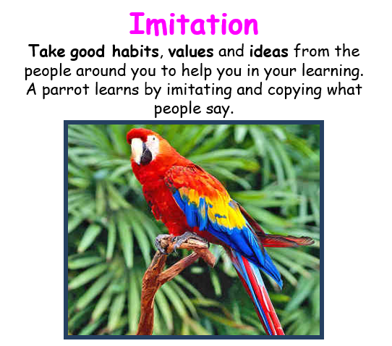
This week’s learning animal is the PARROT. The parrot is good at imitating which helps it to learn. Look for times when you are learning like a parrot!

