The Stations of the Cross
We did not get around to learning about these before Easter.
These are places that were on the route that Jesus took to His crucifixion. Several things happened to Him whilst carrying the cross.
You can still visit many of these places.
Can you match the stations to the description of what is happening?
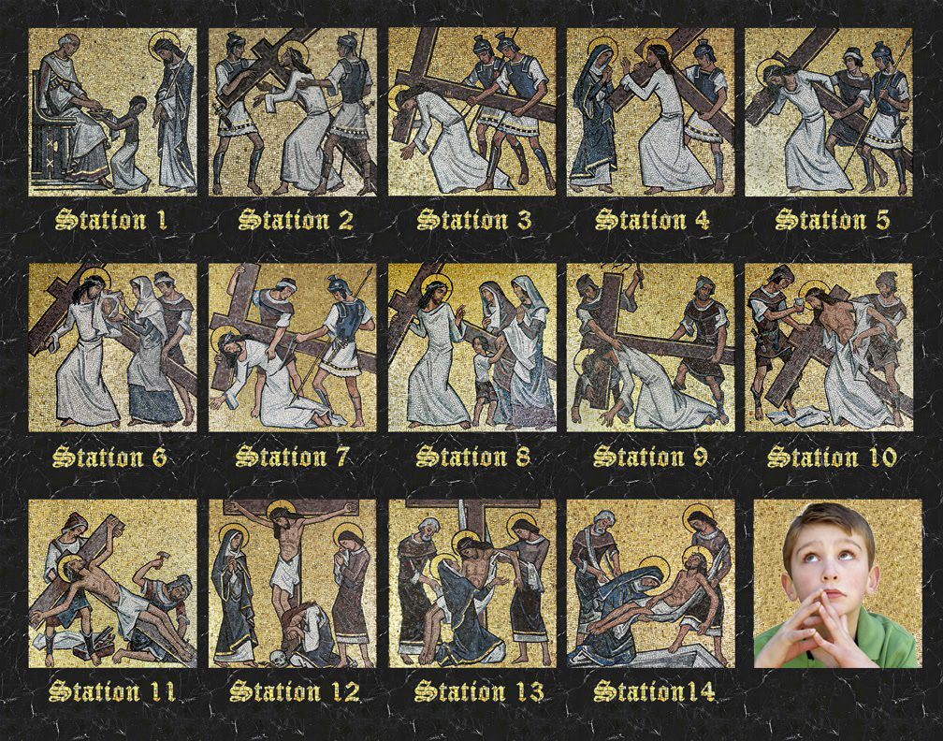
Jesus is condemned to death.

Jesus is crucified.

Jesus falls for the first time.

Jesus meets Mary.

Jesus falls for the second time.

Jesus meets the women of Jerusalem.

Jesus falls for the third time.

A woman wipes Jesus’s brow.

Jesus is disrobed.

Jesus is nailed to the cross.

Simon of Cyrene helps Jesus to carry the cross.

Jesus’s dead body is taken down.

Jesus is given a cross to carry.

Jesus’s body is taken away to be placed in a tomb.

