Learning from Home

Year: 3  Wk beg: 18.1 | Lesson One  (Look at this week’s reading comprehension activity on google classroom) | Lesson Two | Lesson Three | Lesson Four | Lesson Five
Monday | Reading  Read library book or allocated bug club books | English  Go to google classroom  Monday 18th January  LO: I can write complex sentences to define a word. | Maths  Go to google classroom  Monday 18th January  LO: I can develop mental methods of subtraction: subtract by counting up. | Science  Go to google classroom  Monday 18th January  How are organisms adapted to hot environments? | PE  Go to google classroom  Monday 18th January  PE with Joe-youtube
Tuesday | Reading  Read library book or allocated bug club books | English  Go to google classroom  Tuesday 19th January  LO: I can put words in alphabetical order. | Maths  Go to google classroom  Tuesday 19th January  LO: I can develop mental methods of subtraction: subtract by counting up. | RE  Go to google classroom  Tuesday 19th January  What is the holy book of Islam? | Collective Worship  Go to google classroom  Tuesday 19th January  Perseverance with Mrs Padbury
Wednesday | Reading  Read library book or allocated bug club books | English  Go to google classroom  Wednesday 20th January  LO: I can find definitions for my difficult words and understand them. | Maths  Go to google classroom  Wednesday 20th January  LO: I can develop mental methods of subtraction: subtract by counting up; Find change from £1. | History  Go to google classroom  Wednesday 20th January  What was the Golden Age of Greece? | PE  Go to google classroom  Wednesday 20th January  PE with Joe-youtube
Thursday | Reading  Read library book or allocated bug club books | English  Go to google classroom  Thursday 21st January  LO: I can write examples of my difficult word in a sentence. | Maths  Go to google classroom  Thursday 21st January  LO: I can use Frog on a beaded line to subtract (counting up). | Geography  Go to google classroom  Thursday 21st January  What are the physical features of Europe? | Mental Health  Stay hydrated  Keep a log of how many glasses of water you drink each day until next Thursday.
Friday | Reading  Read library book or allocated bug club books | English  Go to google classroom  Friday 22nd January  LO: I can write my own clear definitions. | Maths  Go to google classroom  Friday 22nd January  LO: I can use Frog on a landmarked line to subtract (counting up). | Science  Go to google classroom  Friday 22nd January  How are organisms adapted to cold environments? | PE  Go to google classroom  Friday 22nd January  PE with Joe-youtube
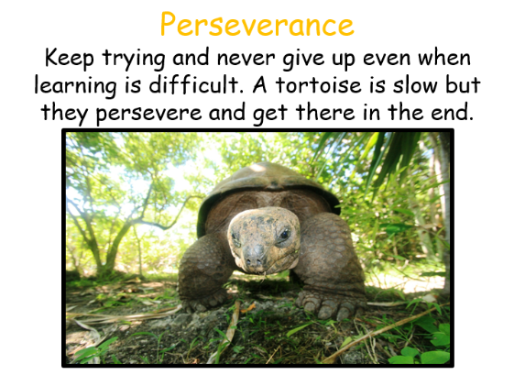
This week our learning animal is the tortoise. Please can your adult look for times when you are showing this learning behaviour.
If possible, your adult could email any examples of your perseverance to me. I will add them to our class display.

Miss Plumridge

